

Leeds Beckett University

School of Computing, Creative Technology and Engineering

**Module: Database Systems**

**Academic Year: 2019/20**

**Level 5: Semester A**

**Assignment Title: DS Assessment 1 Component 2**

**Date Due: 15th January 2020.**

**Tutor: Rohit Raj Pandey.**

**Student Name: Avhimanhu Sapkota**

**Student ID: c7202323**

# Table of Contents

Table of Contents 2

Introduction 3

Task 1: Implementation and Testing 4

Trigger 1: Code and Test Implementation. 4

Trigger 2: Code and Test Implementation. 7

CRUD Triggers 10

Task 2: Application Builder 18

Application: CARS4U Cars Hire Company. 18

Home Page (with CSS) 18

Navigation Menu with Icons 19

Dashboard 22

Master Detail Forms 23

Insertion Forms for Master Page 26

Graphs and Charts 32

Calendars 34

Reports of Assignment Component 1 36

Reports with Forms 39

Multiple User Access 45

Application Administrator 48

Application’s Reader – CARS4U Customer 49

Application’s Contributor – CARS4U Team 51

Bibliography 53

Appendix 53

# Introduction

This is a report of the assignment of Database Systems, a syllabus curriculum of Leeds Beckett University which is also taught in The British College. Students were supposed to create EERM, ERD, tables with all valid data, views and reports in the first phase of the assignment. This report is based on the second phase of the assignment which is the extension version of the previous report. Thus, this report makes use of all those tables, views and reports created in component 1 of the assignment.

In this particular assignment, we were supposed to choose one option to perform key database solutions. I have chosen the second option i.e. Importance of programming, validations and other Apex features to ensure data quality. However, choosing option two is not quite sufficient to ensure the complete application environment therefore I have also added some features of option one into my assignment.

This report consists of screenshots of the task performed during the creation and implementation of various features of the application. Screenshots of triggers created to perform particular operations, application’s home page, dashboard, master detail form, forms to insert data, charts, calendar, reports, other validations and multiple user login process have been included along with a brief description.

# Task 1: Implementation and Testing

## Trigger 1: Code and Test Implementation.

This trigger has been created for HIRE_INVOICE table during INSERTION or UPDATE process in order to calculate discount for hire. This trigger has various conditions to fulfill before inserting or updating into a table. Those conditions are:

* If the total amount to be paid is higher than 10000 then 10% discount.
* If the total amount to be paid is higher than 15000 then 15% discount.
* If the total amount to be paid is higher than 20000 then 20% discount.
* If the total amount to be paid is higher than 25000 then 25% discount.
* If the total amount to be paid is higher than 30000 then 30% discount.
* Finally, no discount will be offered if the total amount to be paid is less than 10000.
* Screenshot of trigger code and statement that says trigger created:

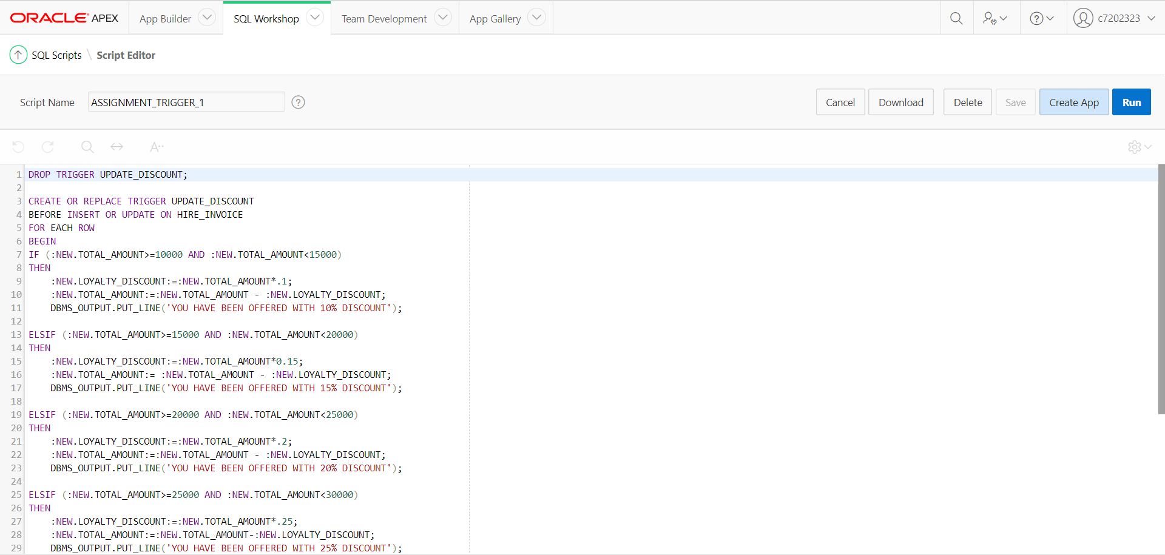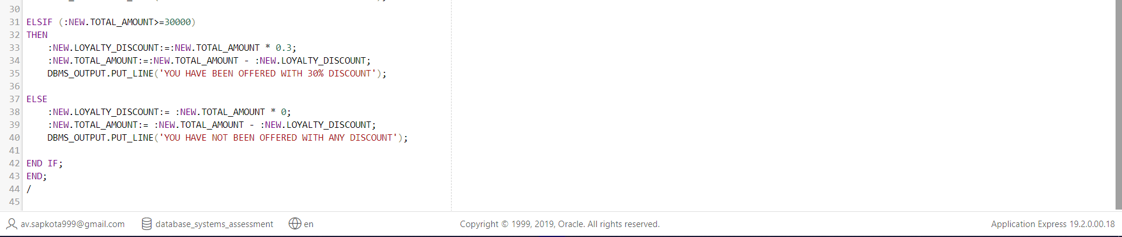

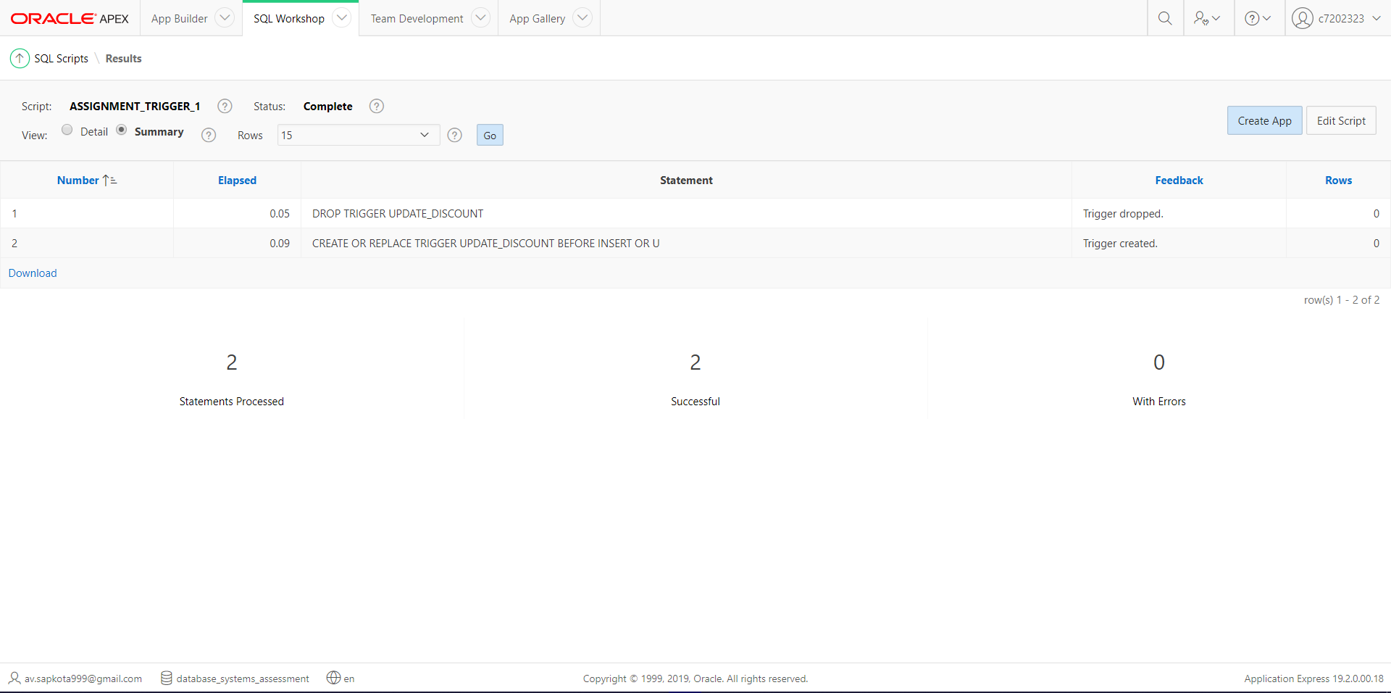

* Screenshot of trigger’s implementation test code along with the inserted/updated value:

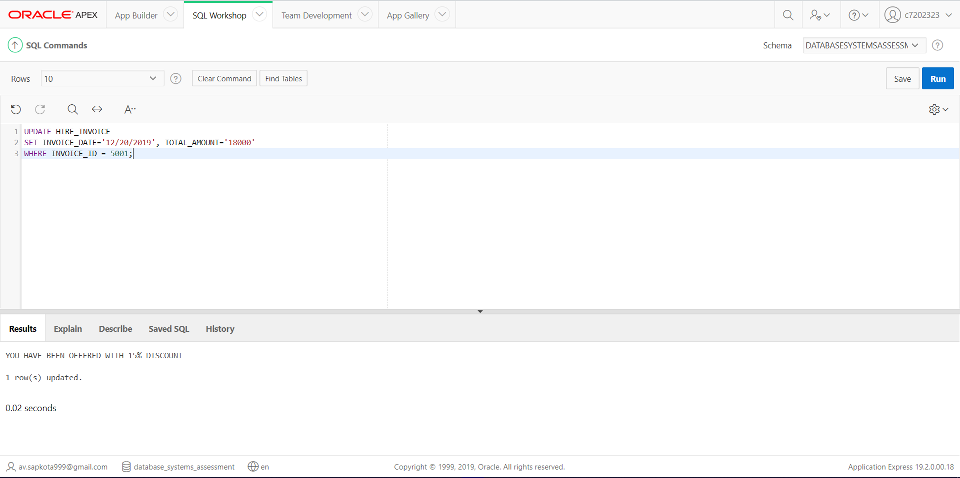

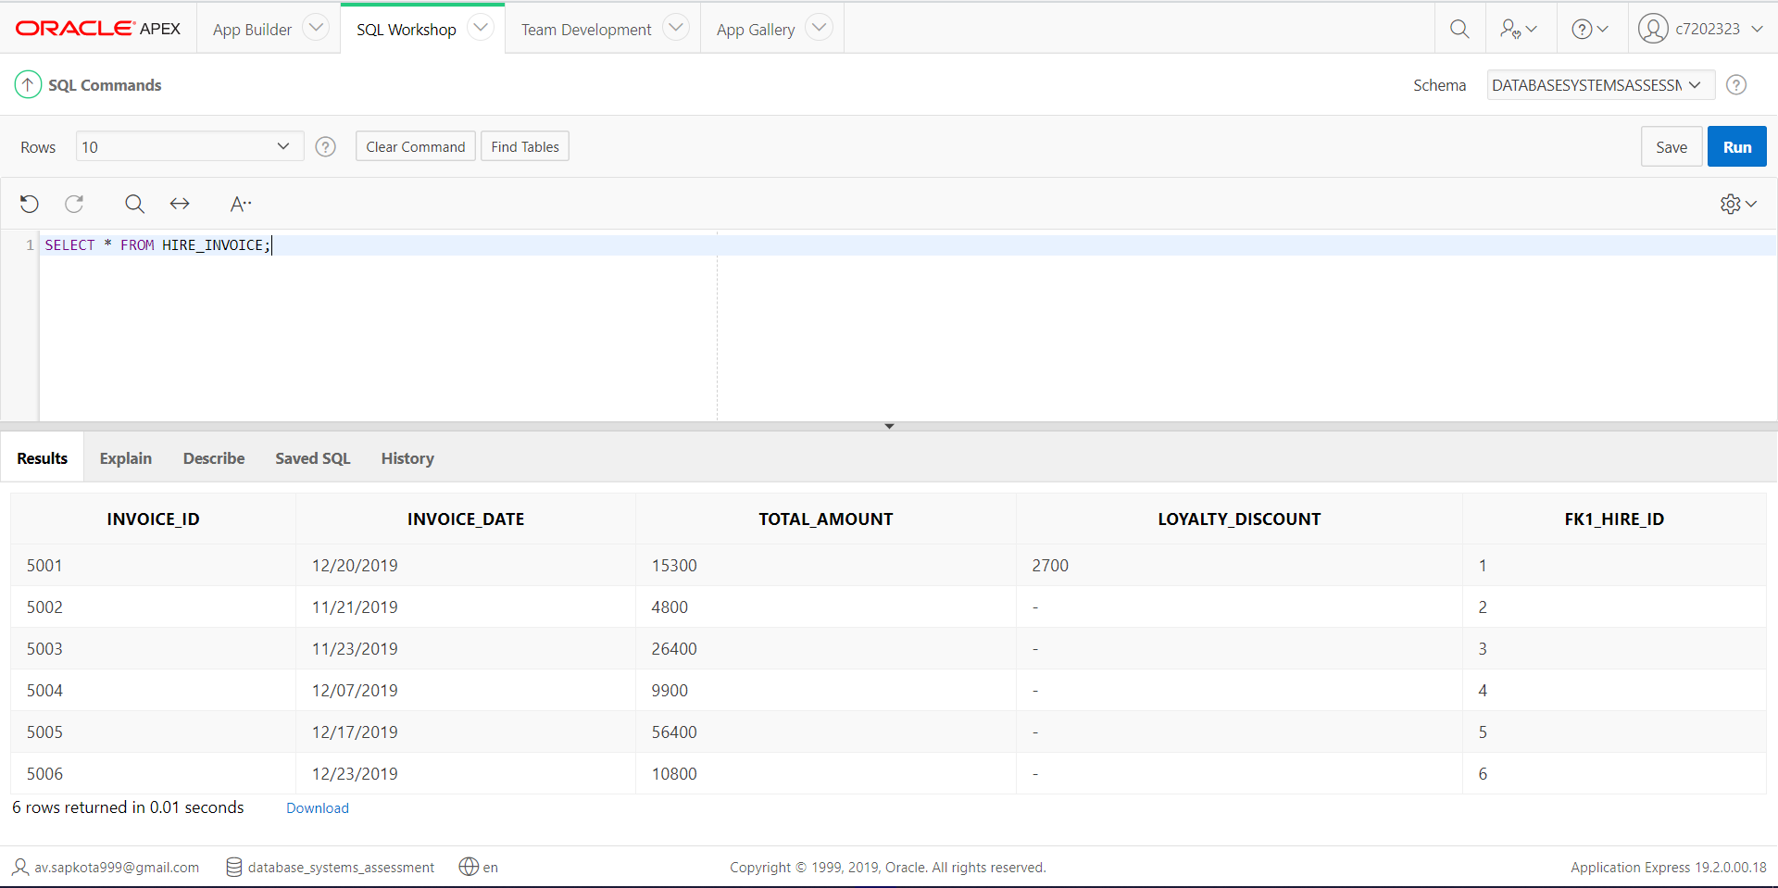

## Trigger 2: Code and Test Implementation.

This trigger has been created for VEHICLES table during INSERTION or UPDATE process in order to find out the vehicle class by reading the number of seats of that particular vehicle. This trigger has various conditions to fulfill before inserting or updating into a table. Those conditions are:

* If the number of seats in the vehicle is equal to 5 then the vehicle is of hatchback class.
* If the number of seats in the vehicle is equal to 4 then the vehicle is of Luxury Saloon class.
* If the number of seats in the vehicle is equal to 6 then the vehicle is of Pickup - Truck class.
* If the number of seats in the vehicle is equal to 7 then the vehicle is of SUV (Sport Utility Vehicle) class.
* If the number of seats in the vehicle is greater than 7 and less than or equal to 20 then the vehicle is of Van class.
* If the number of seats in the vehicle is greater than 20 and less than or equal to 55 then the vehicle is of Bus class.
* Finally, if the number of seats does not fall under above mentioned conditions then error is occurred.
* Screenshot of trigger code and statement that says trigger created:

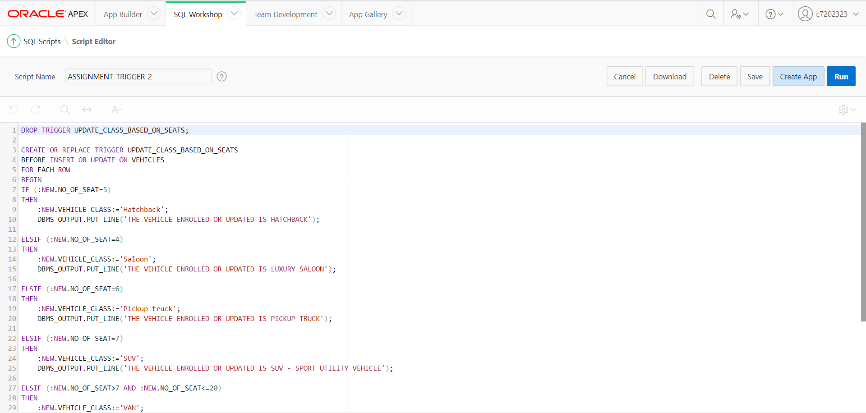

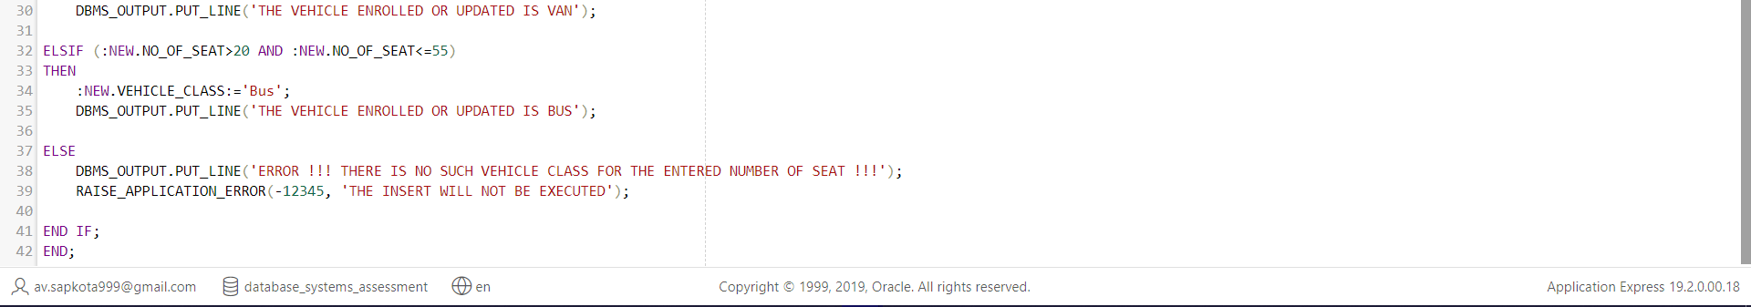

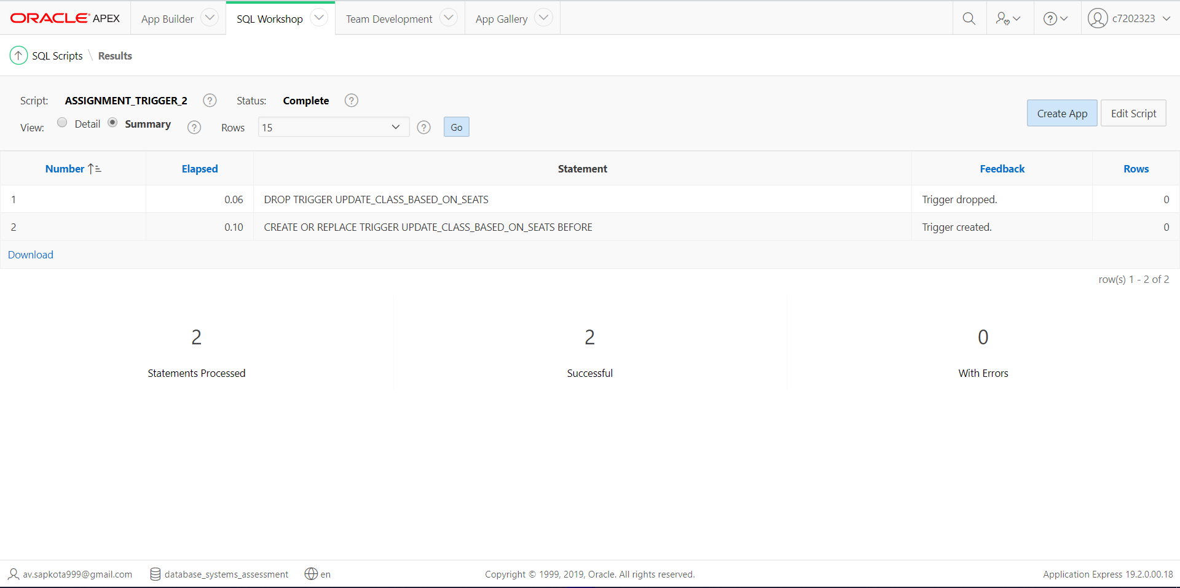

* Screenshot of trigger’s implementation test code along with the inserted/updated value:

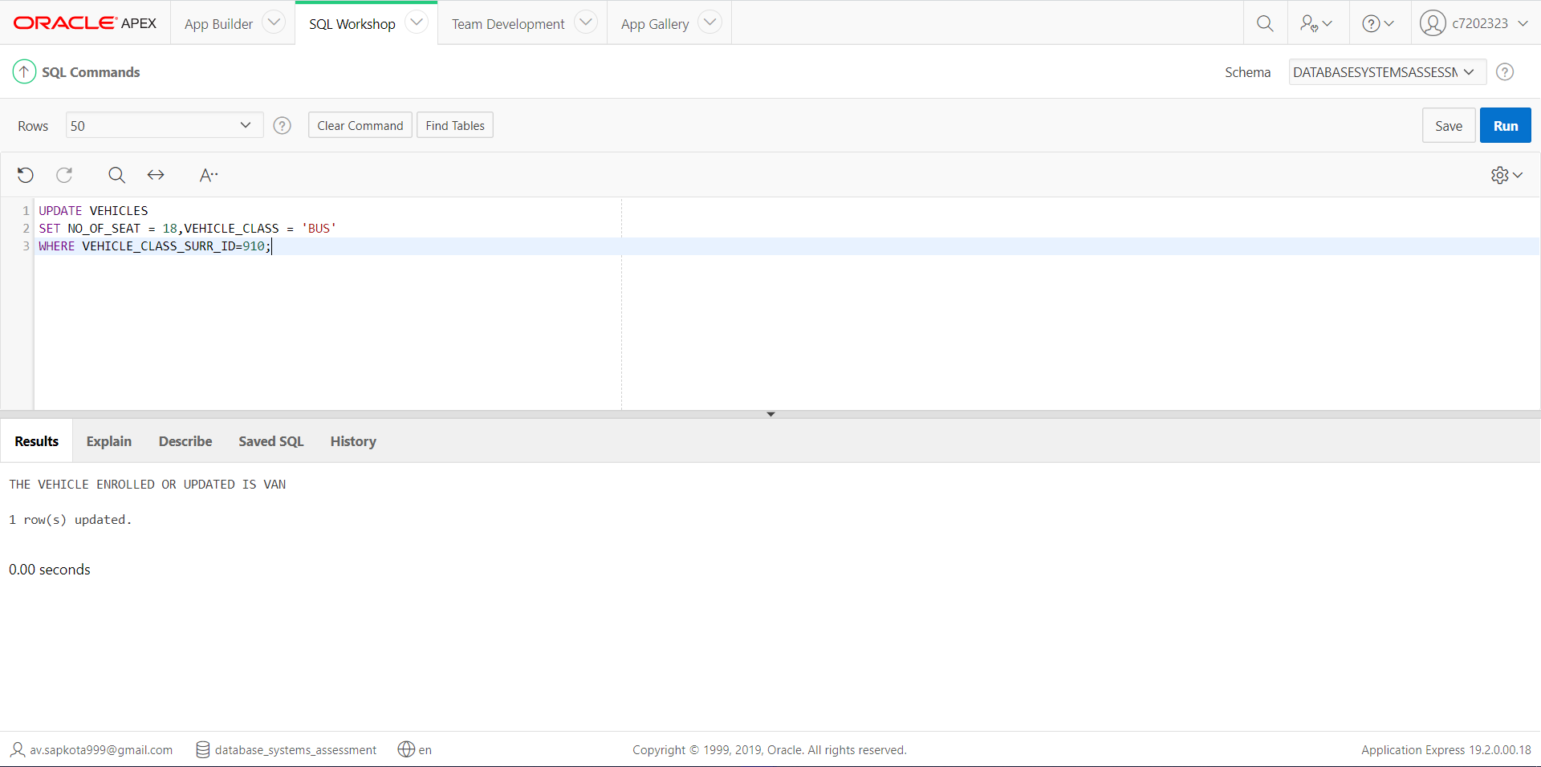

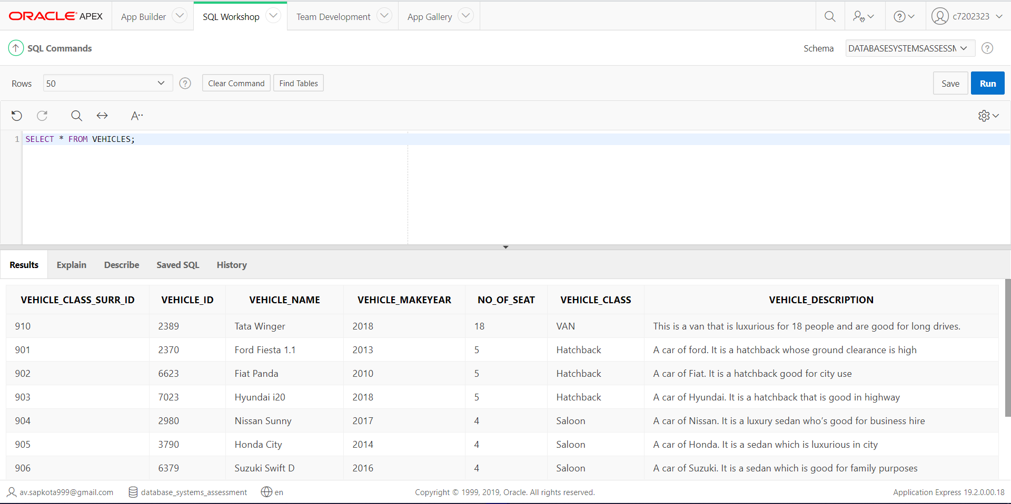

## CRUD Triggers

In this part, triggers have been created for all the tables of CARS4U. These triggers print the message when a CRUD (Create, Update, Delete) operation is performed in the tables.

Codes for CRUD Triggers:

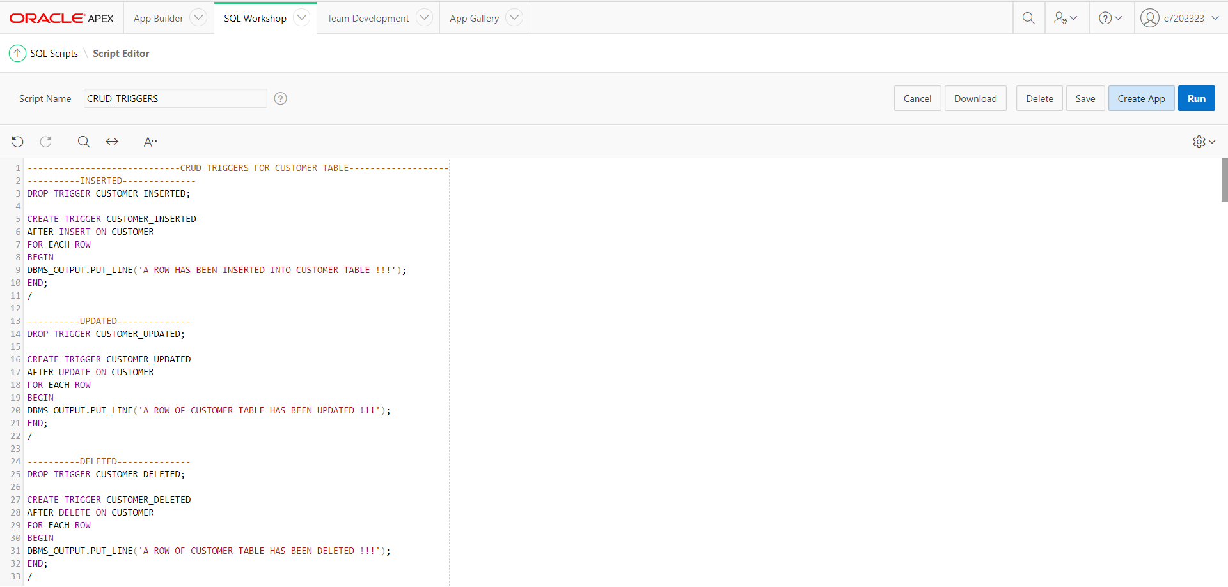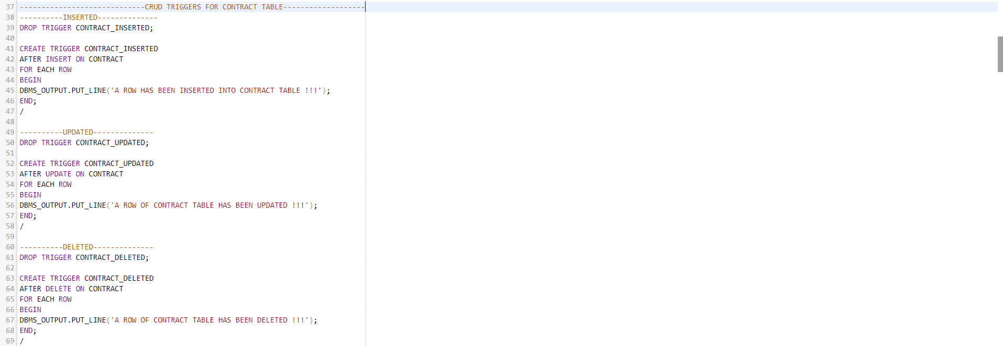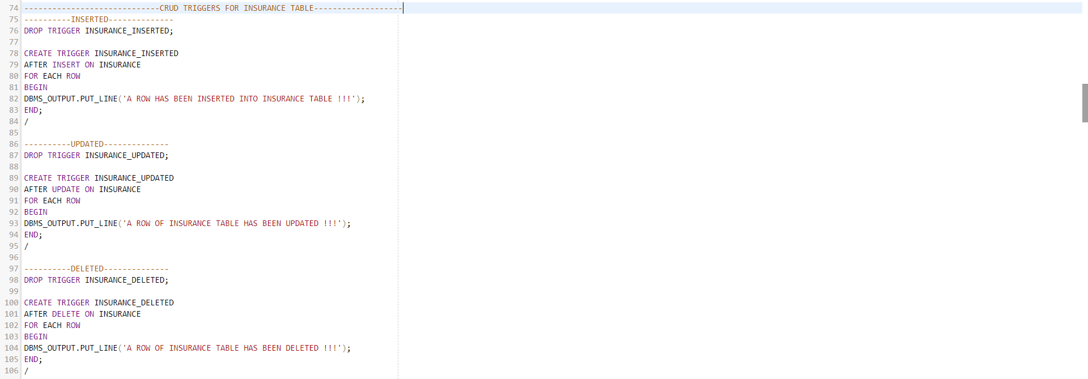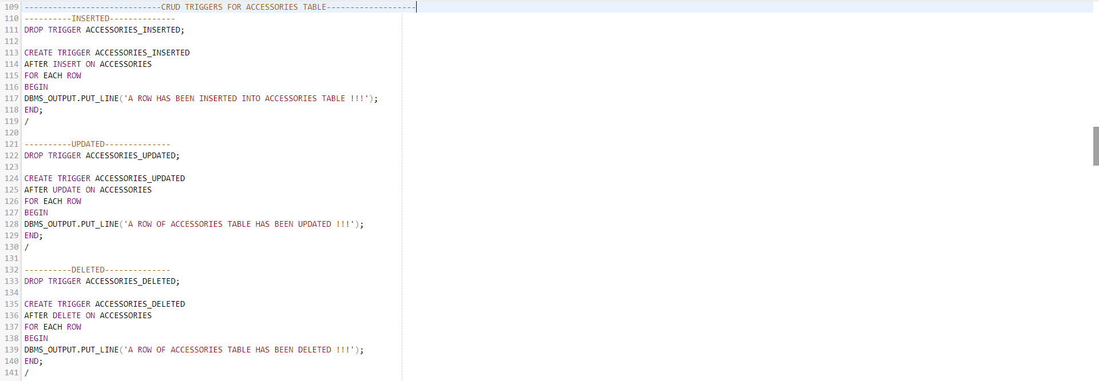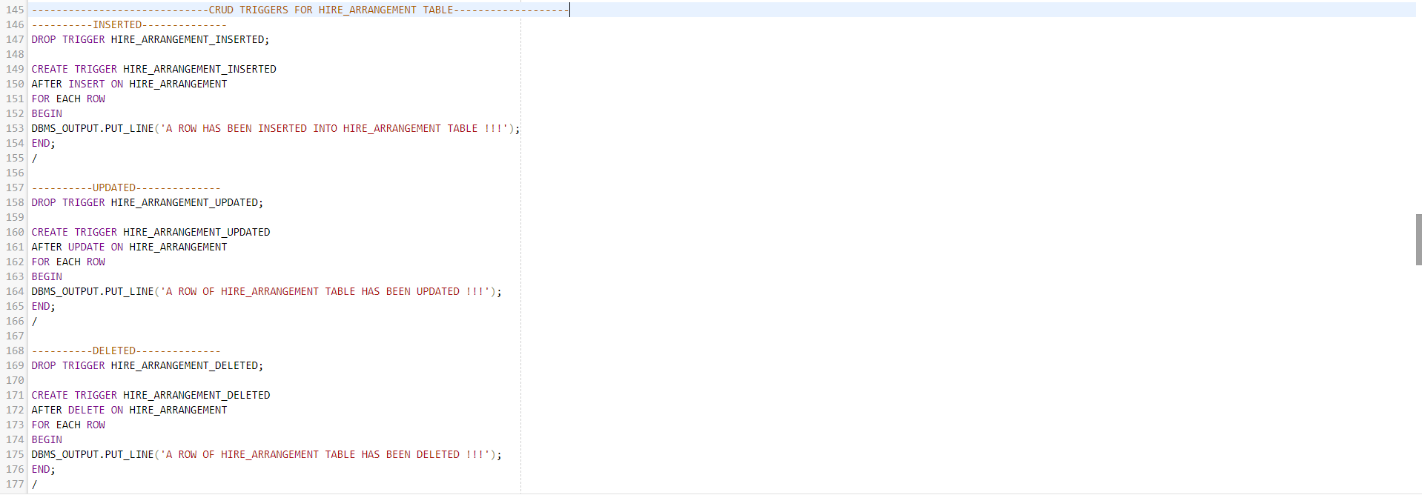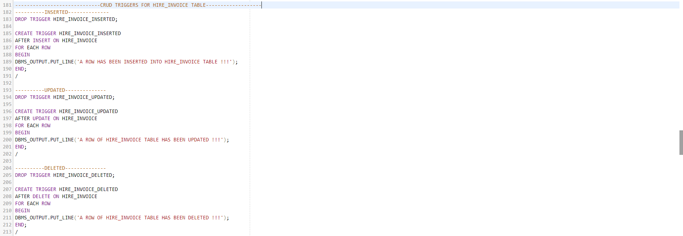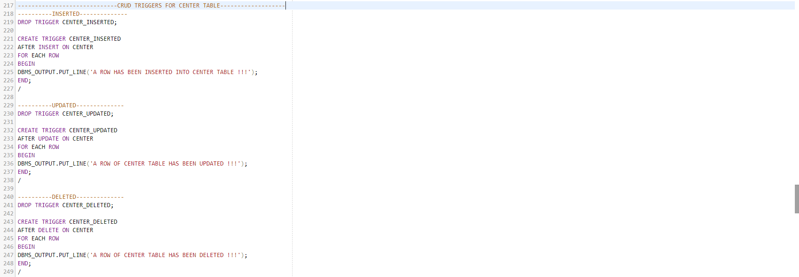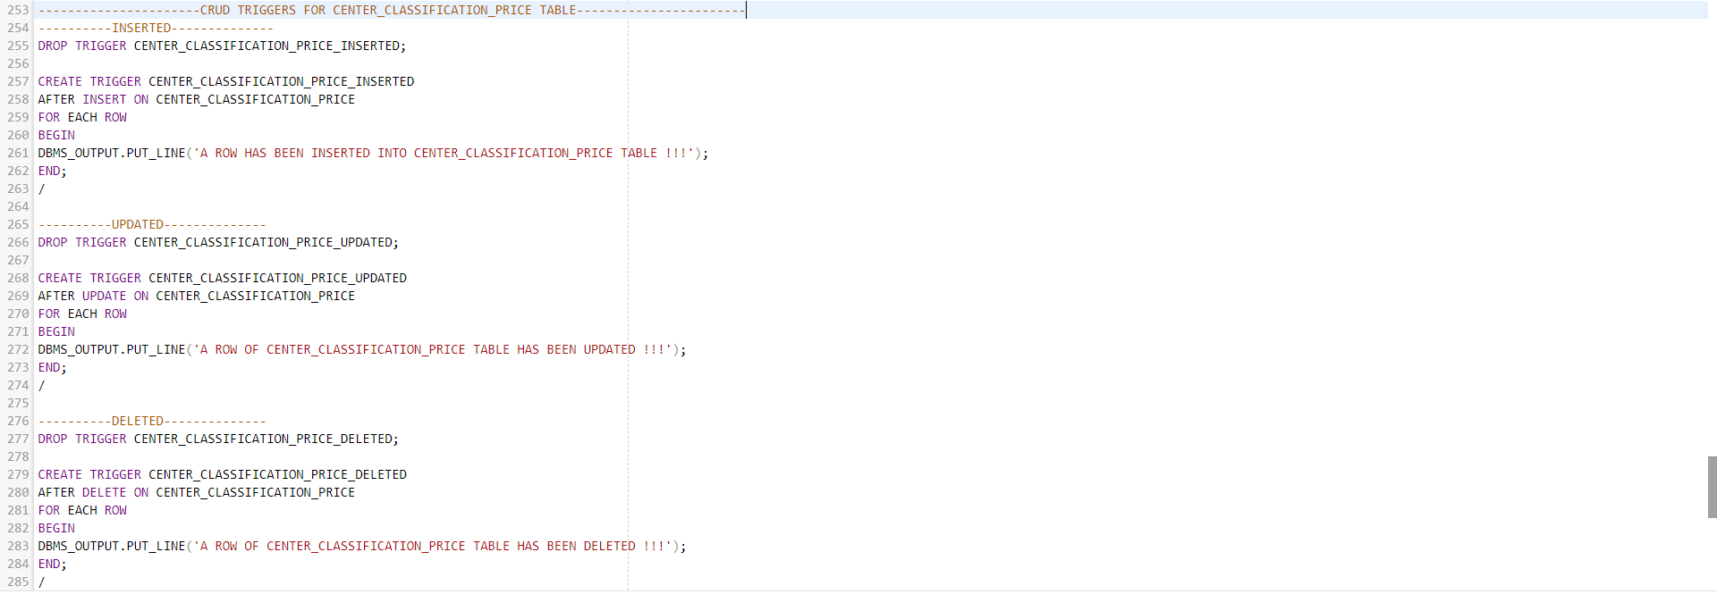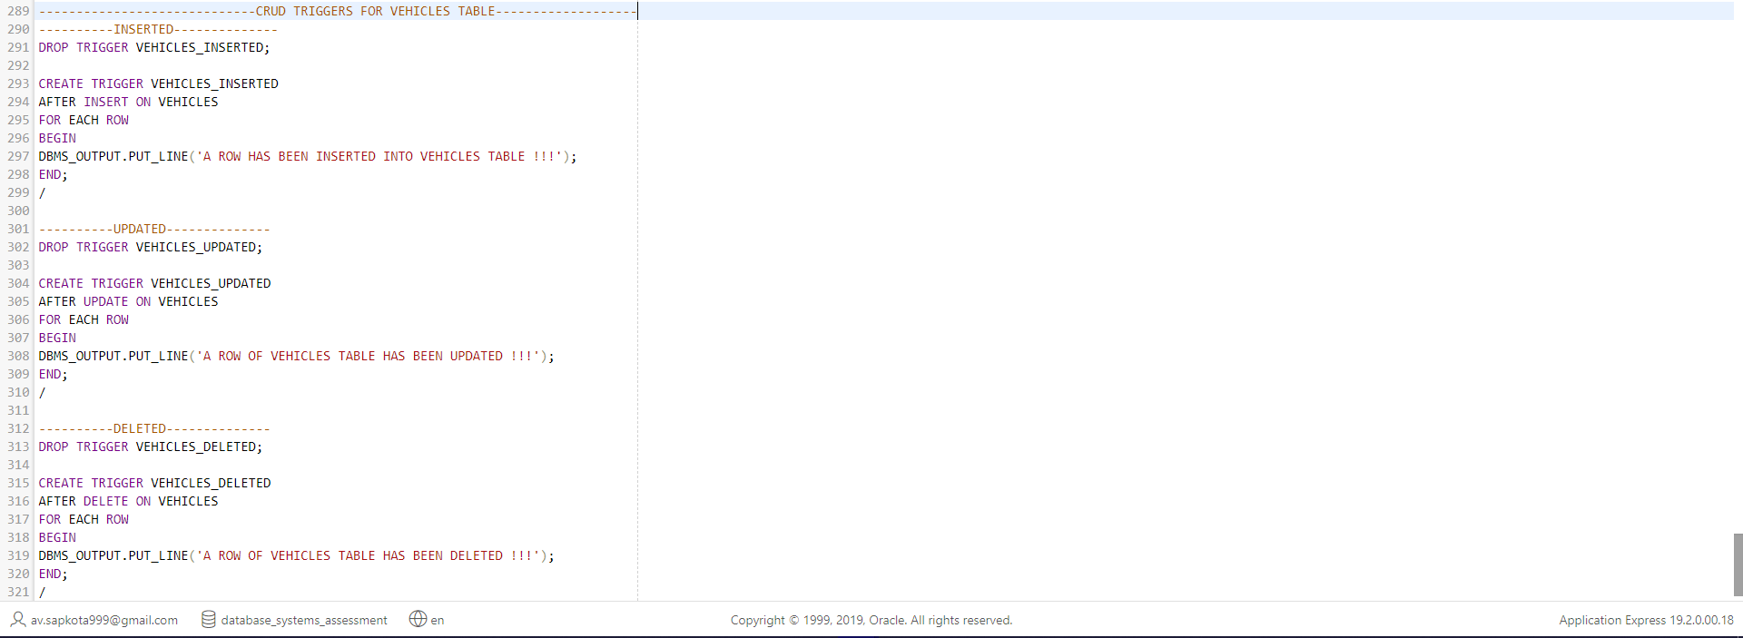

CRUD Triggers Code Implementation:

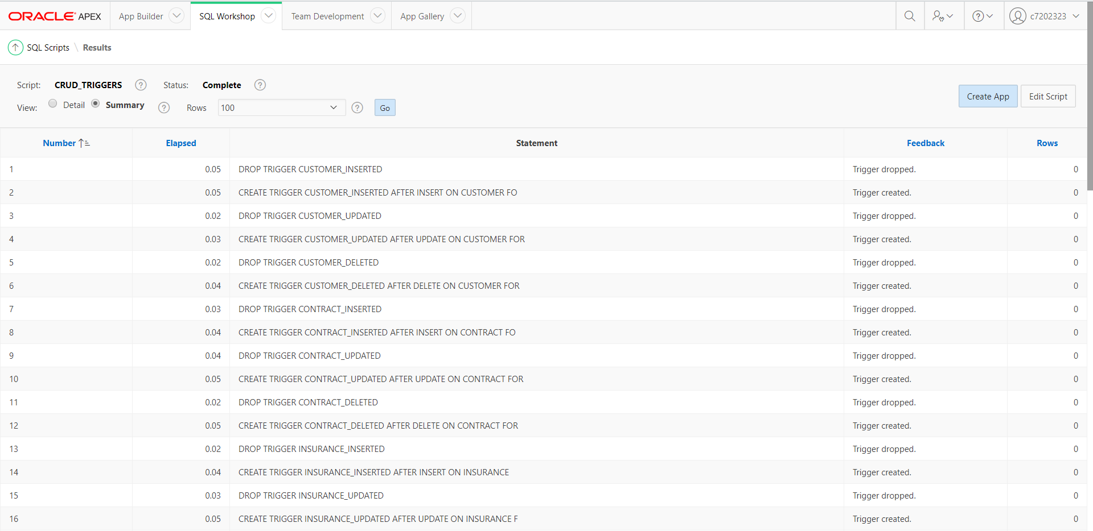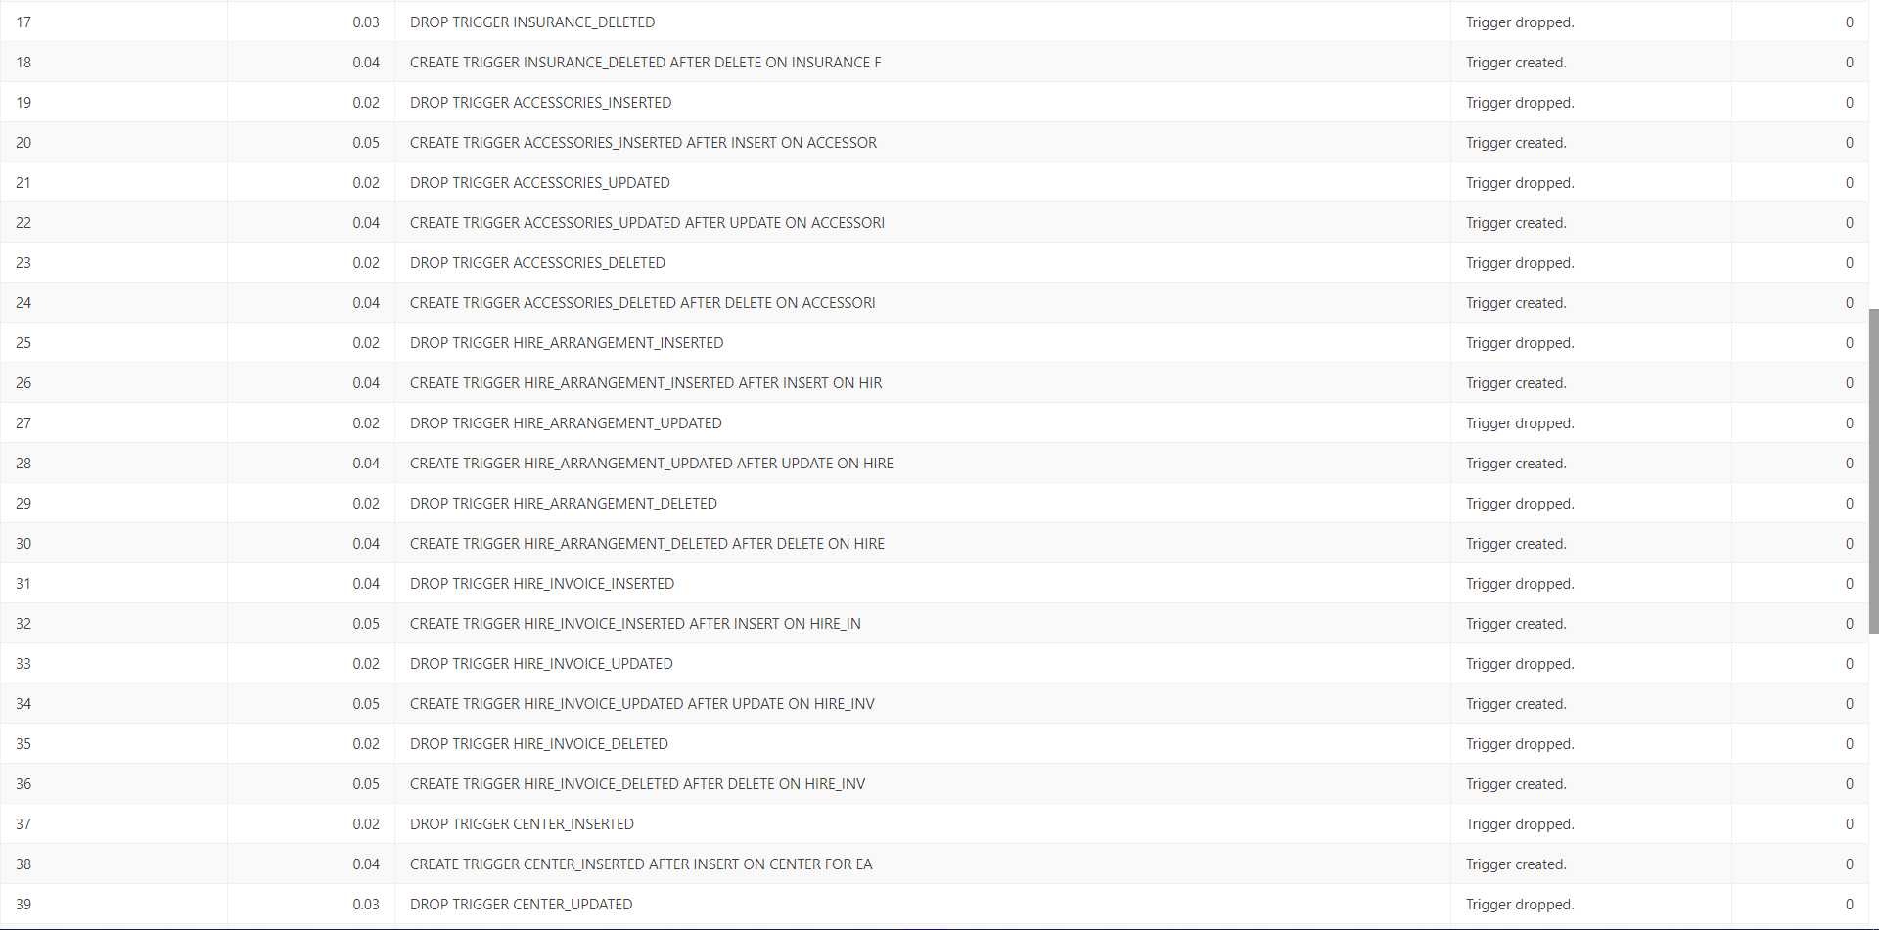

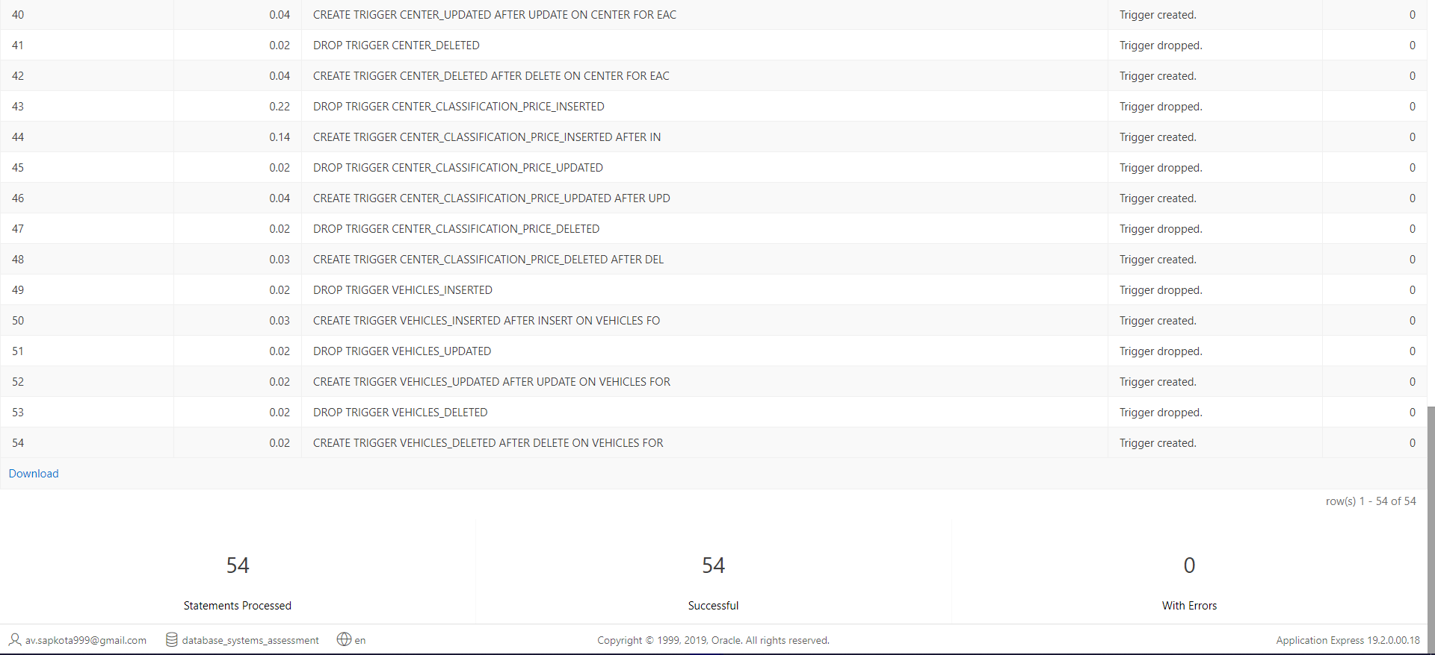

CRUD Triggers Code Test:

The test has been done using ACCESSORIES table only. However, the triggers work for every table.

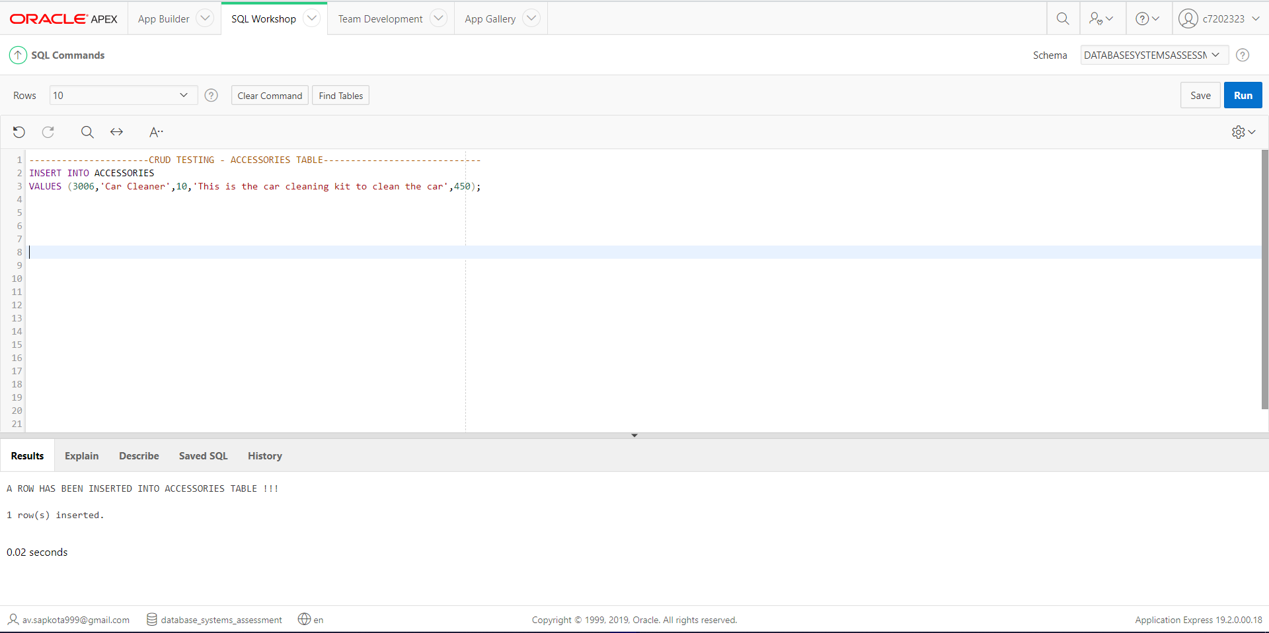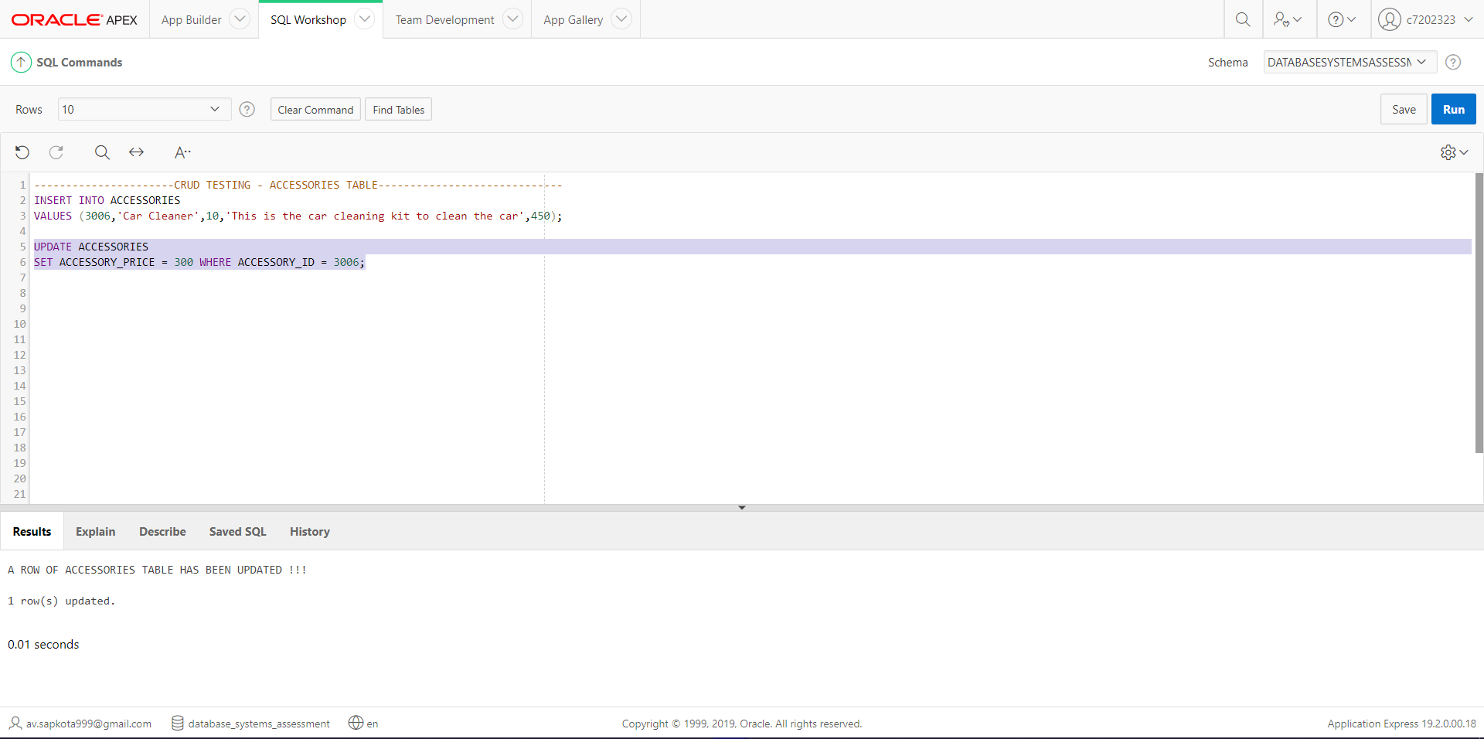

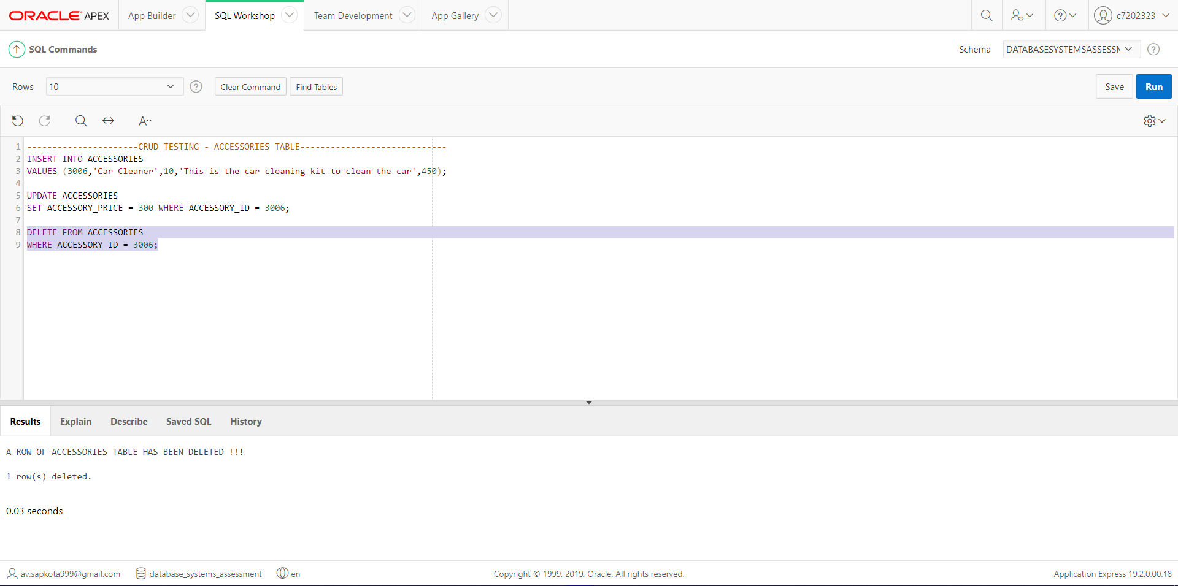

# Task 2: Application Builder

## Application: CARS4U Cars Hire Company.

A desktop application has been built for CARS4U Car Hire Company. The application consists of various functions and features. Some of the features of the CARS4U Car Hire Company’s Applications have been presented below.

### Home Page (with CSS)

The application’s appearance including colors and some other CSS has been beautifully designed.

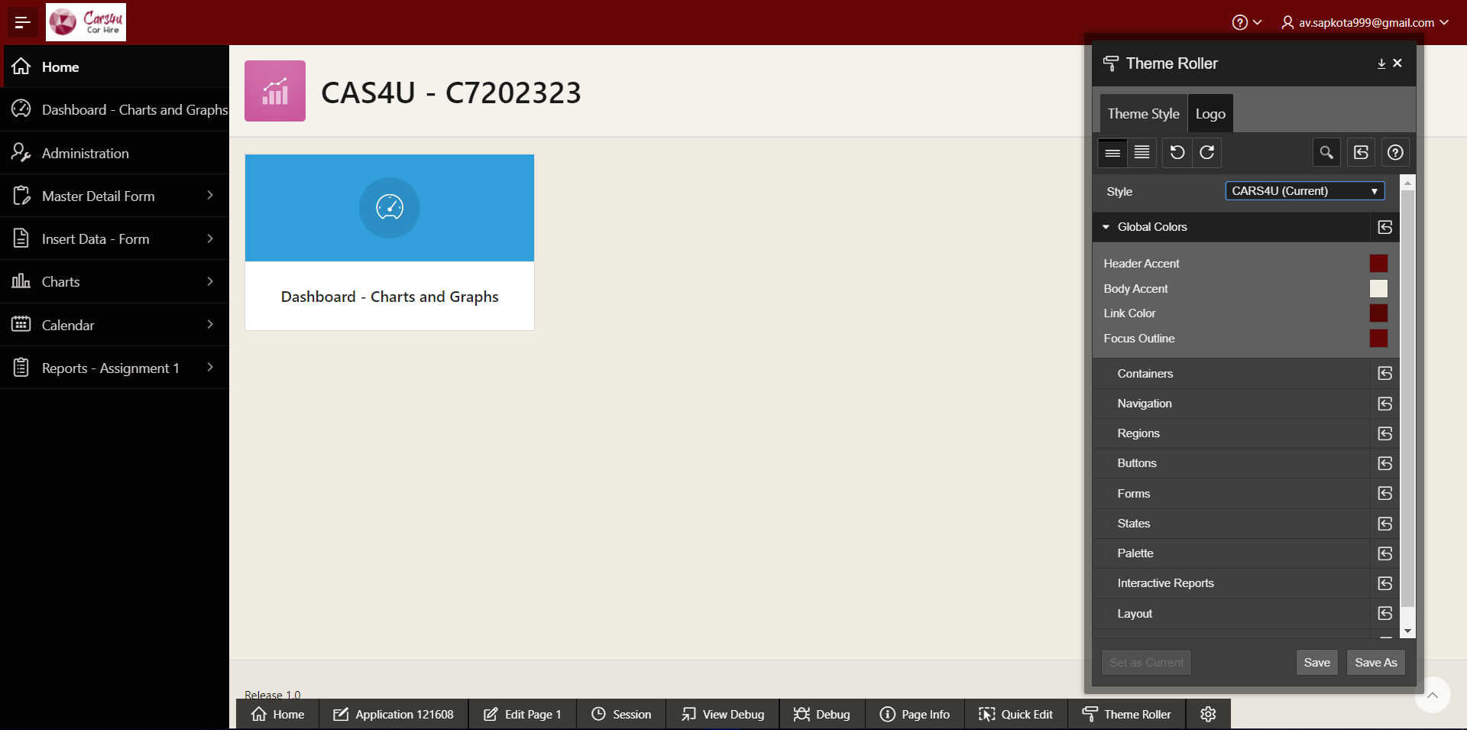

### Navigation Menu with Icons

The navigation menu has been customized with drop-down menus and creative icons.

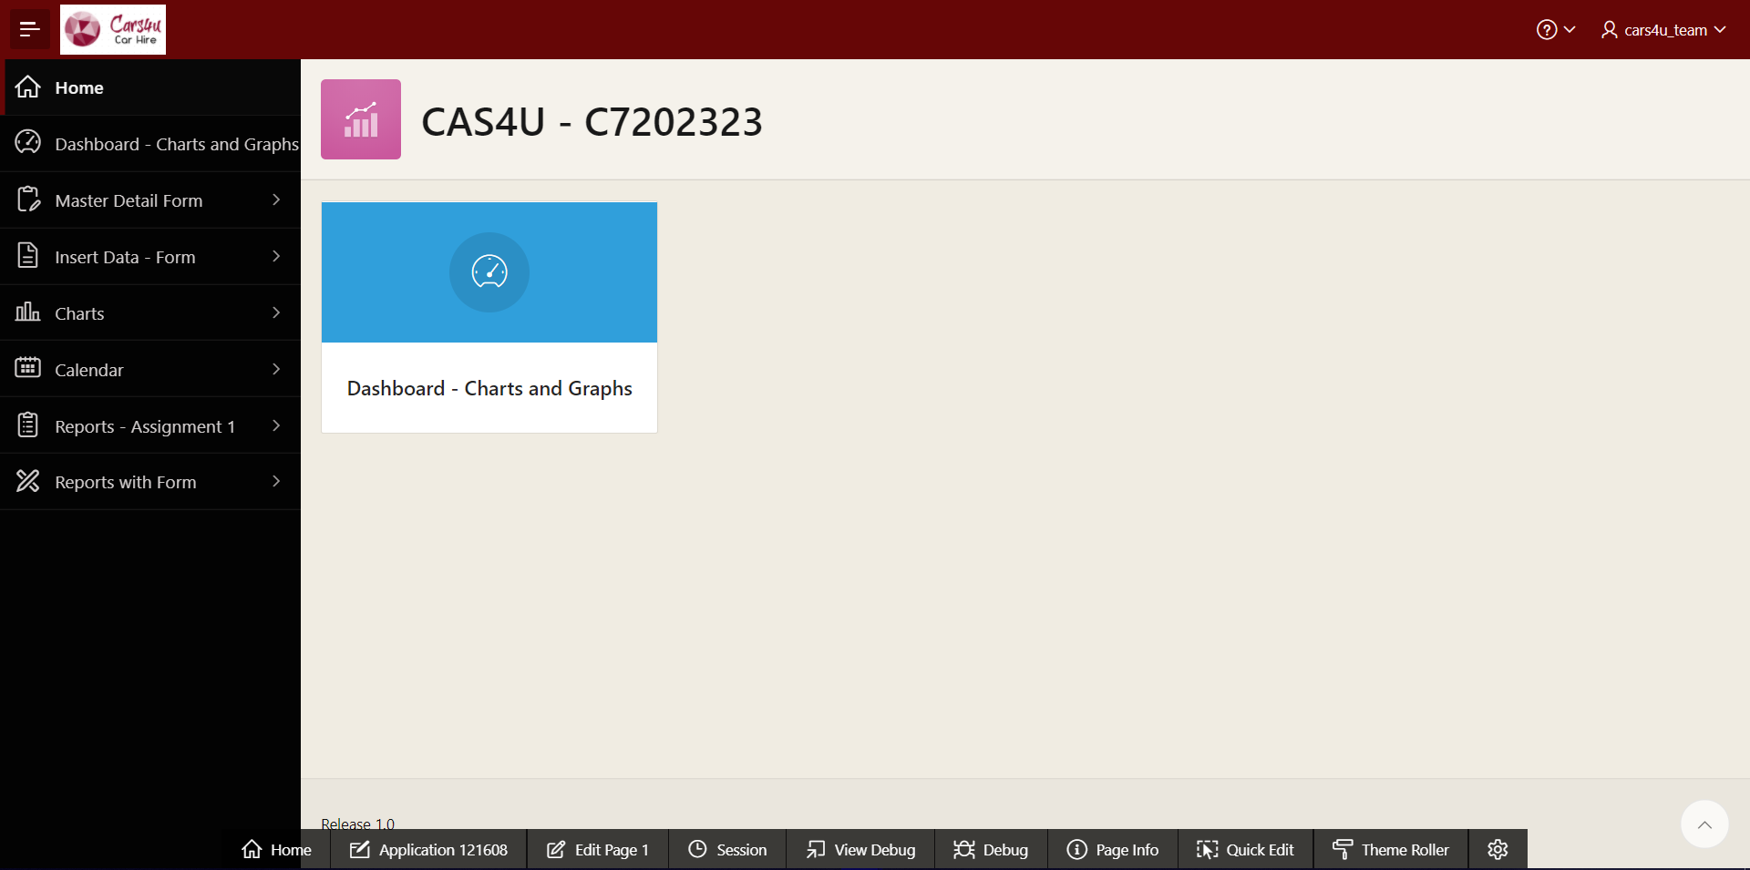

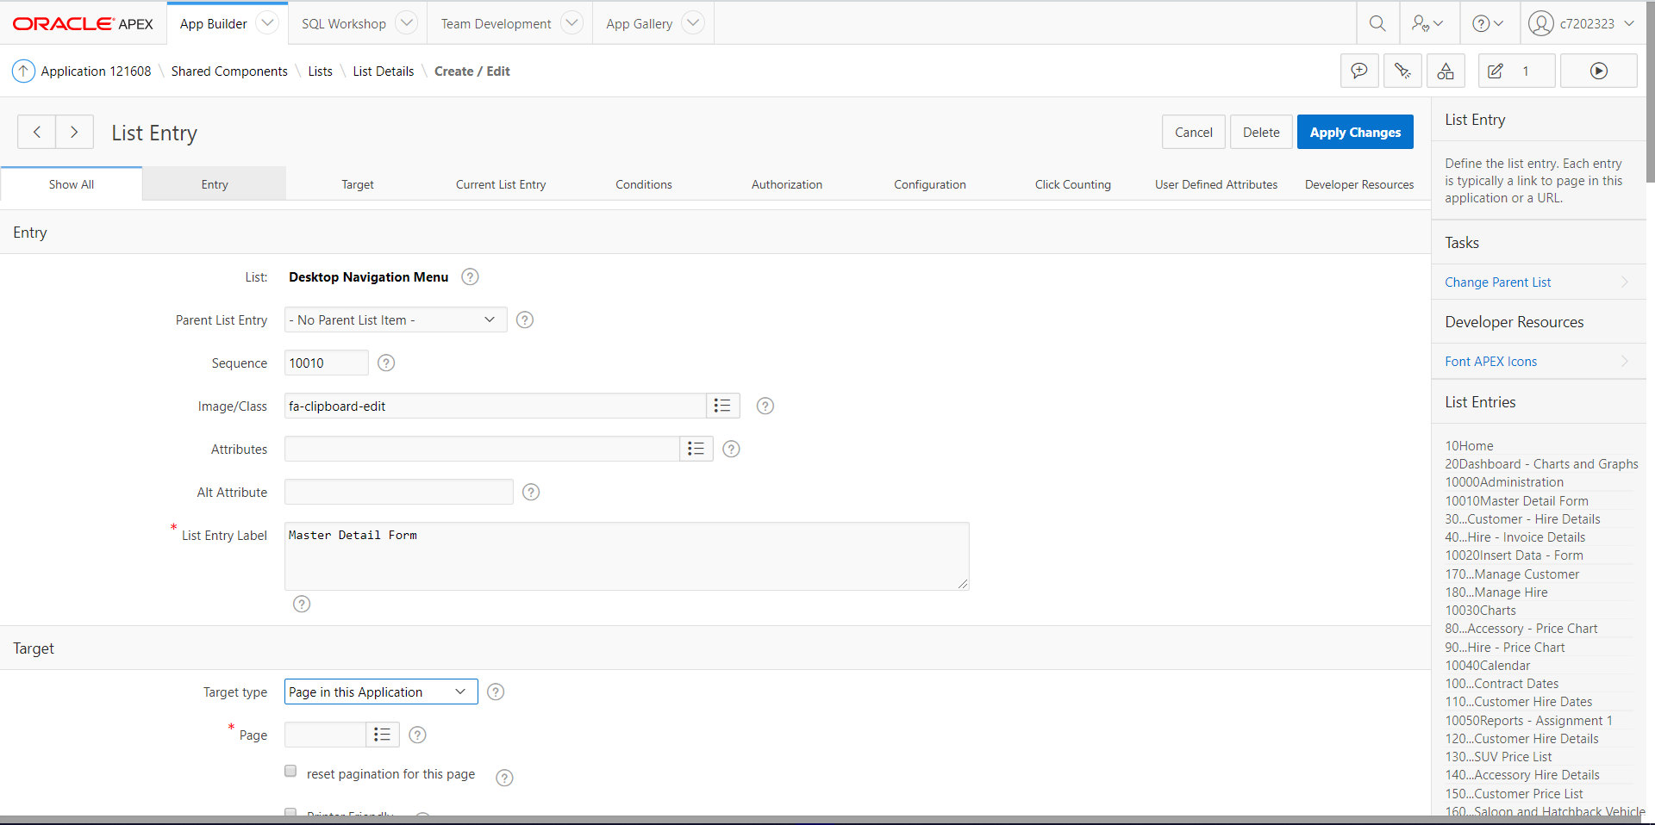

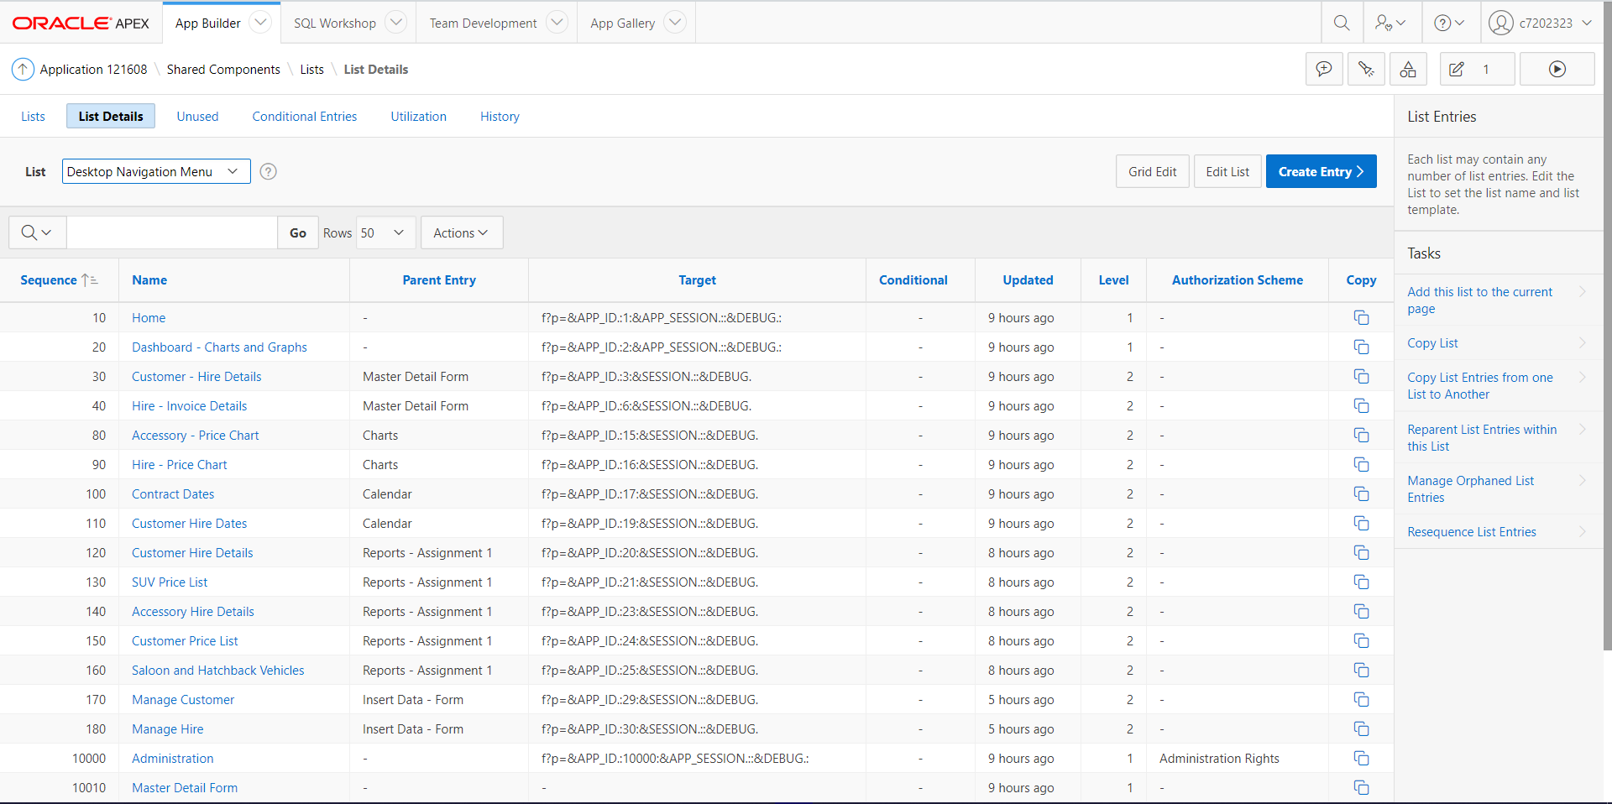

The application has Home Page that consists of Dashboard.

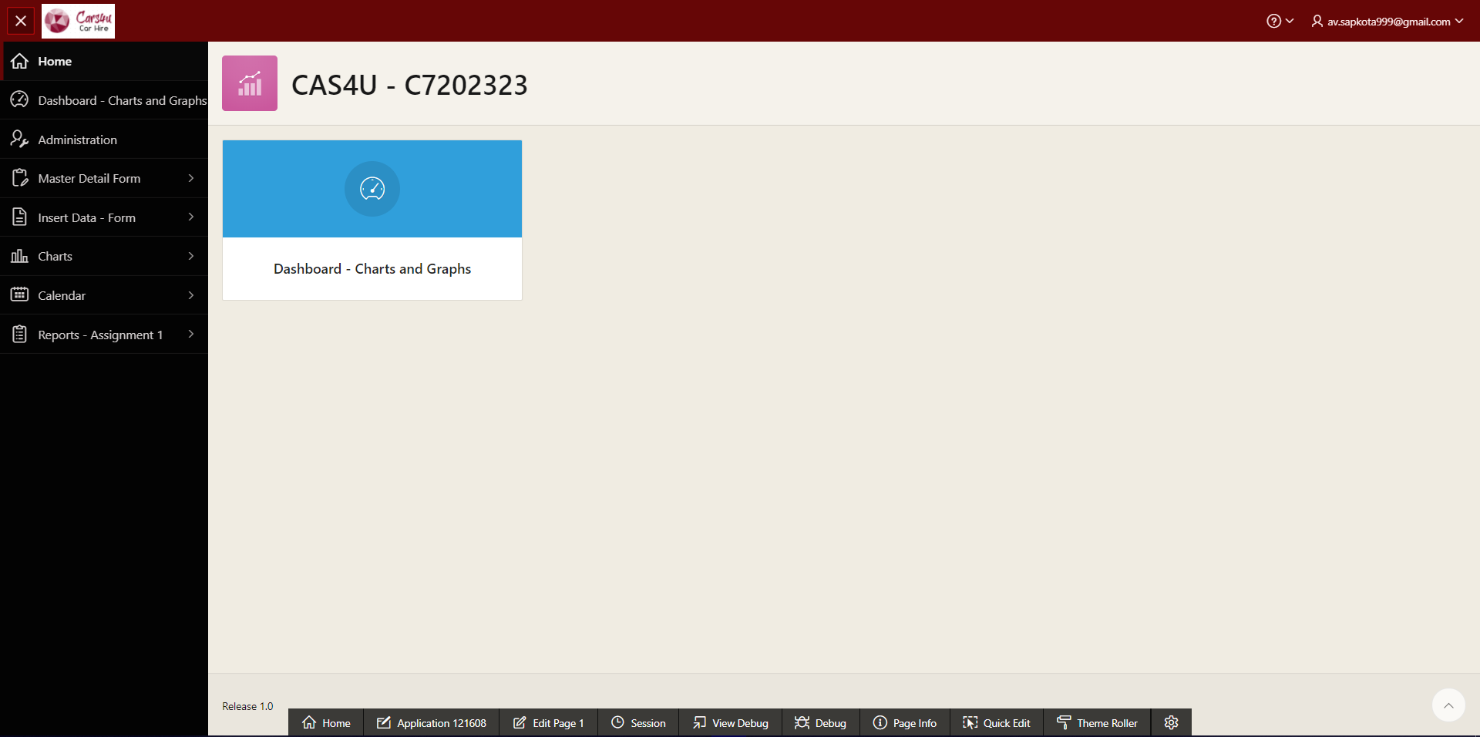

### Dashboard

The dashboard consists of four graphs/charts based on the tables or views created in the first component of the assessment.

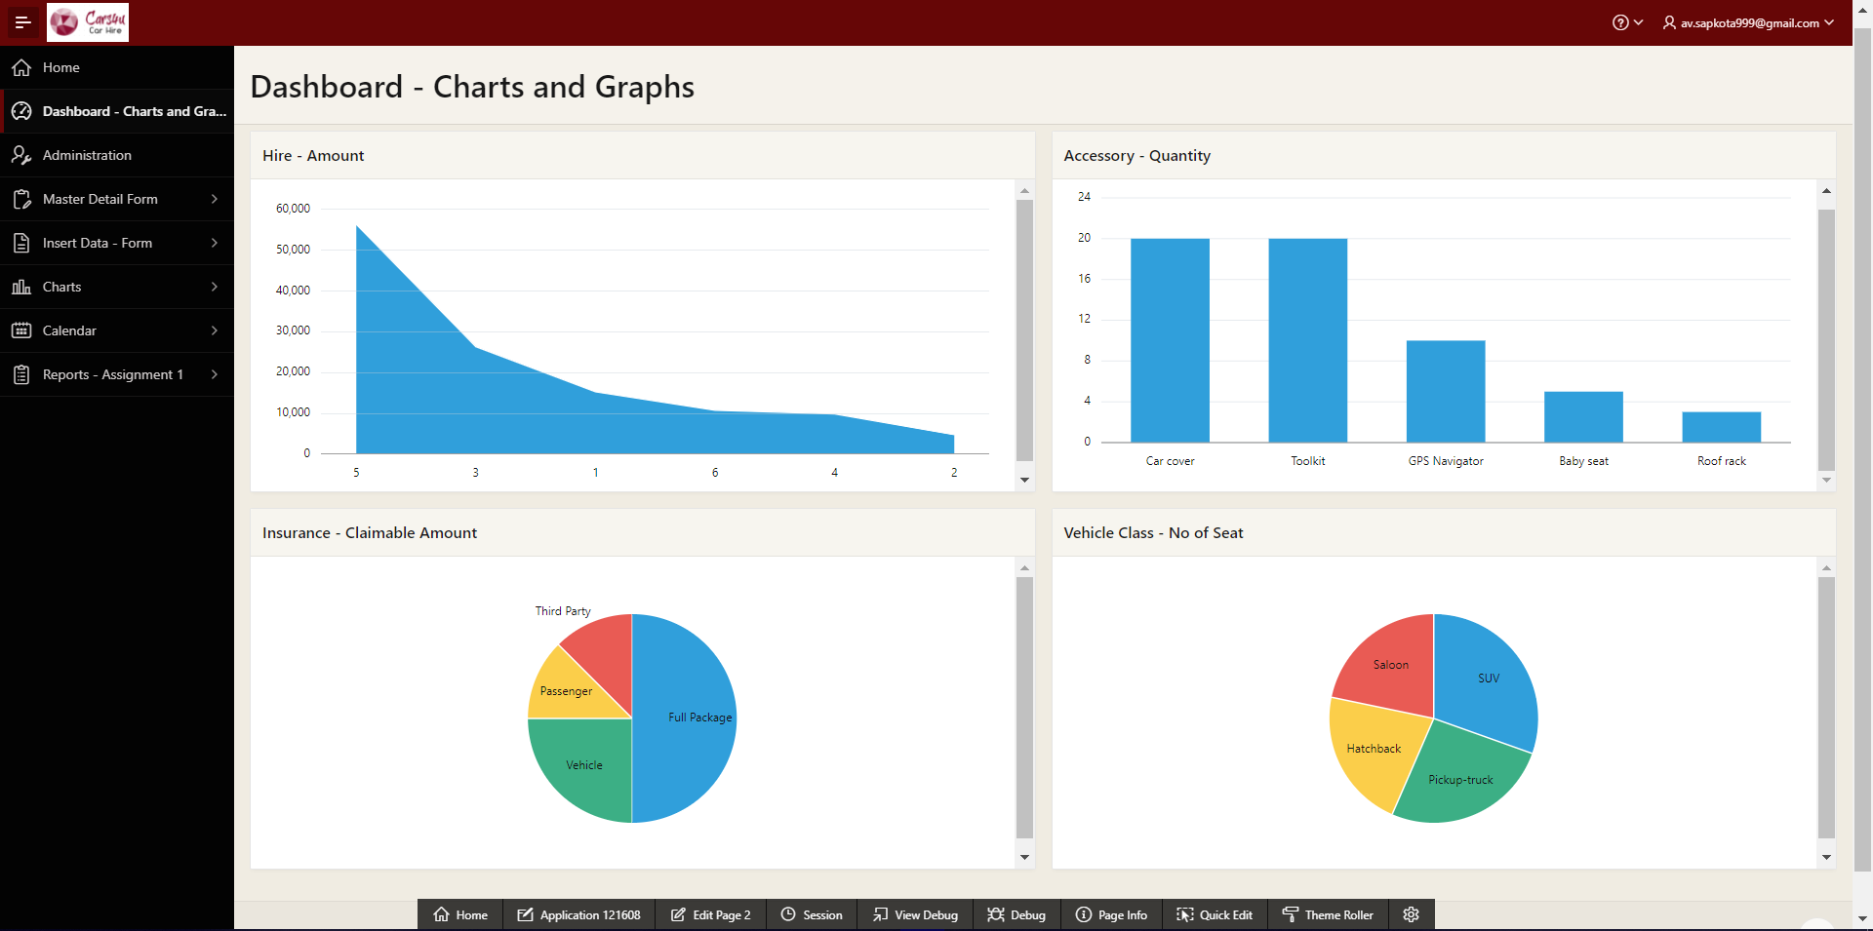

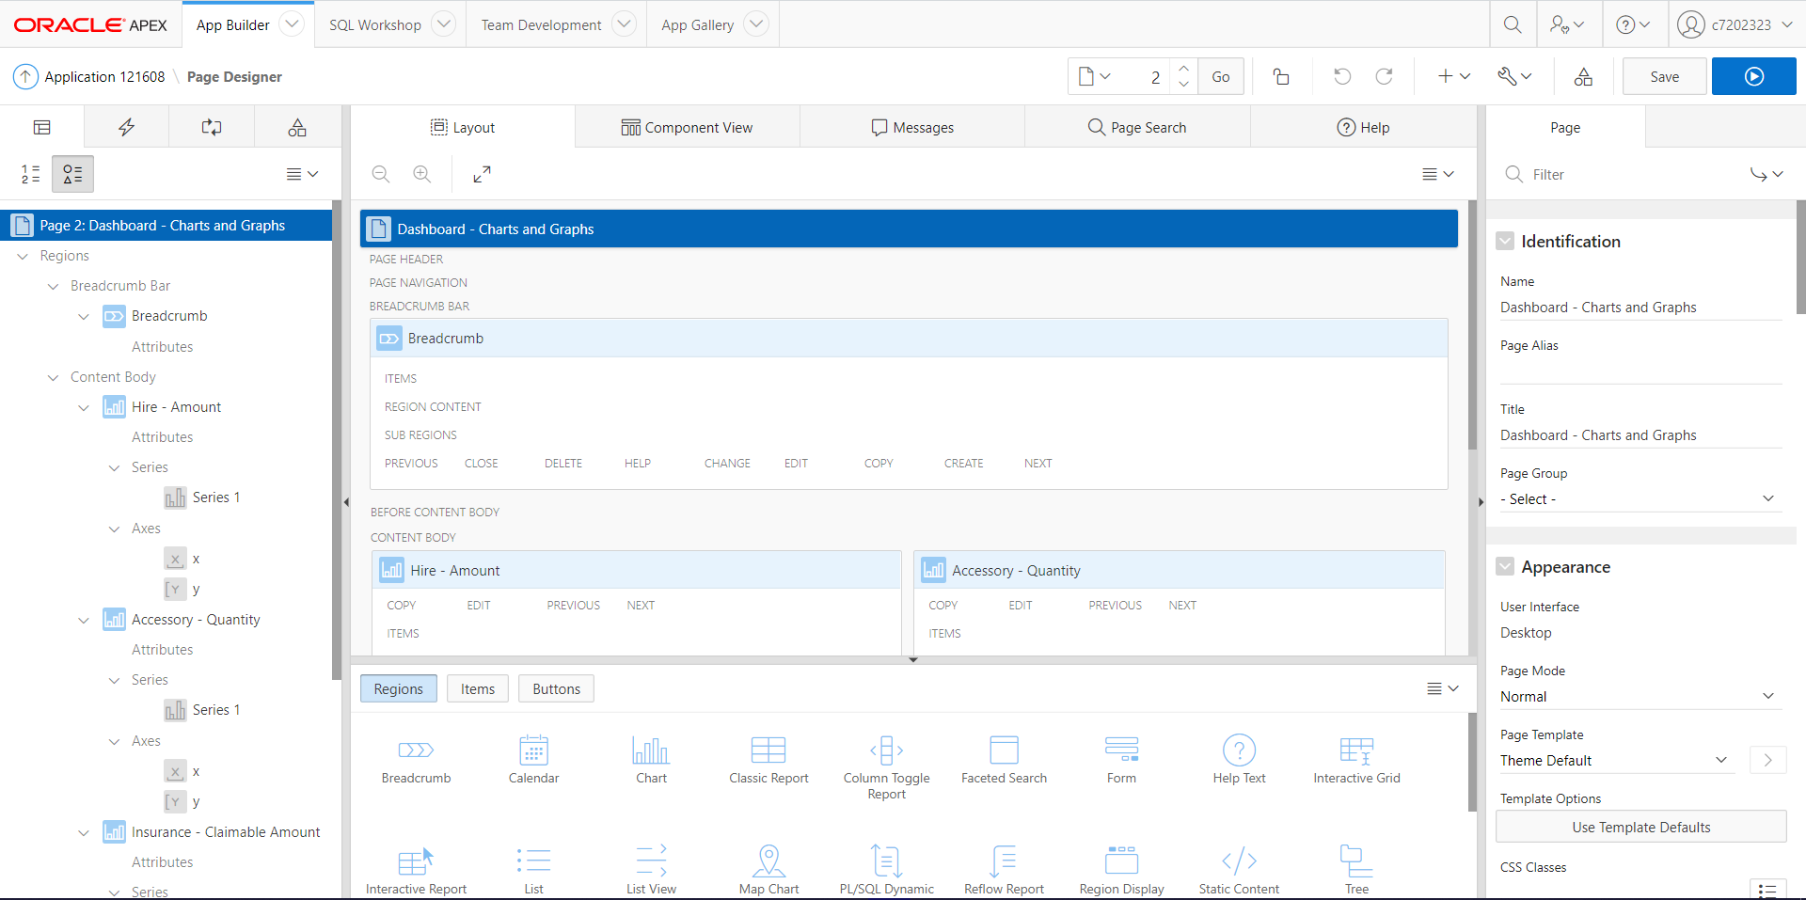

### Master Detail Forms

Two master-detail forms ‘Customer-Hire Details’ and ‘Hire-Invoice Details’ have been created to view the data in detail. Each master detail form consists of Buttons for CRUD functionality (Create, Update or Delete).

Master Detail Form 1:

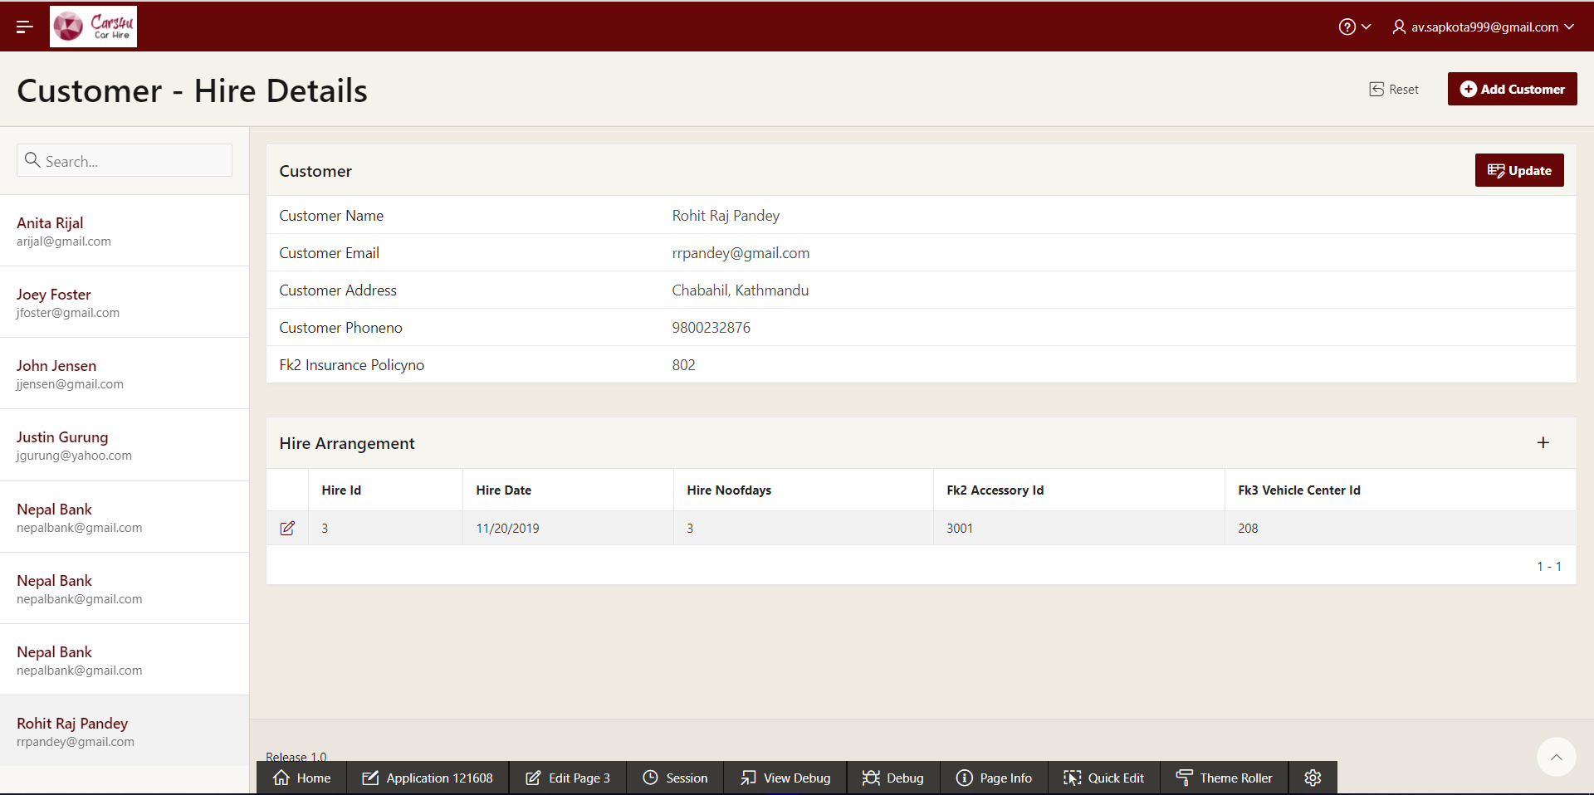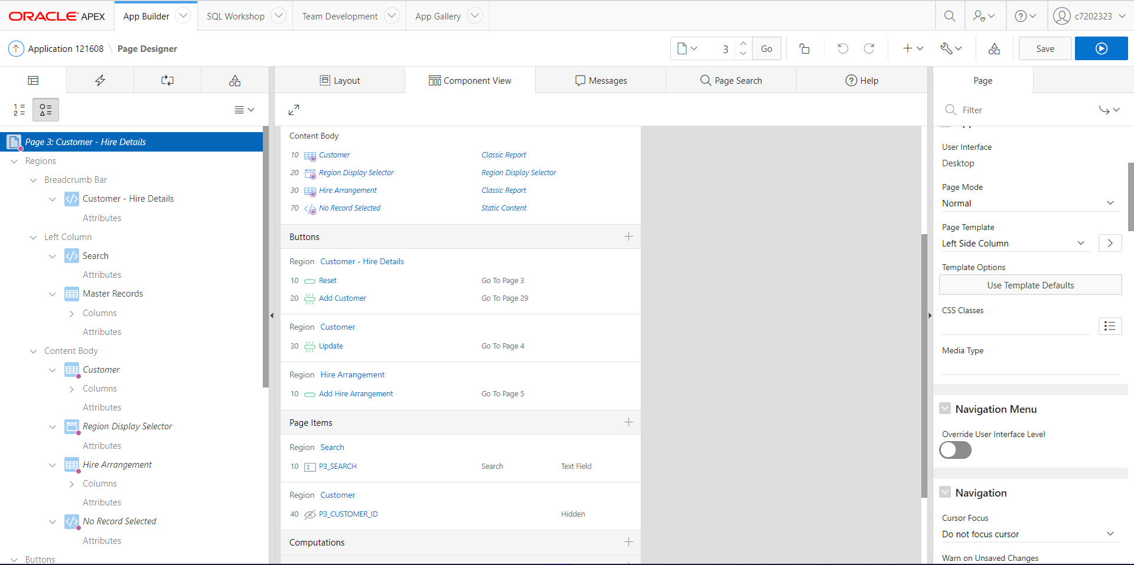

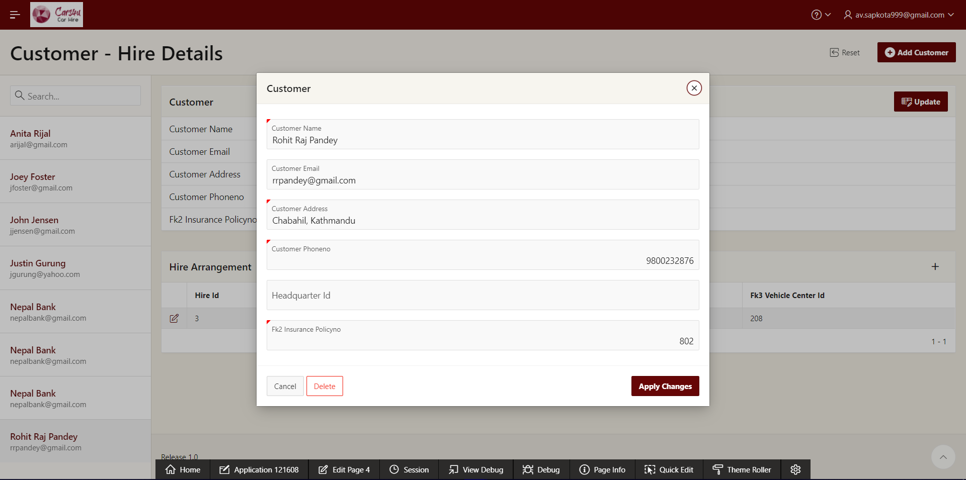

Master Detail Form 2:

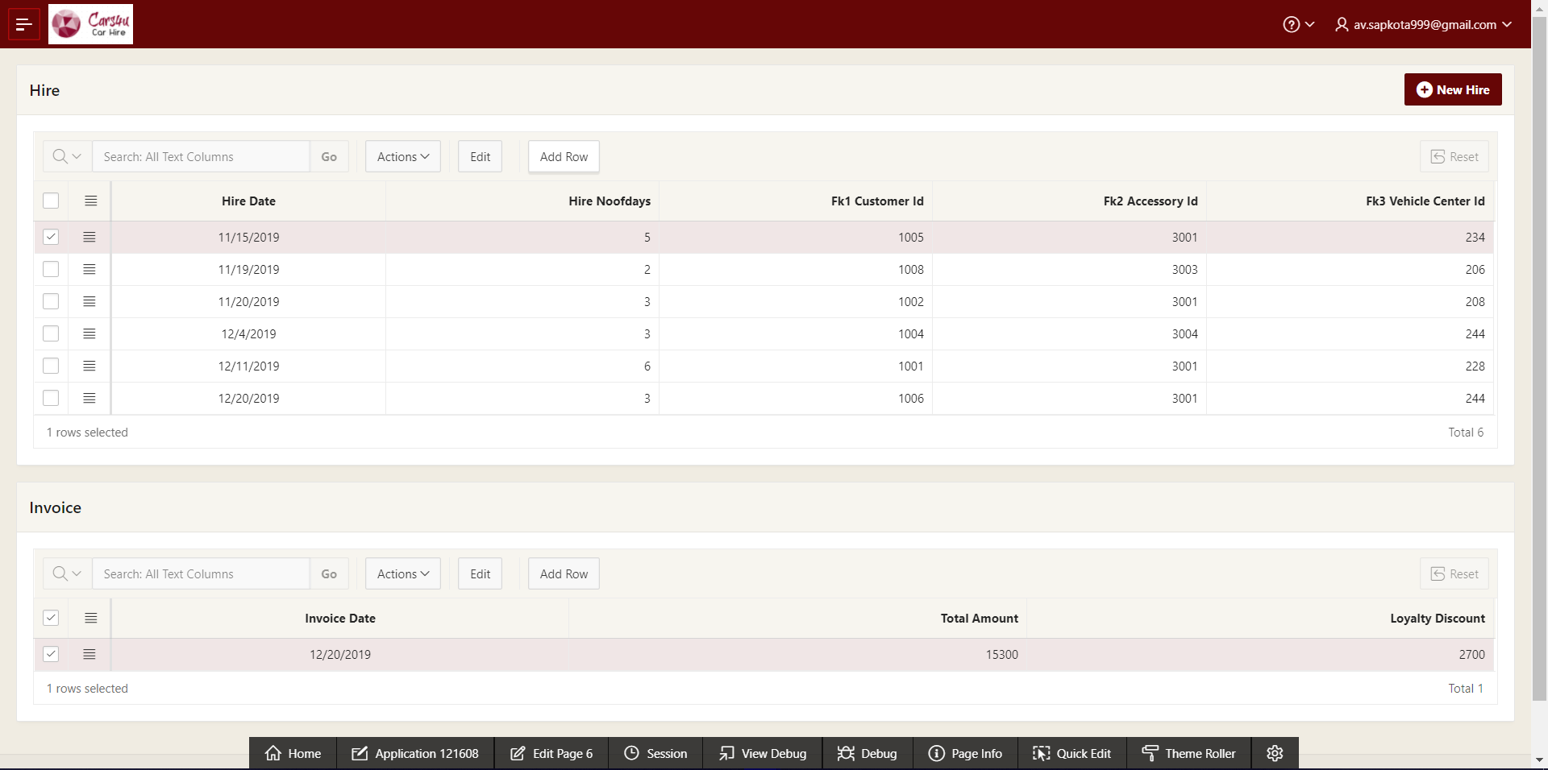

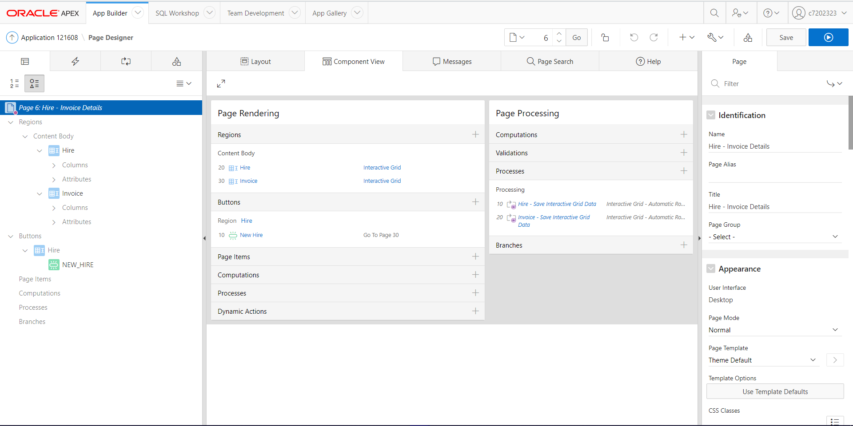

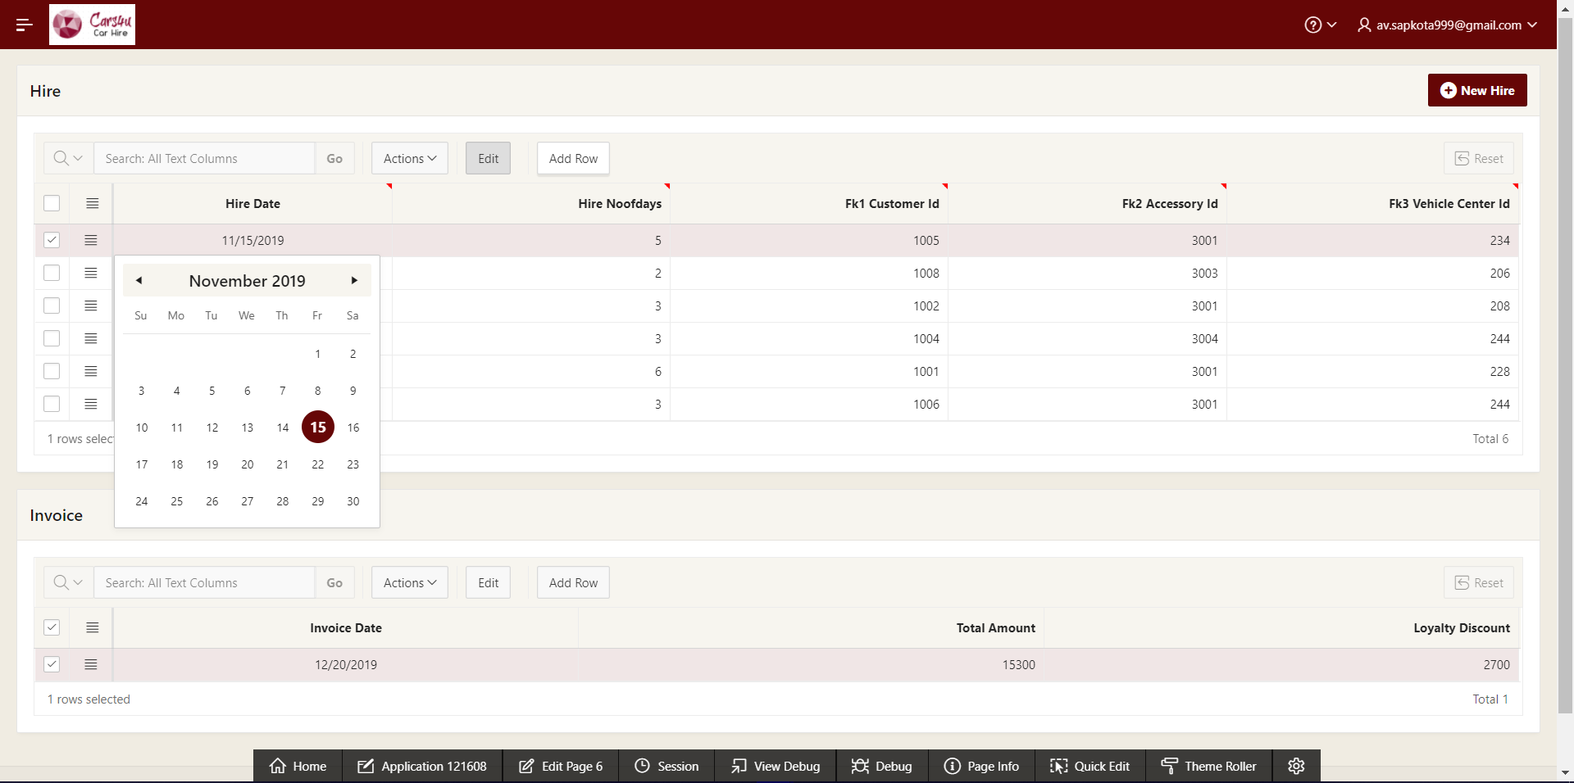

### Insertion Forms for Master Page

The application consists of forms i.e. Manage Customer and Manage Hire. These forms are executed when the buttons in the master-detail form is clicked. These forms have been validated and use List of Values function to fulfill foreign key attributes to facilitate user to insert foreign keys.

Form for Customer – Hire Master Detail (with validations and list of values):

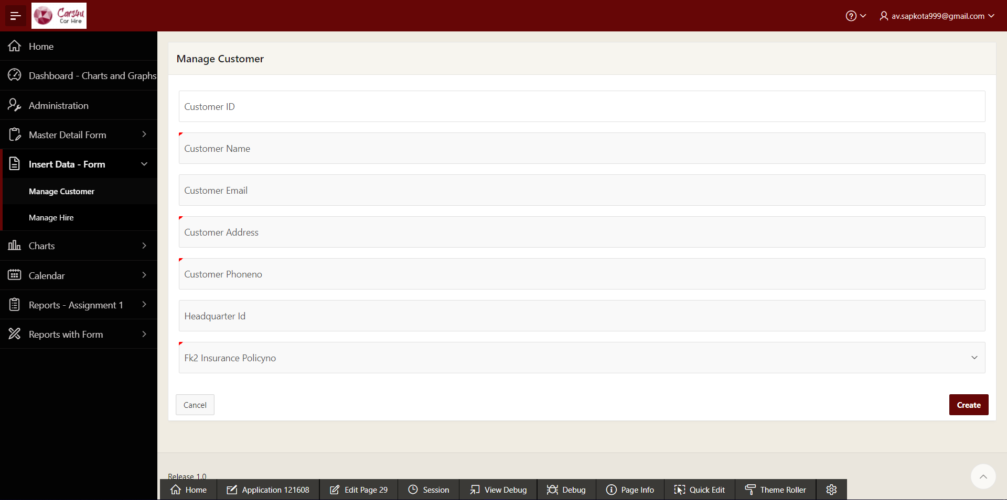

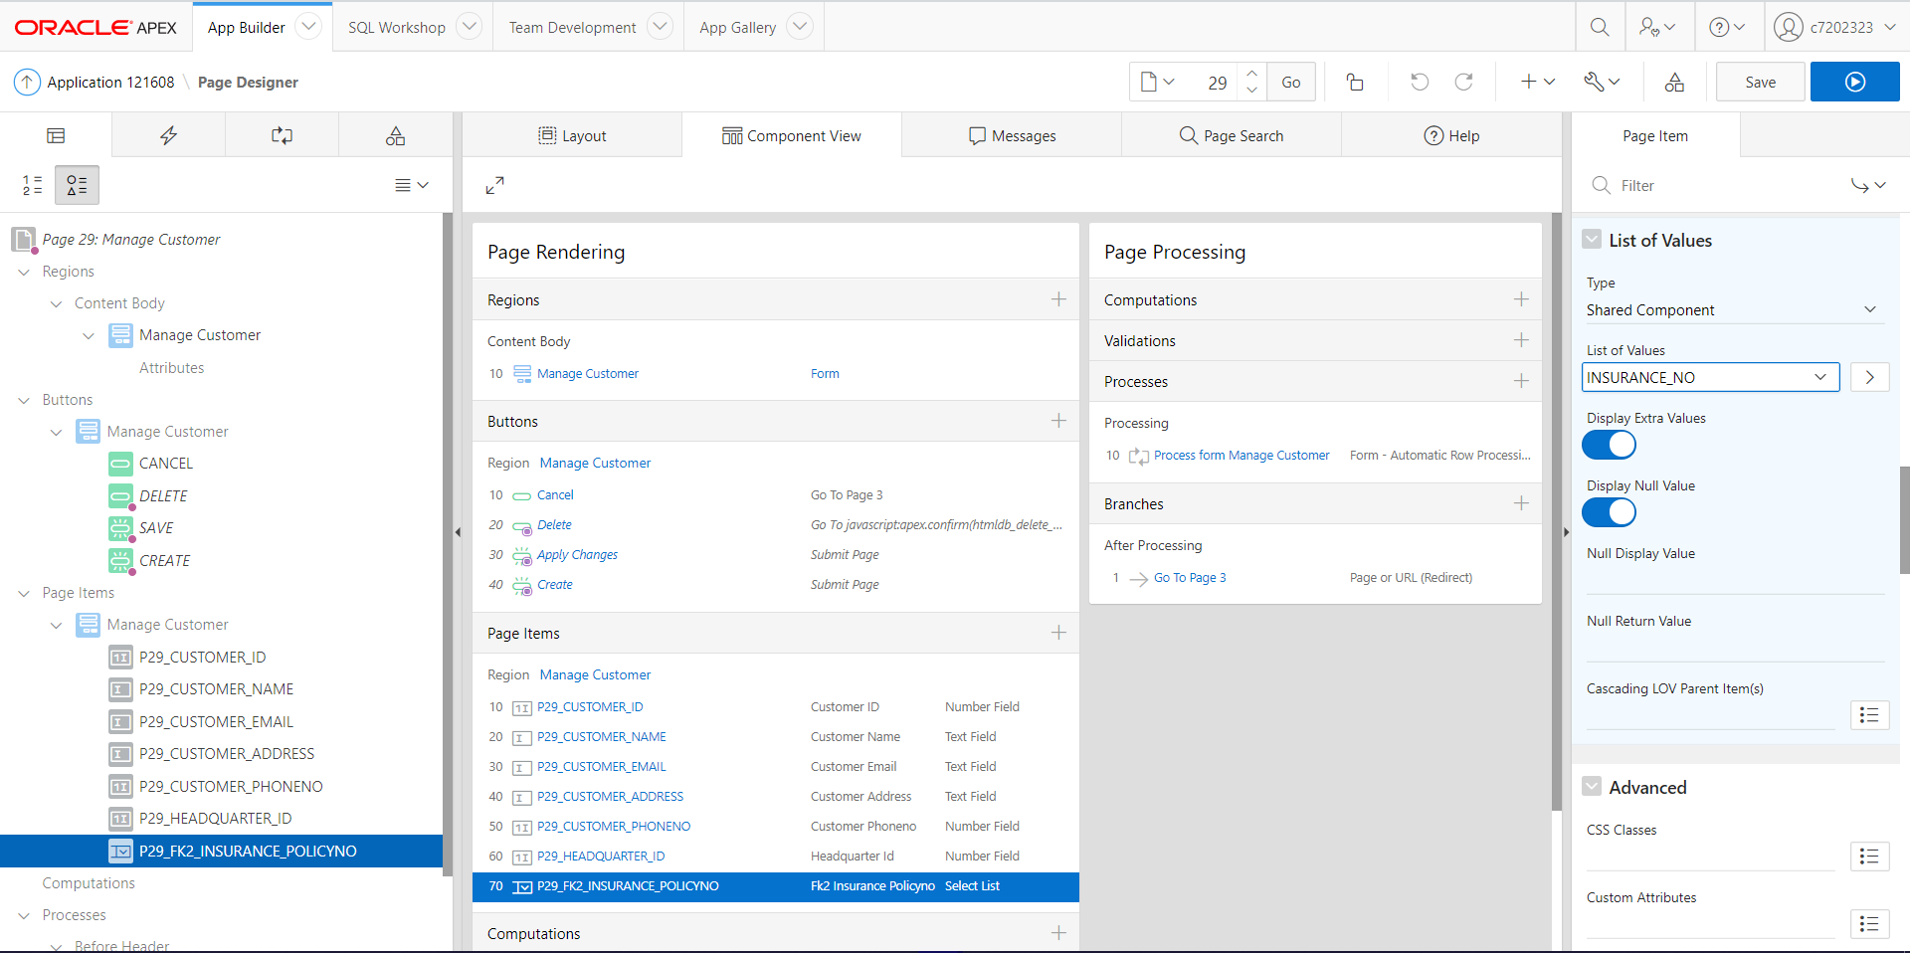

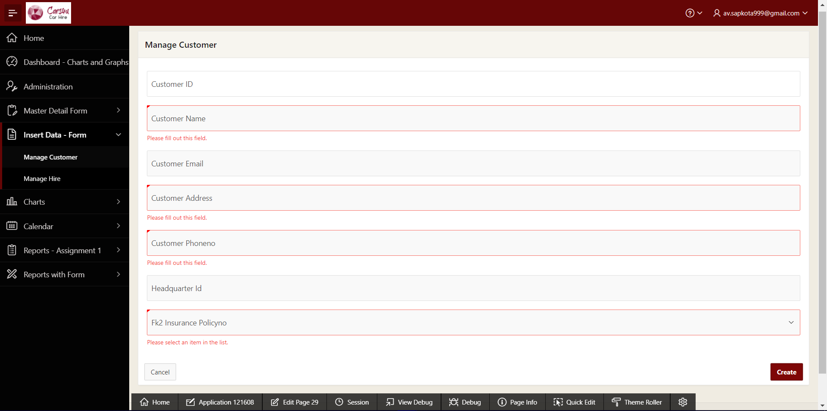

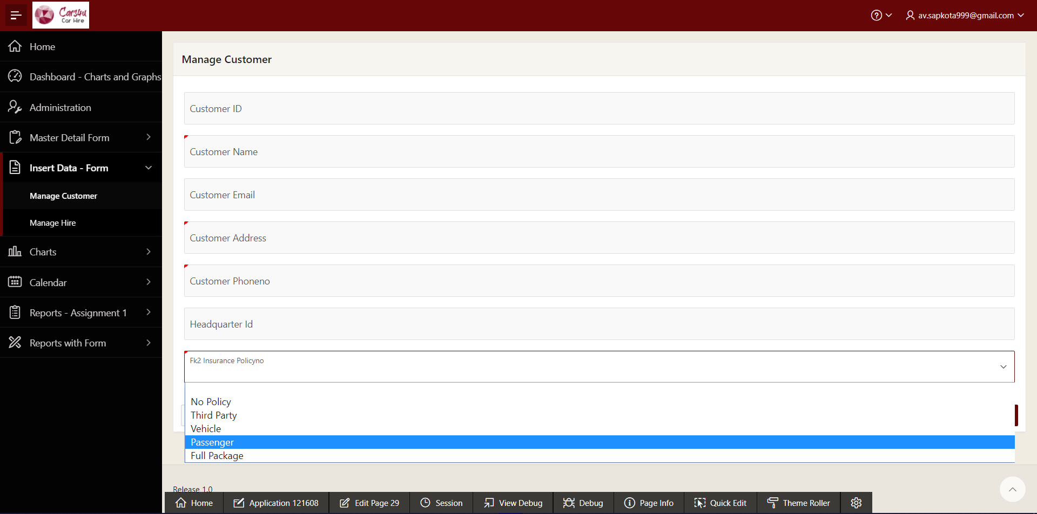

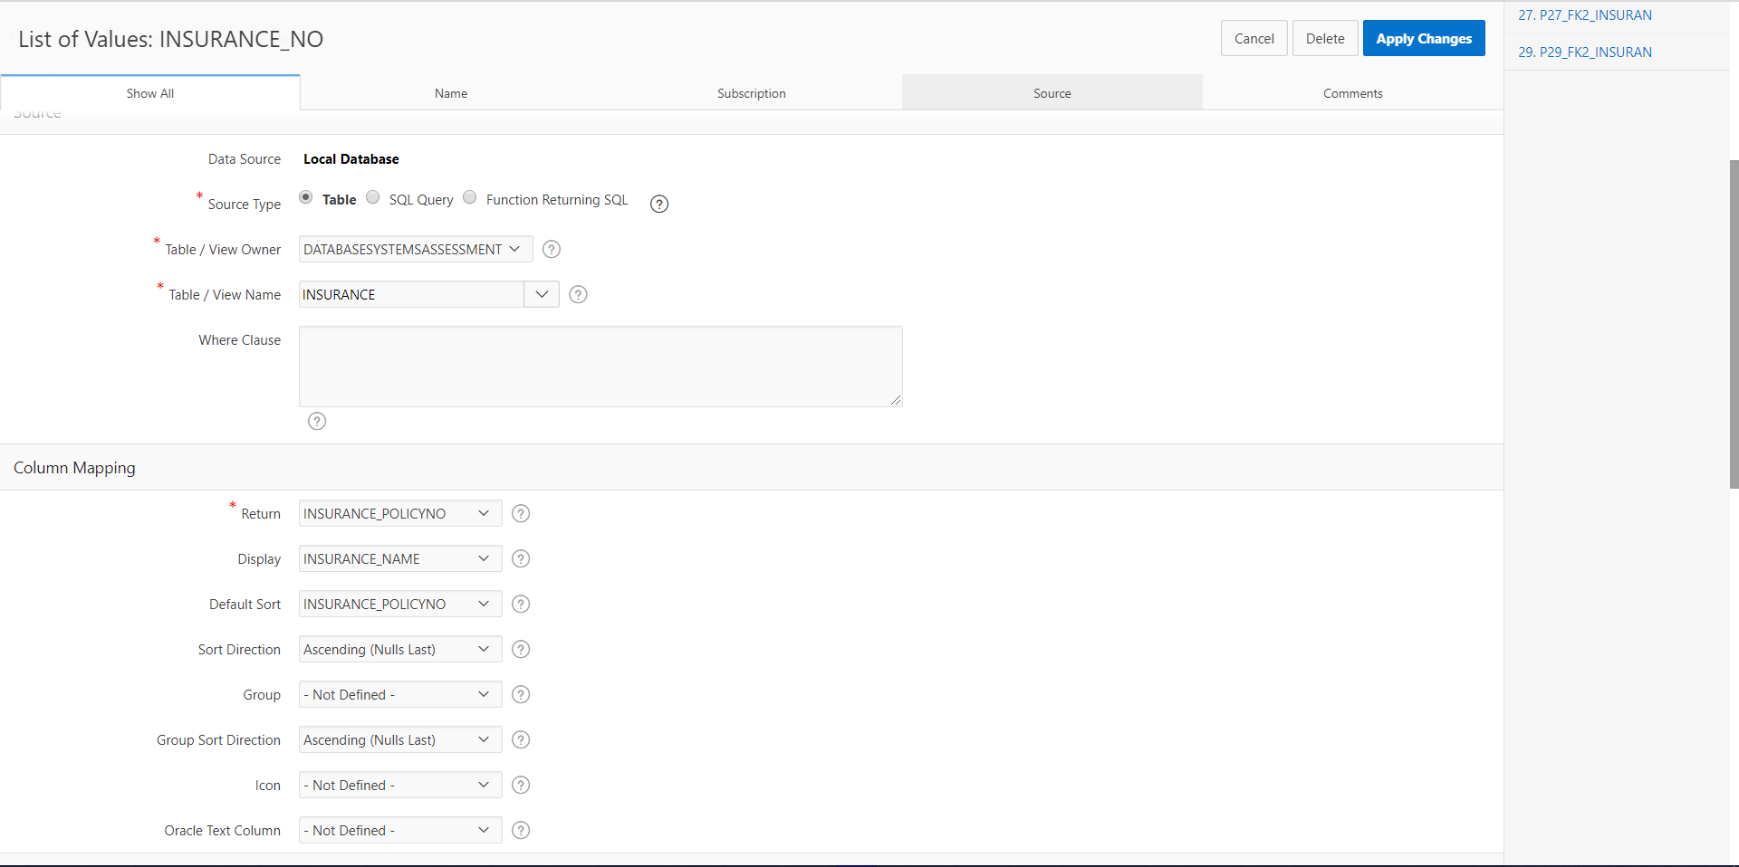

Form for Hire - Invoice Master Detail (with validations and list of values):

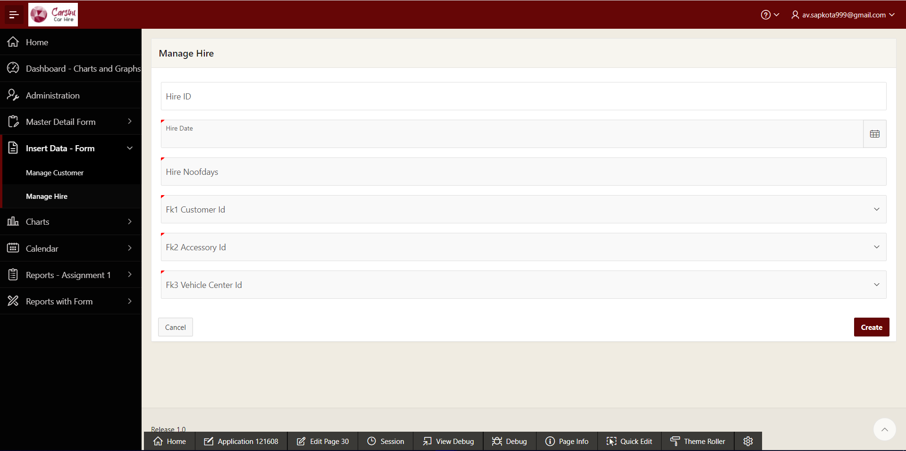

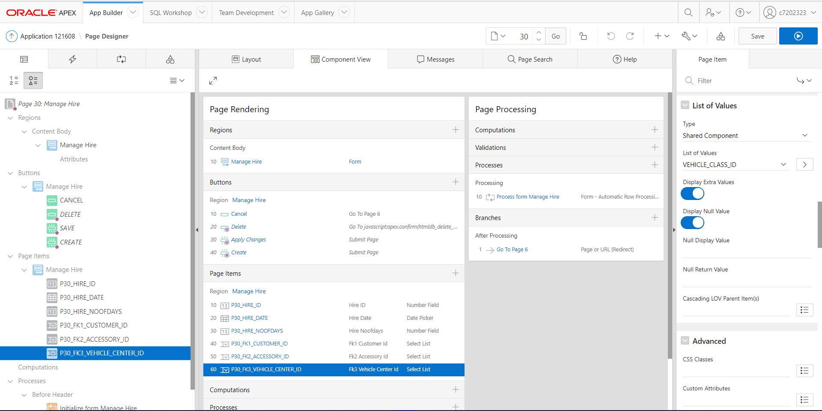

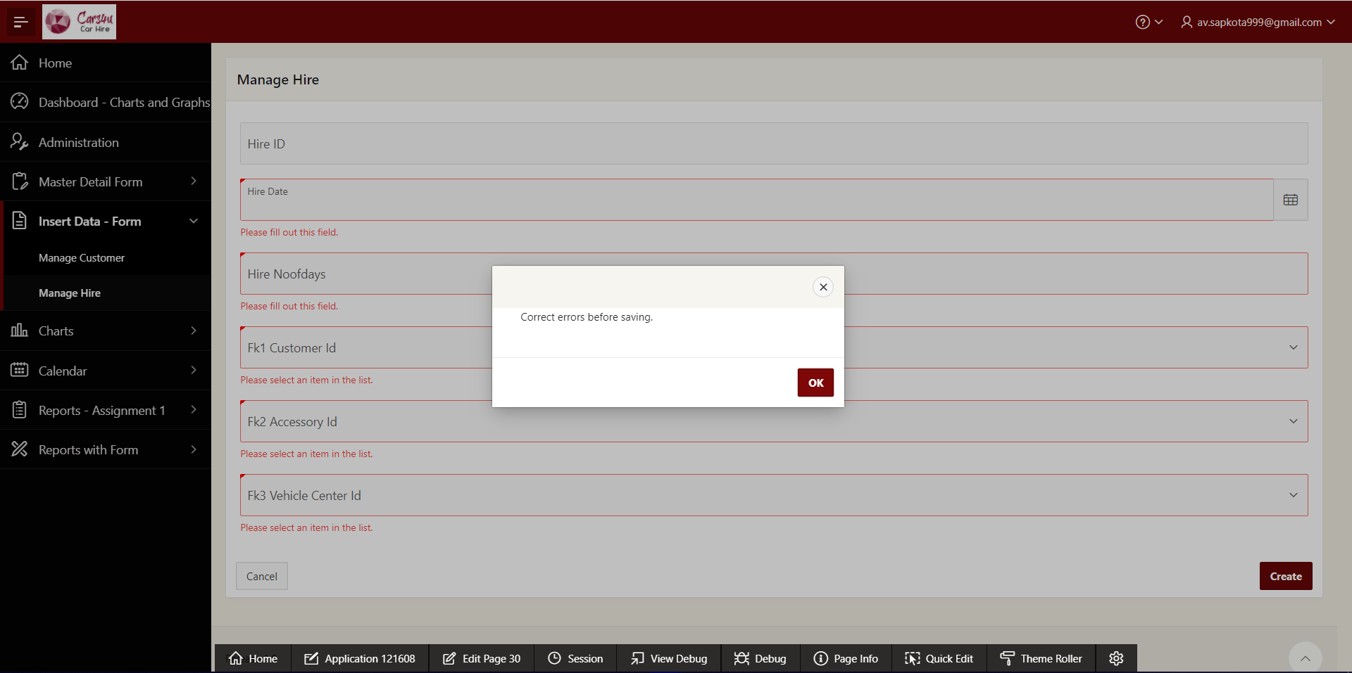

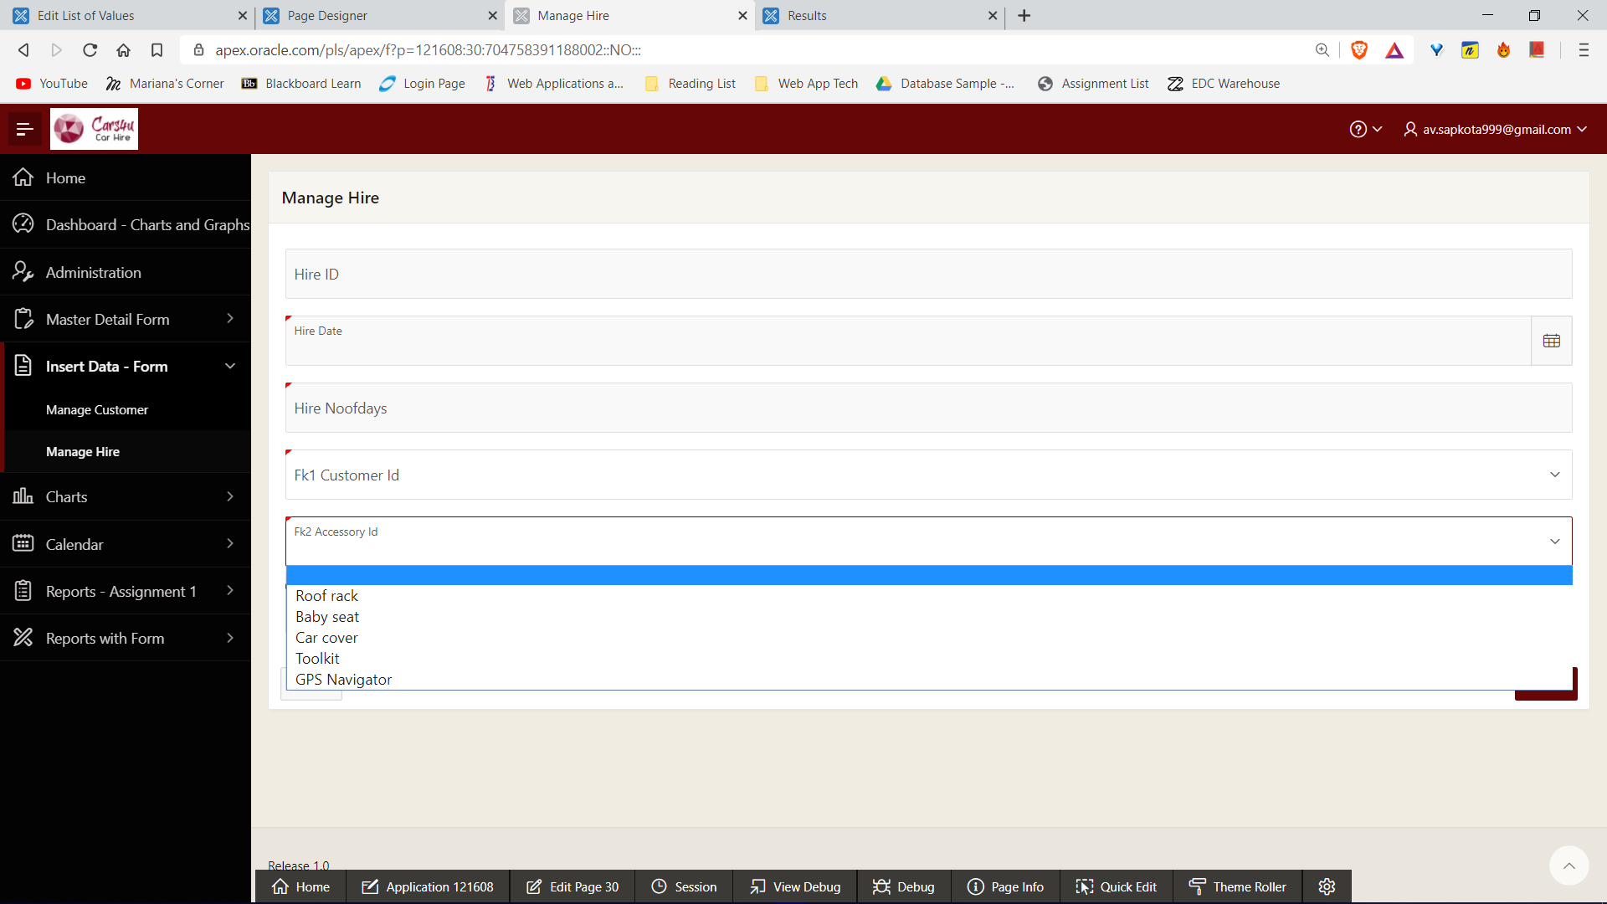

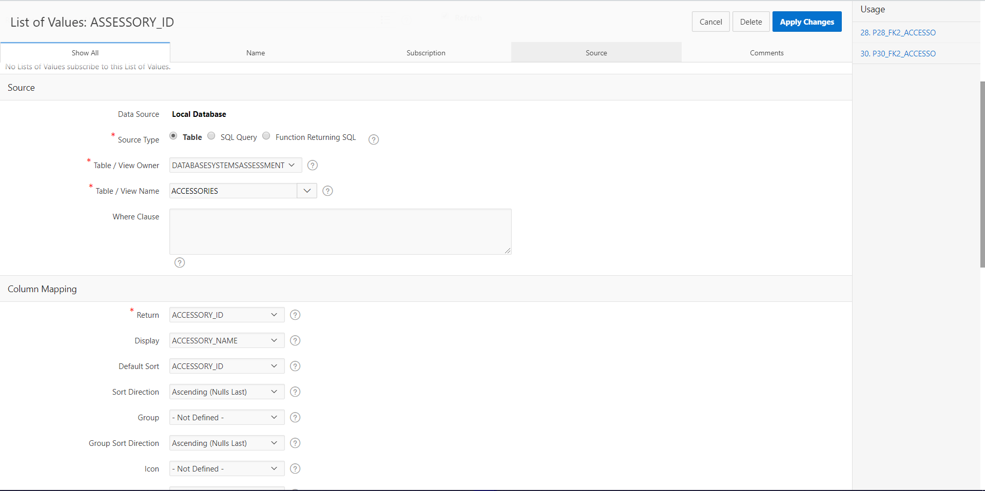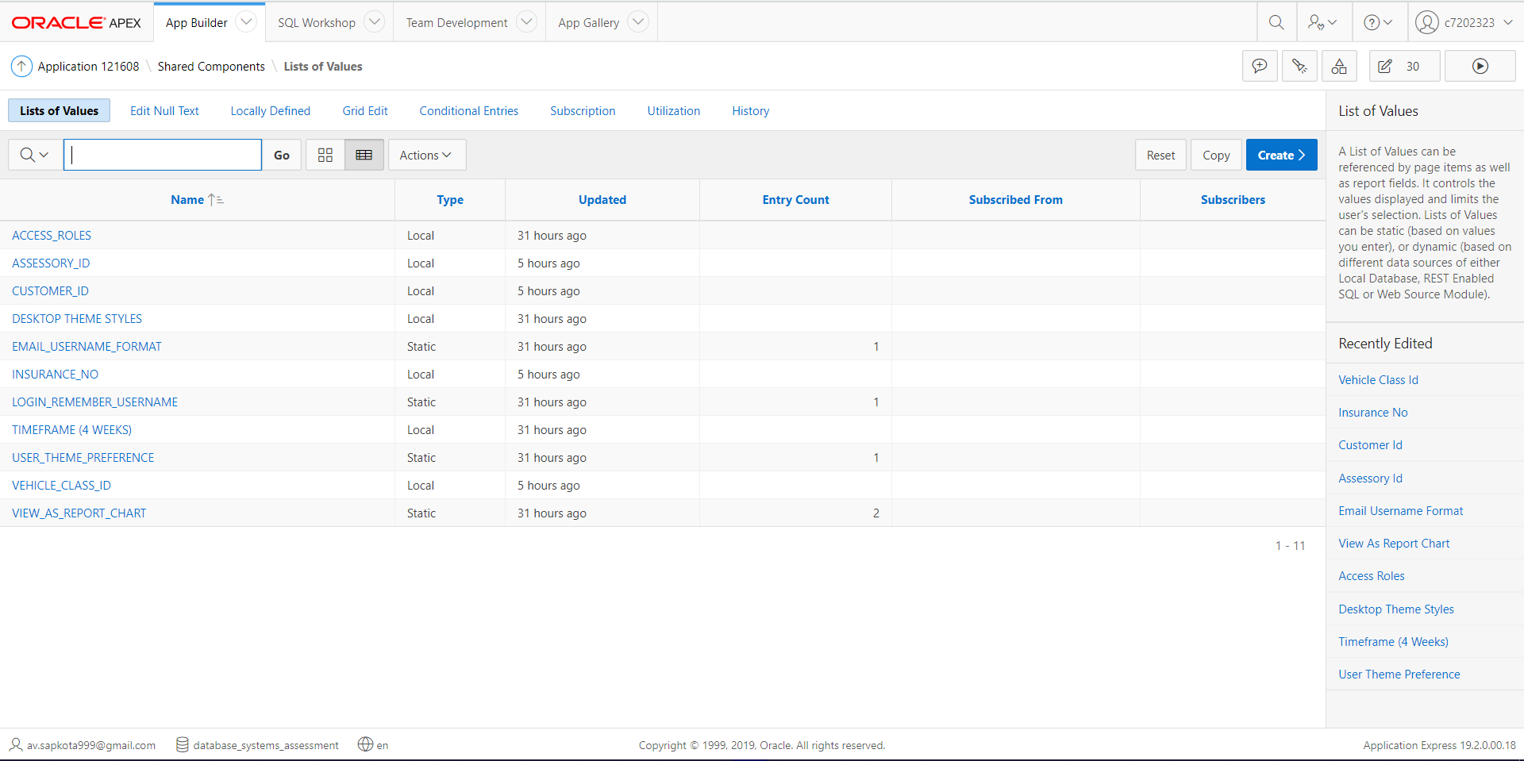

### Graphs and Charts

In addition, the application also has charts ‘Accessory – Price Chart’ and ‘Hire – Price Chart’ which makes the interface more attractive and easier to read progress values.

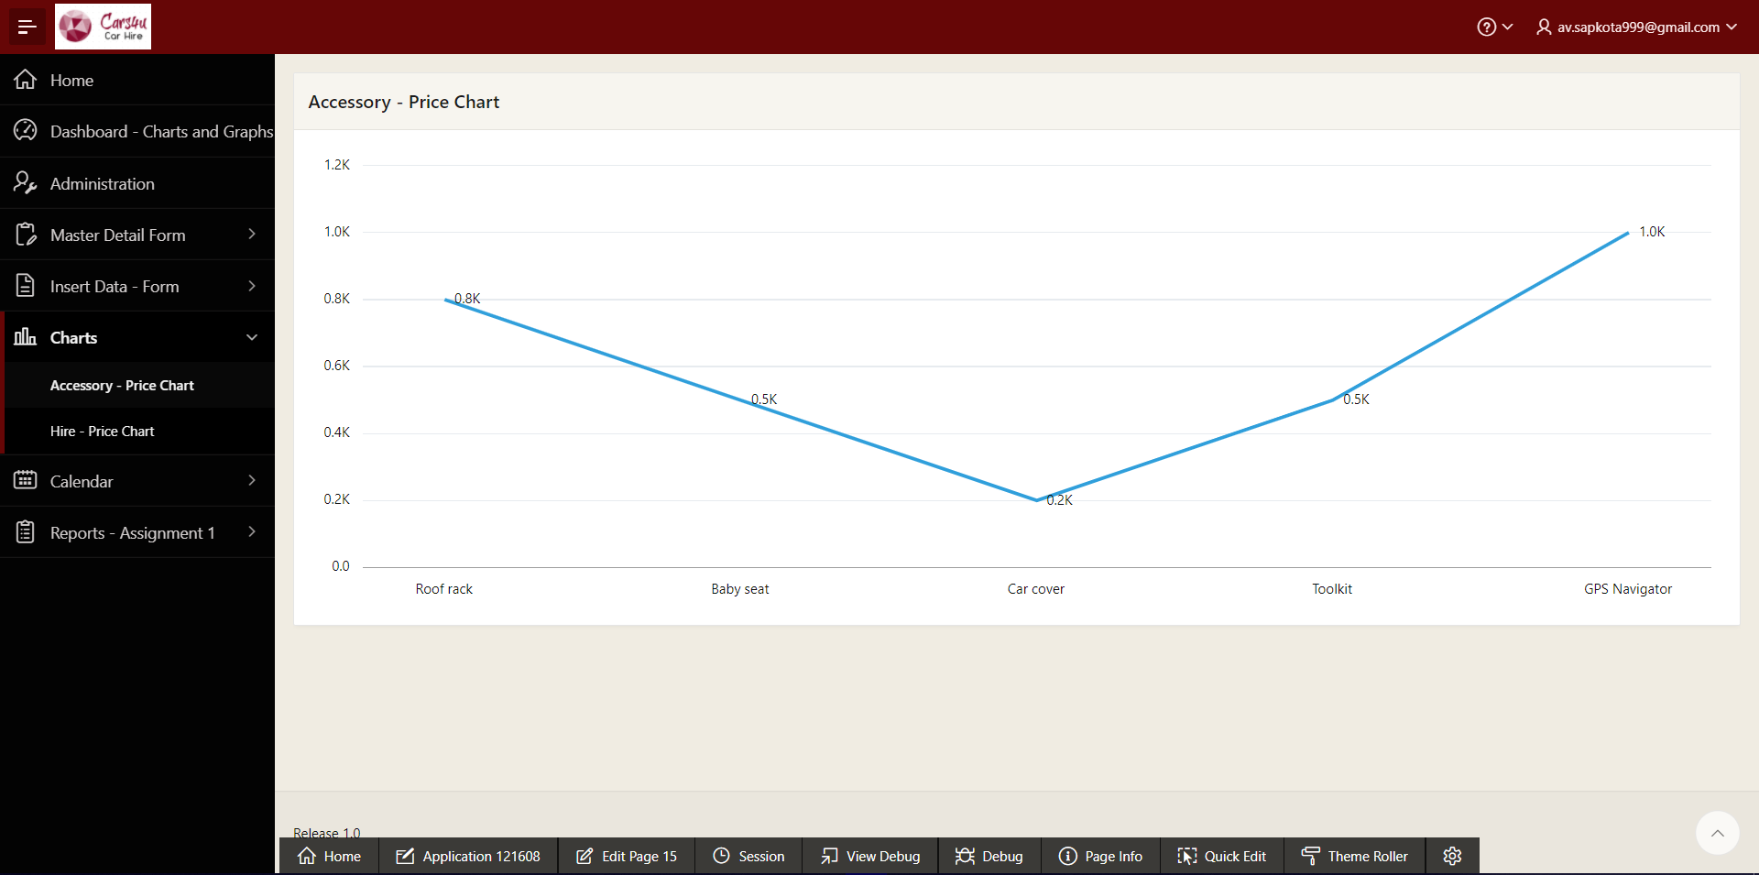

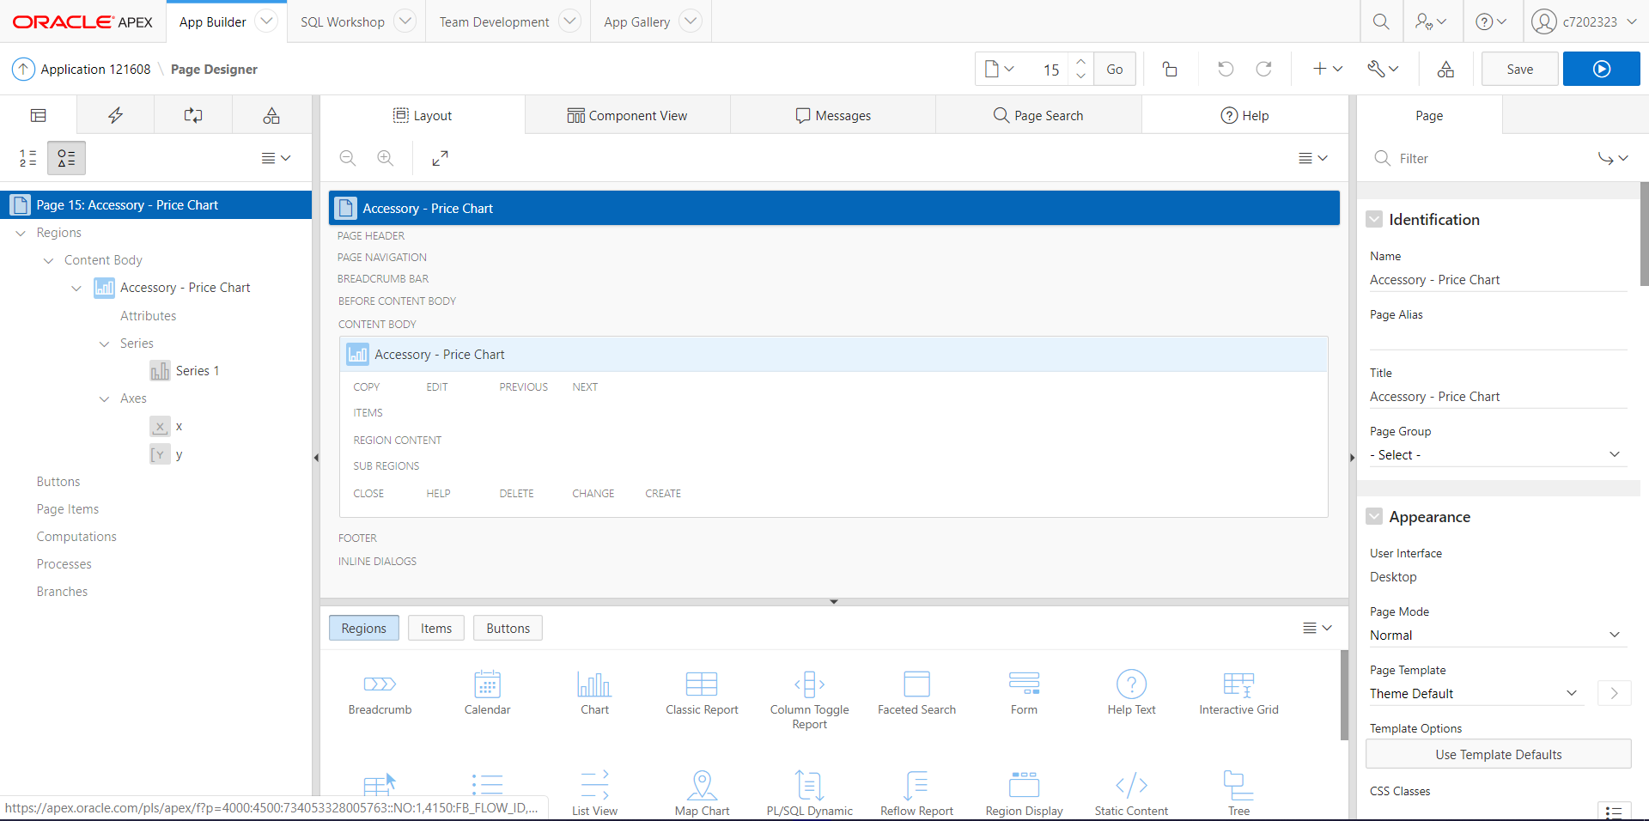

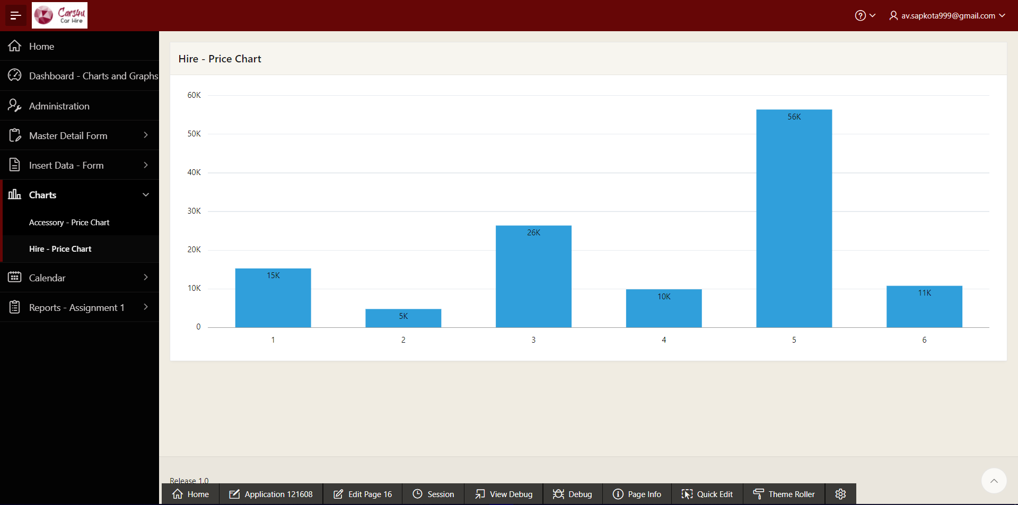

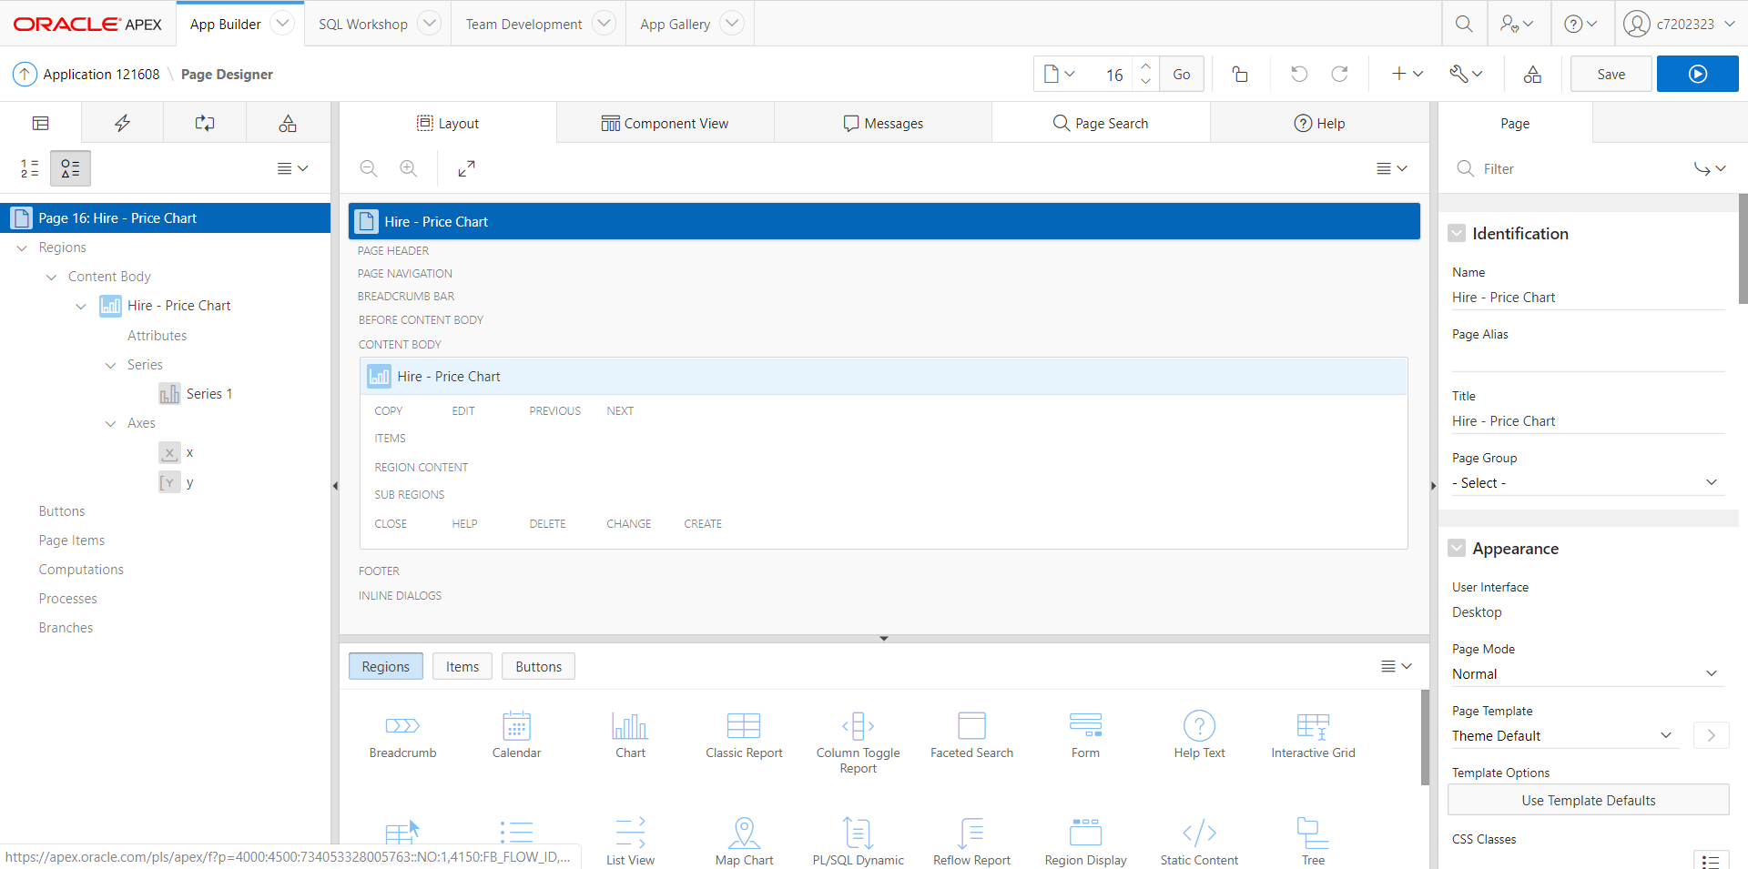

### Calendars

The application also has a calendar features for ‘Contract Dates’ during contract with user and ‘Customer Hire Dates’ to easily point out the hire dates of various users.

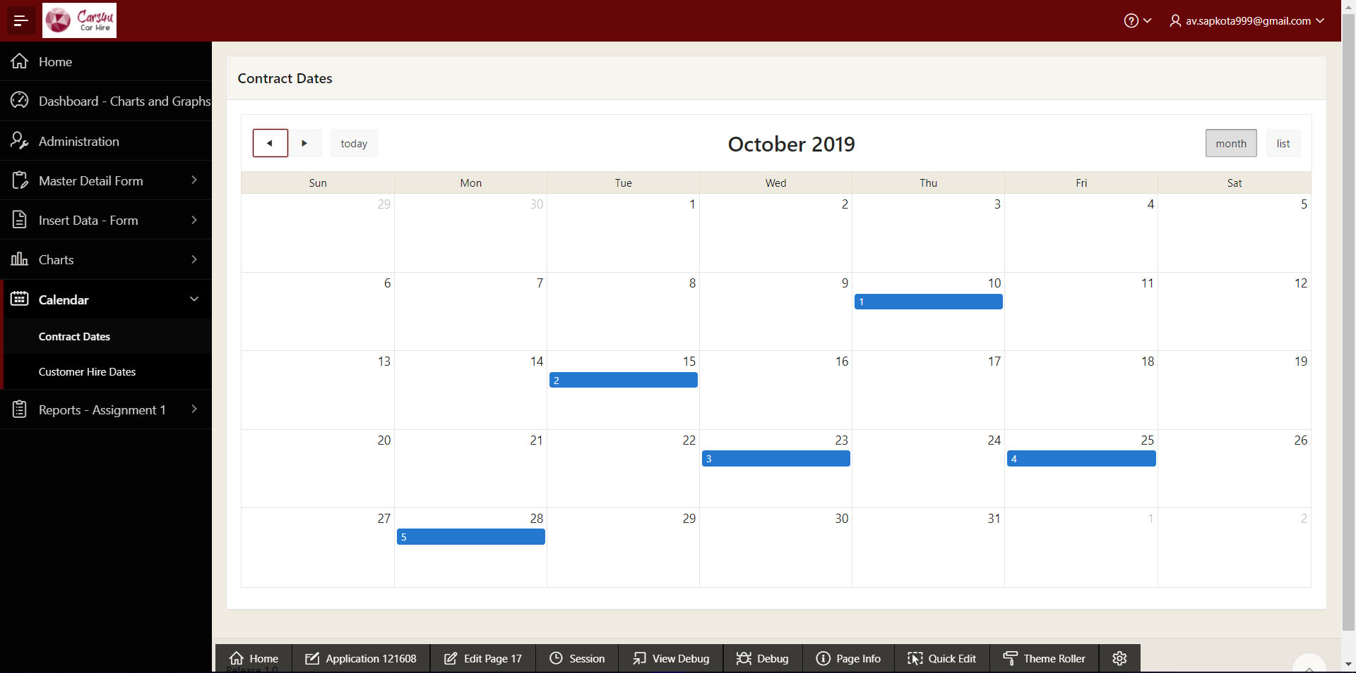

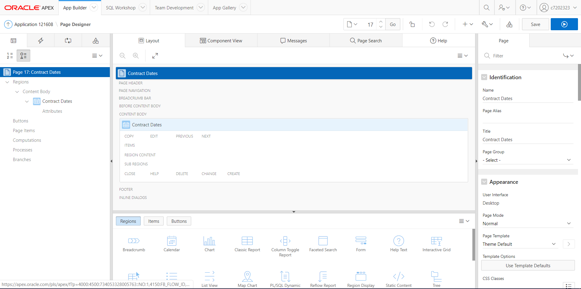

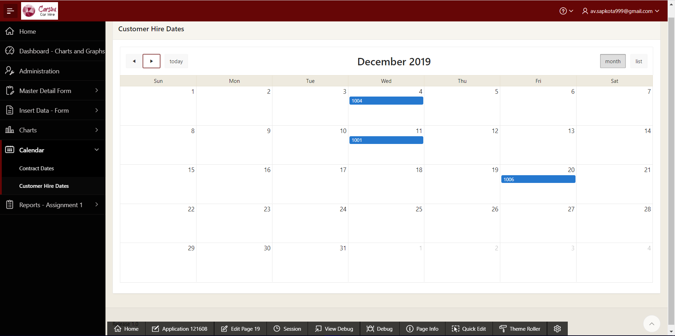

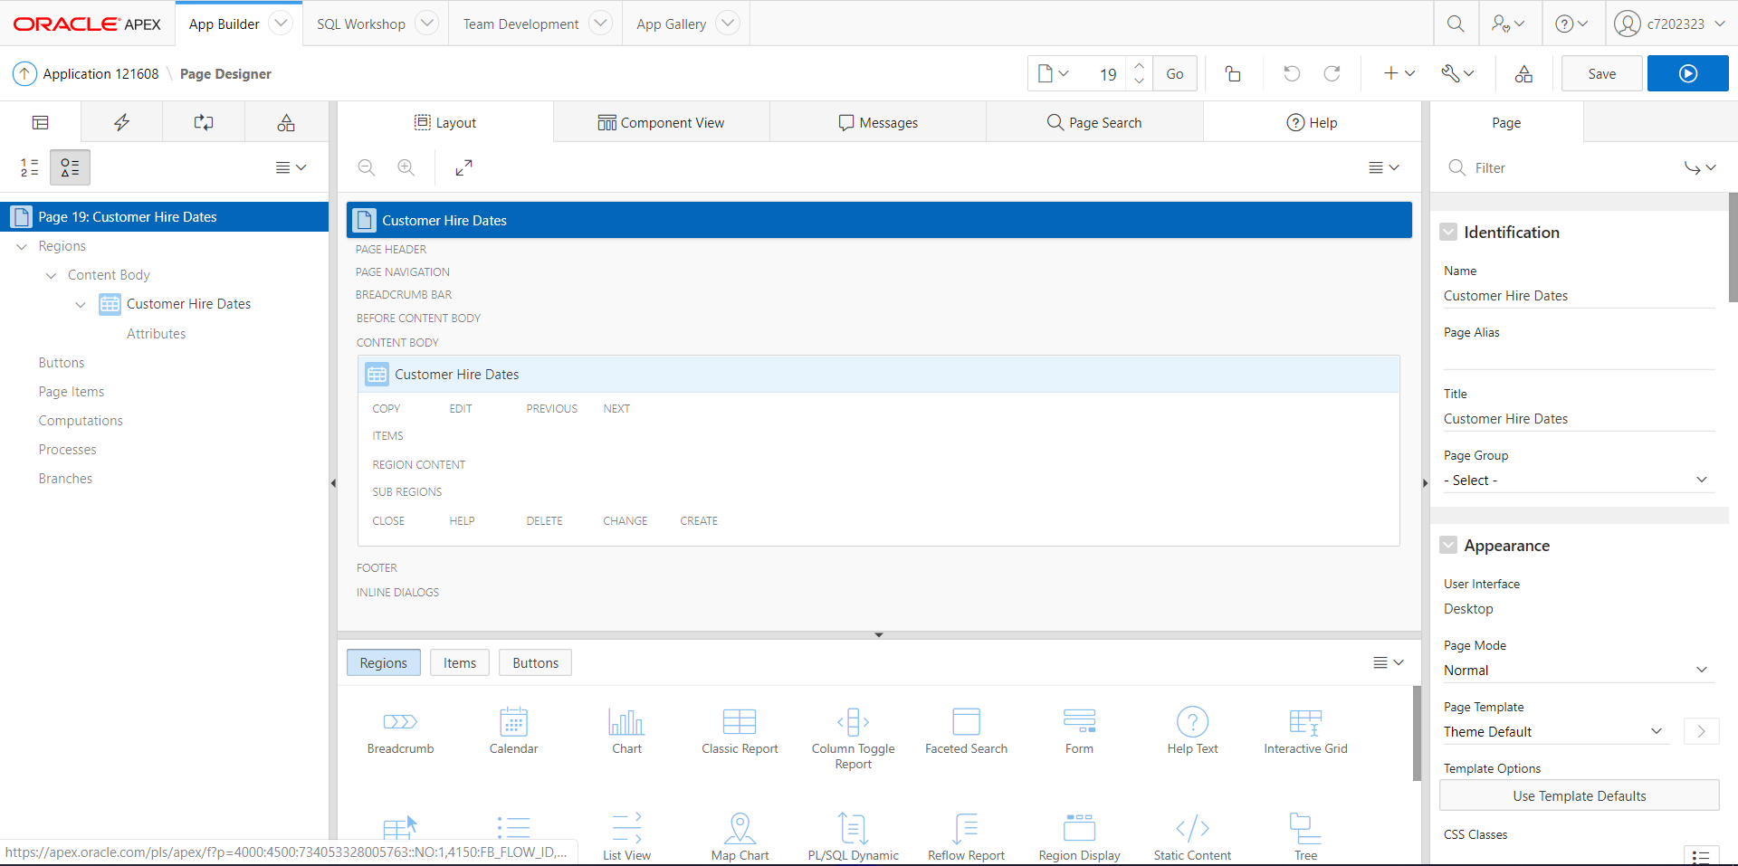

### Reports of Assignment Component 1

Furthermore, the application features with some reports, apparently the reports of component 1, that provides the data that customers and application users may frequently use during the use of this application.

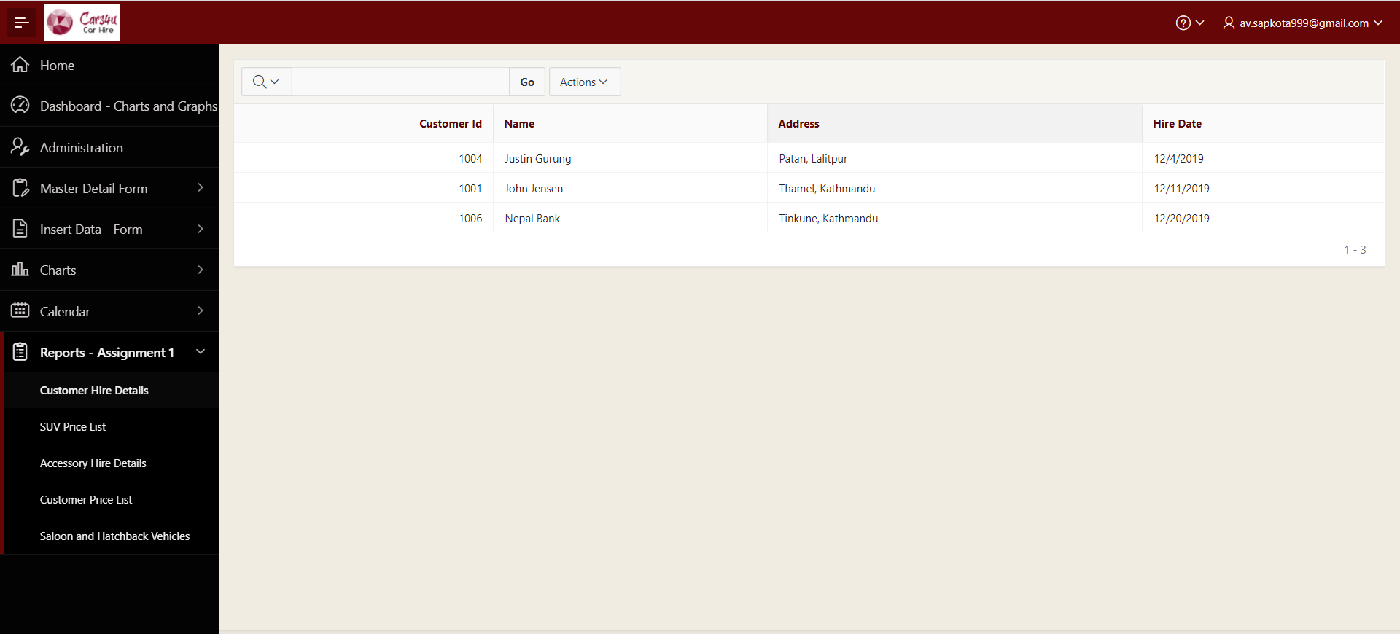

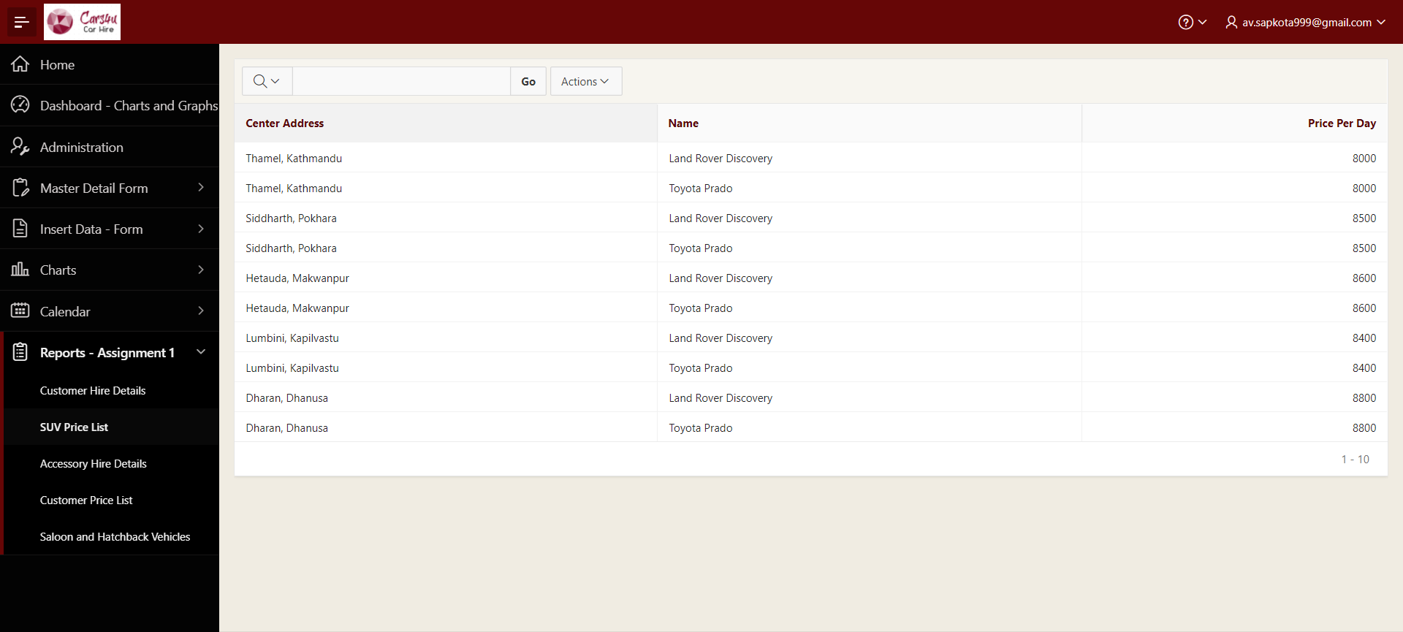

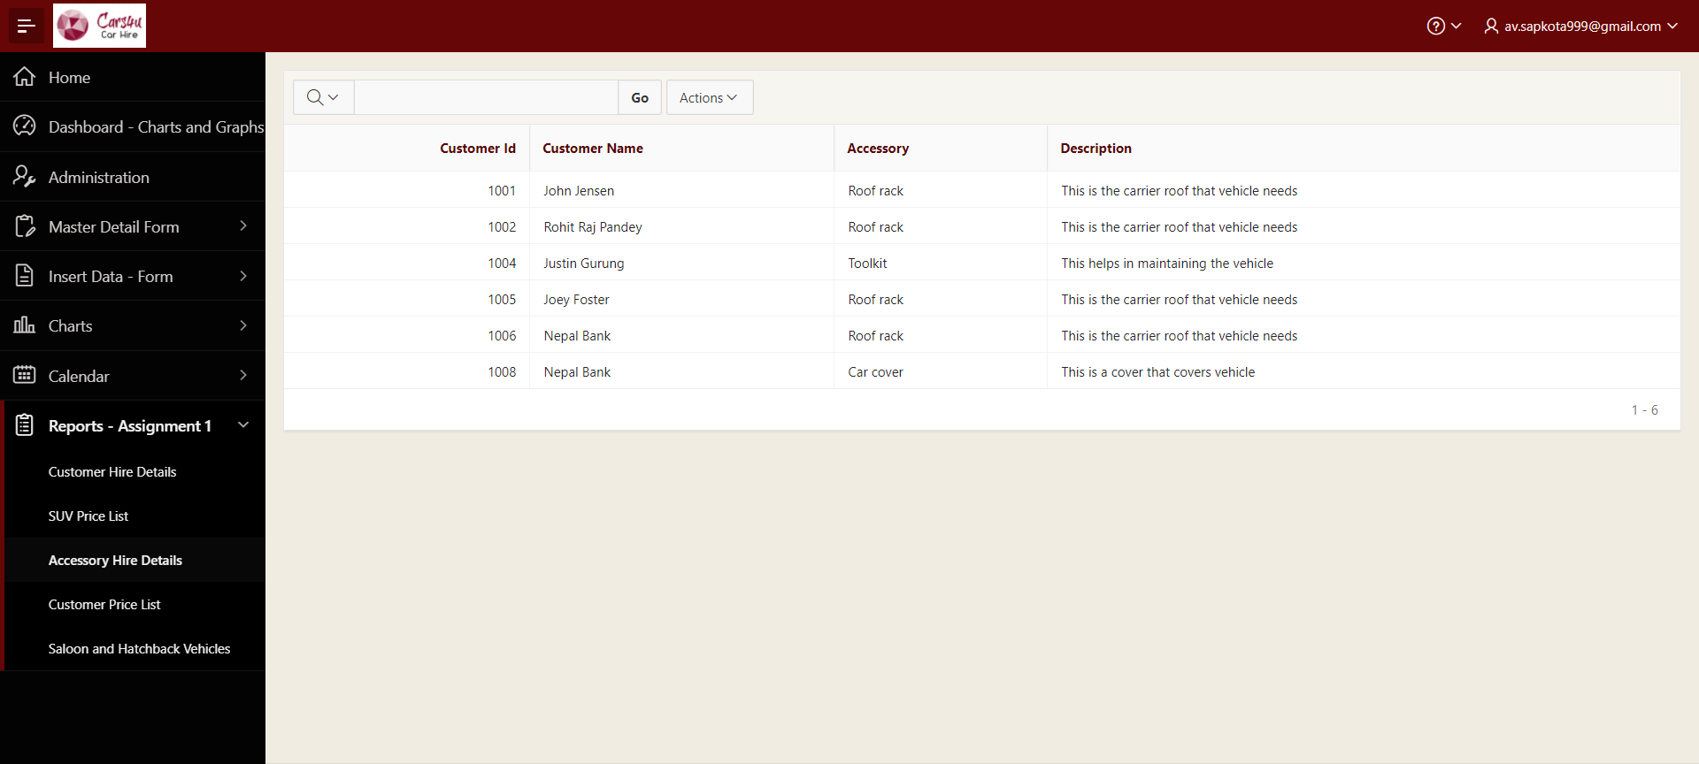

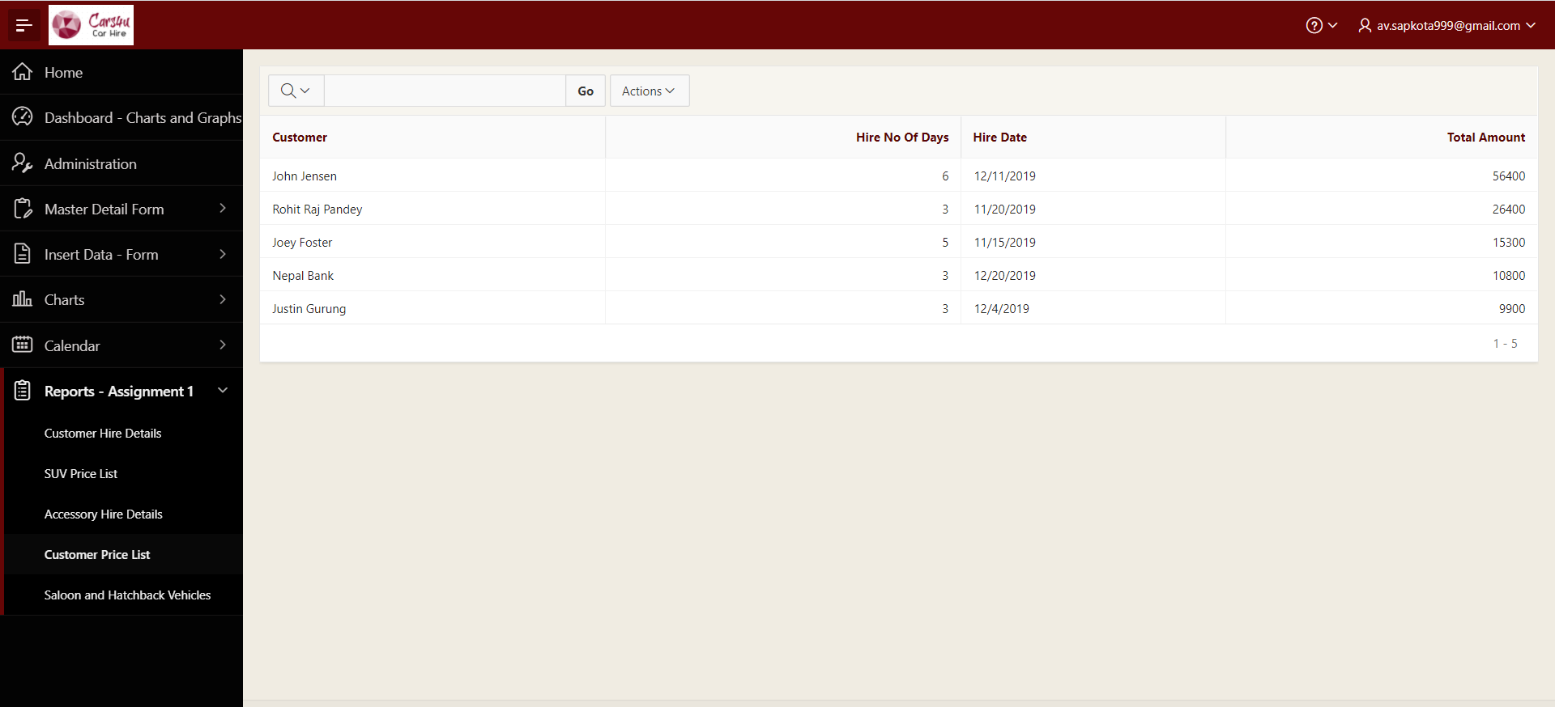

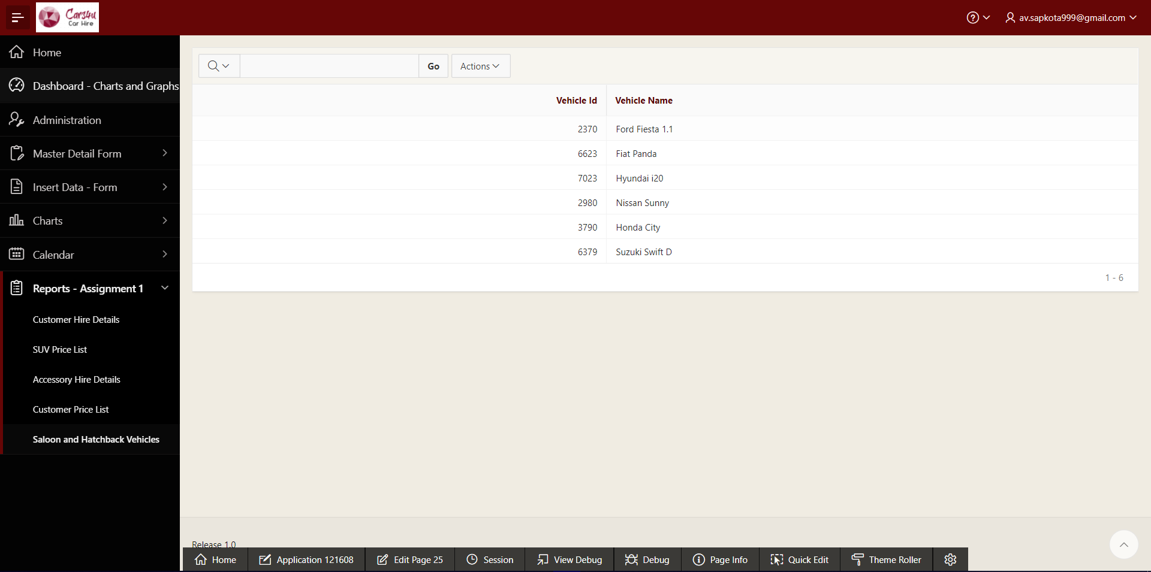

### Reports with Forms

The application also includes reports with form which allows user to read the report and make some edit if necessary, using forms. These reports are the reports of tables where triggers of task 1 has been inserted or updated.

Report with Form 1:

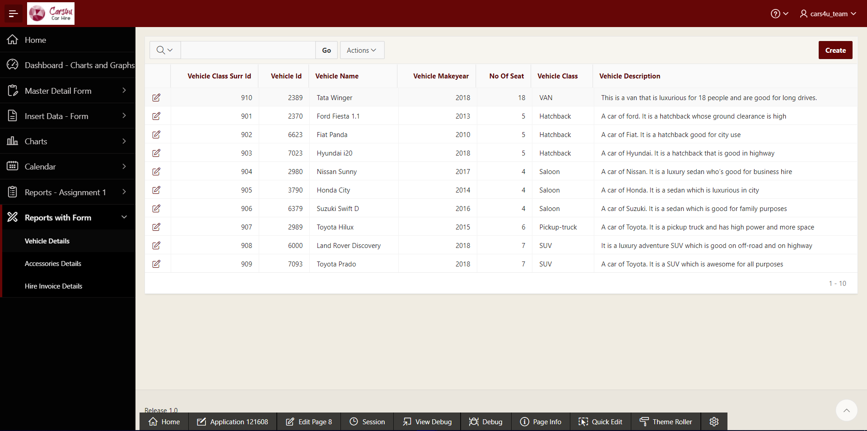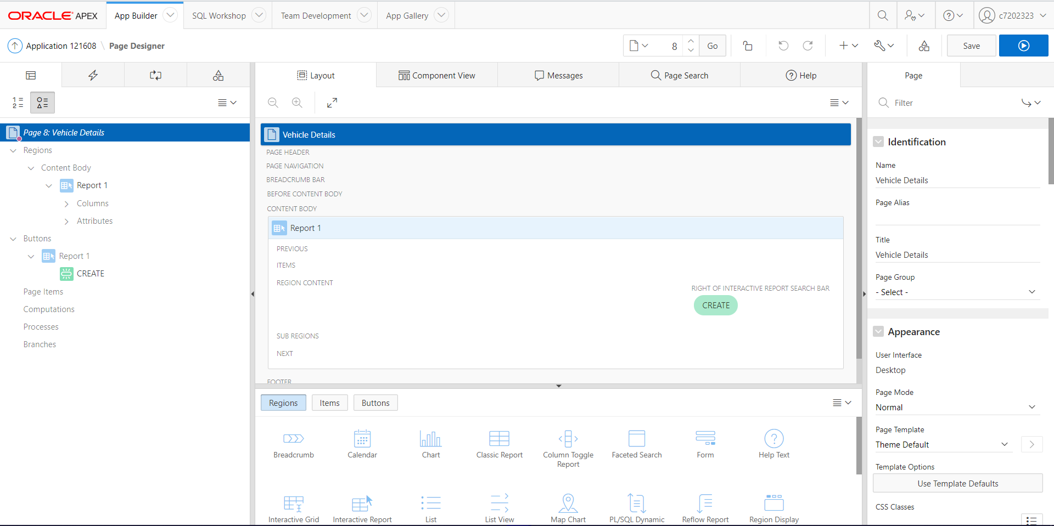

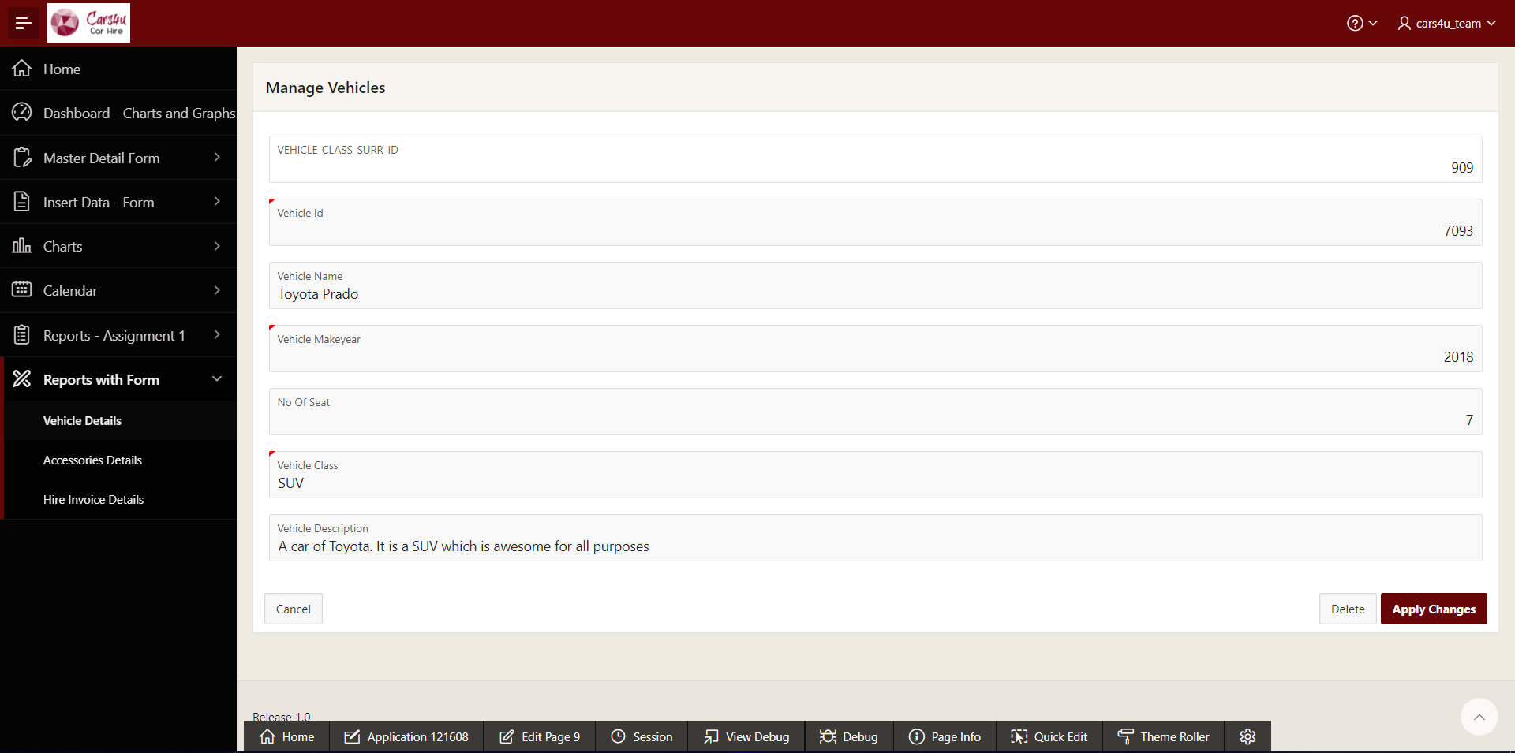

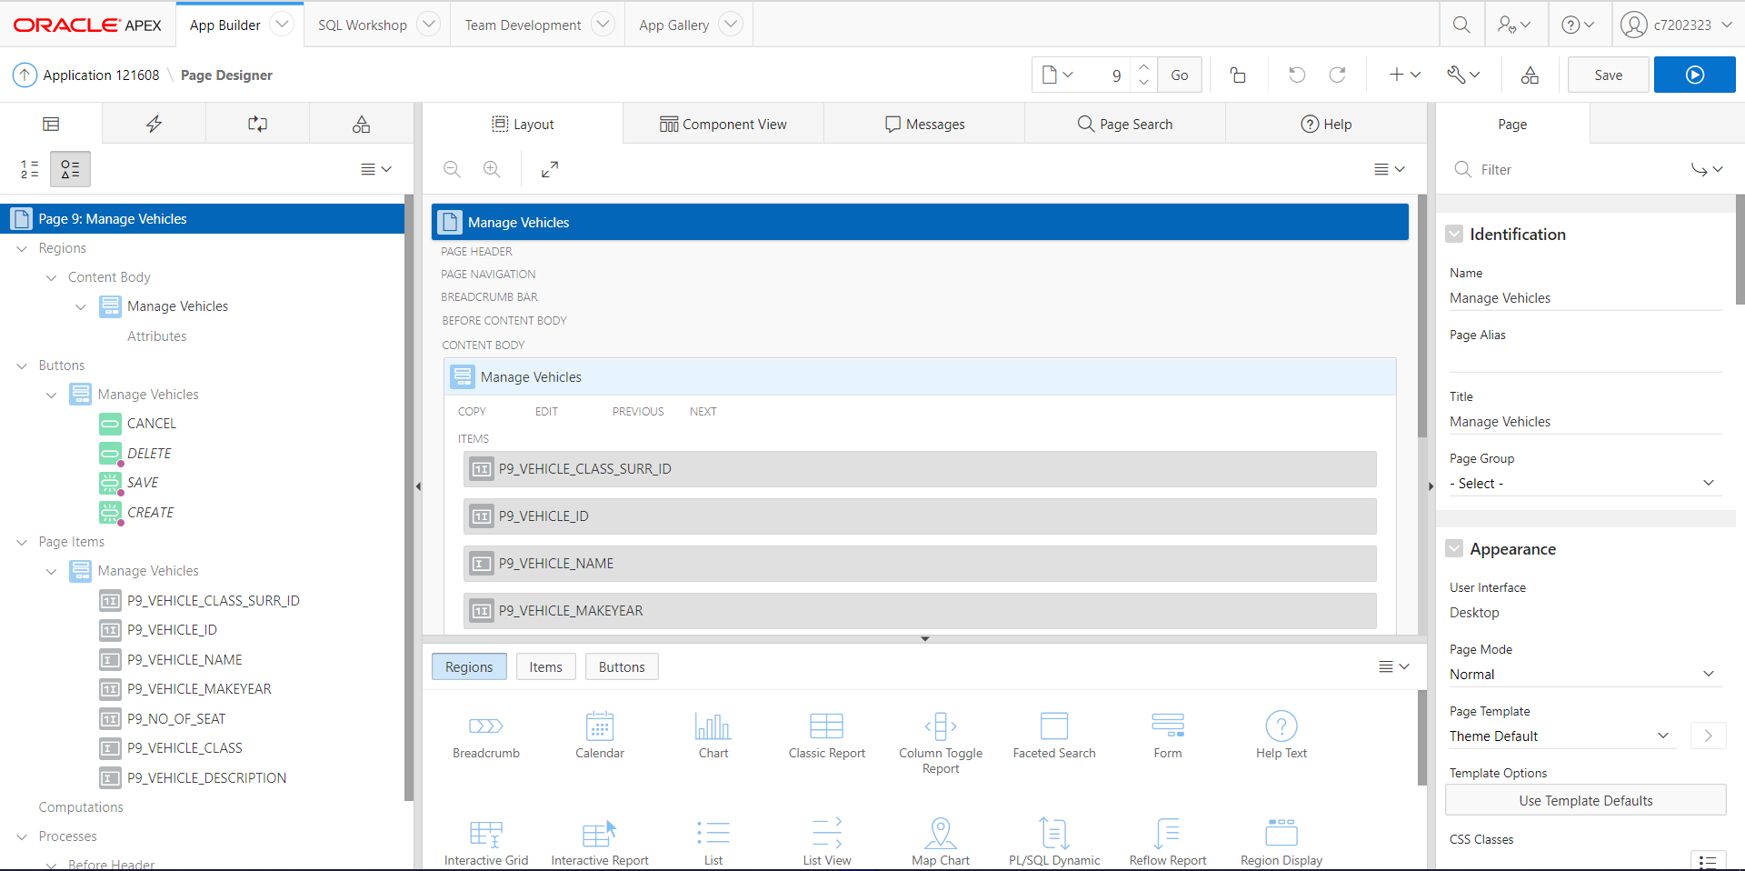

Report with Form 2:

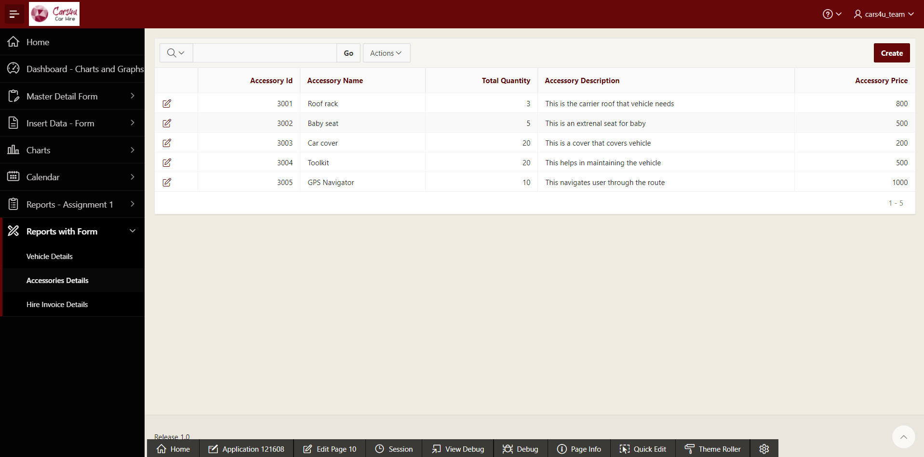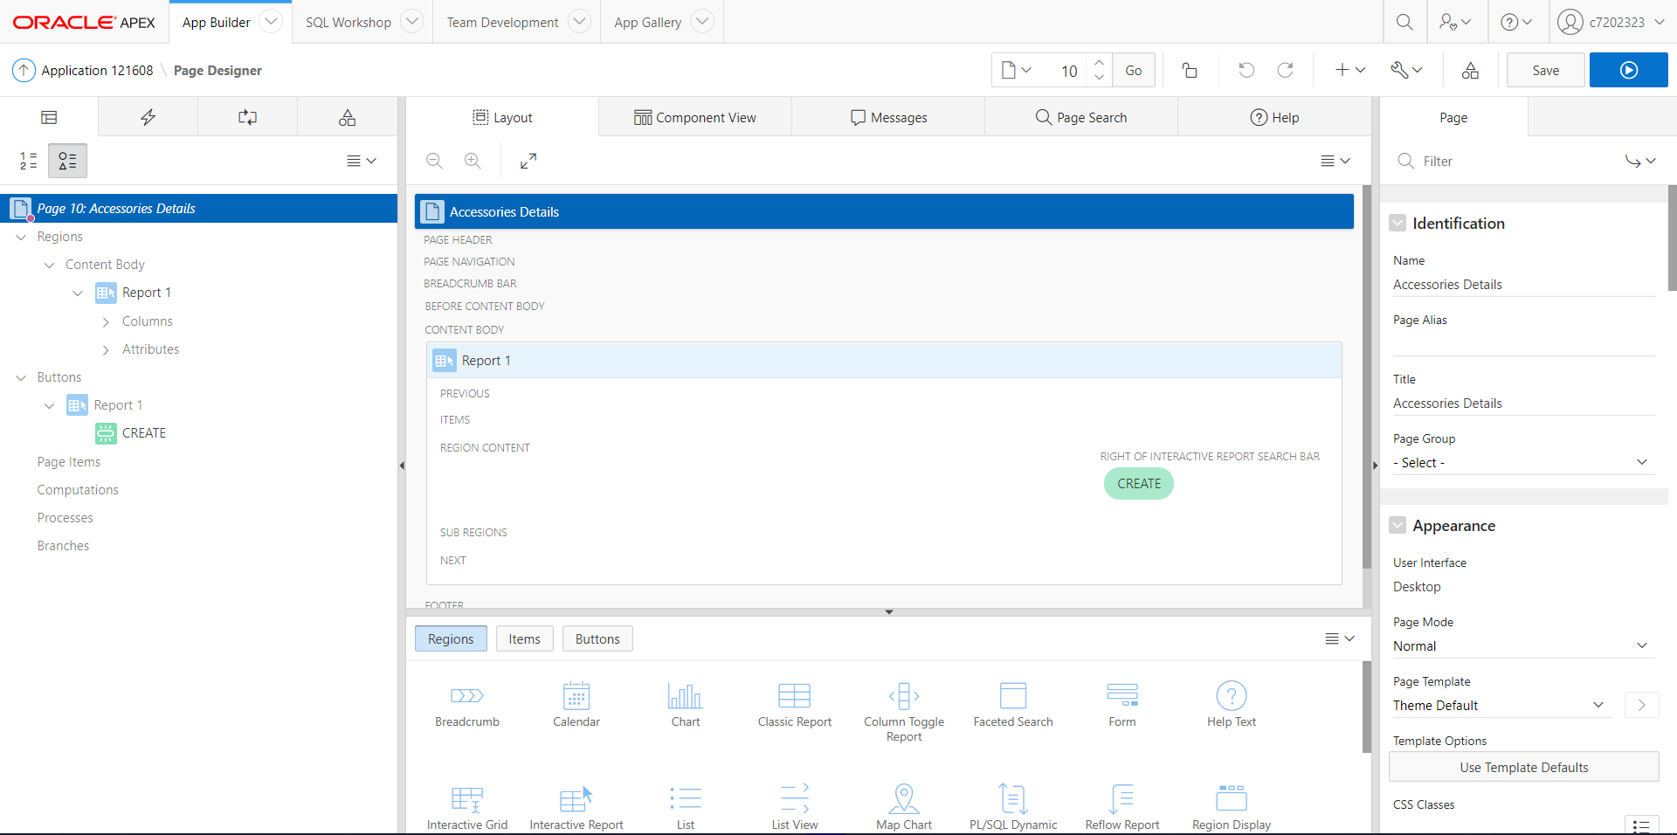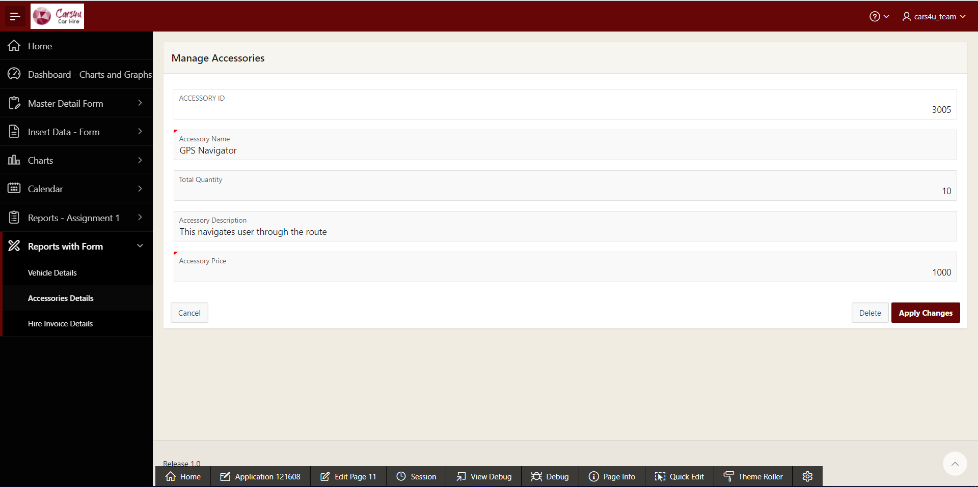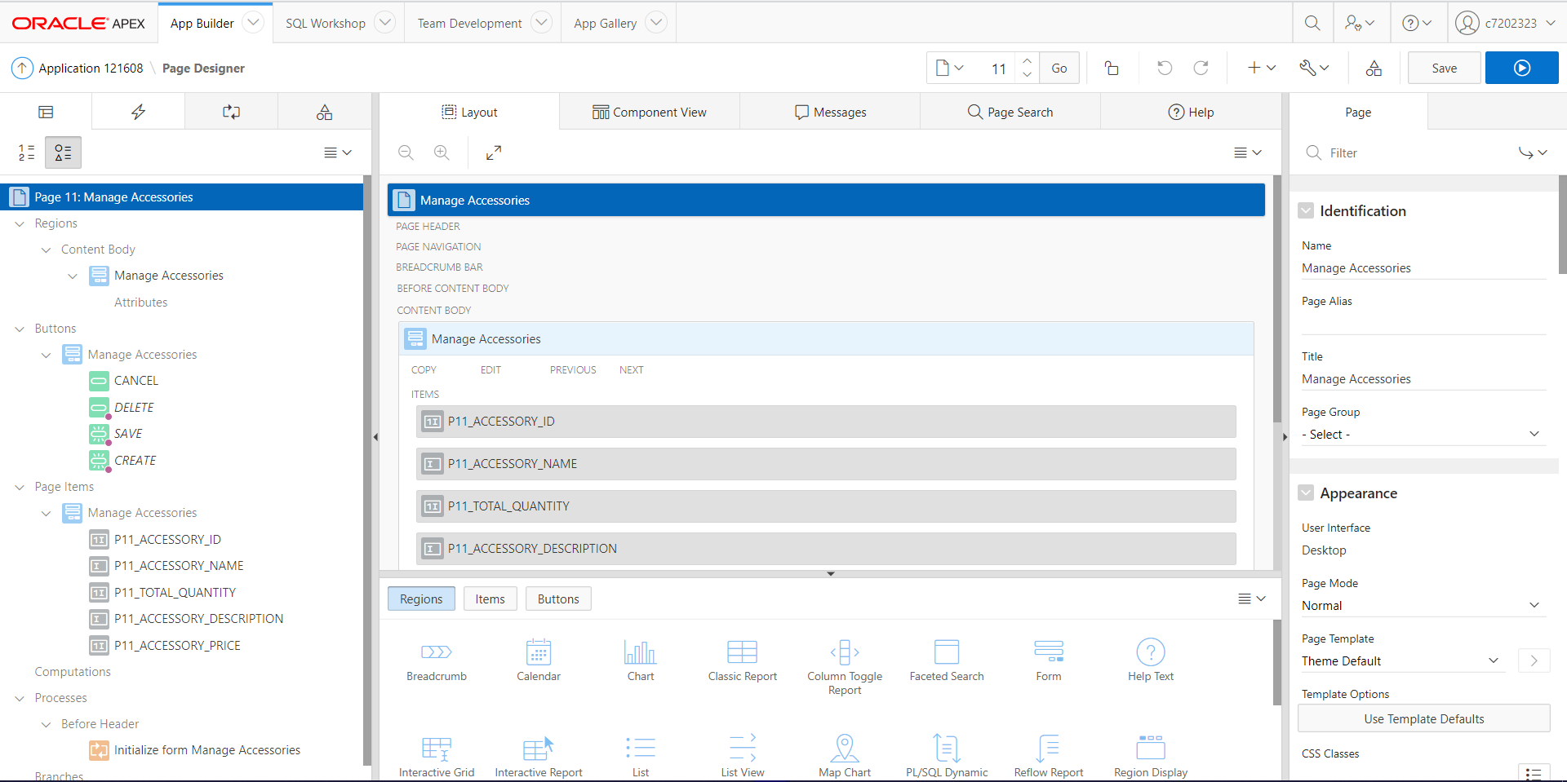

Report with Form 3:

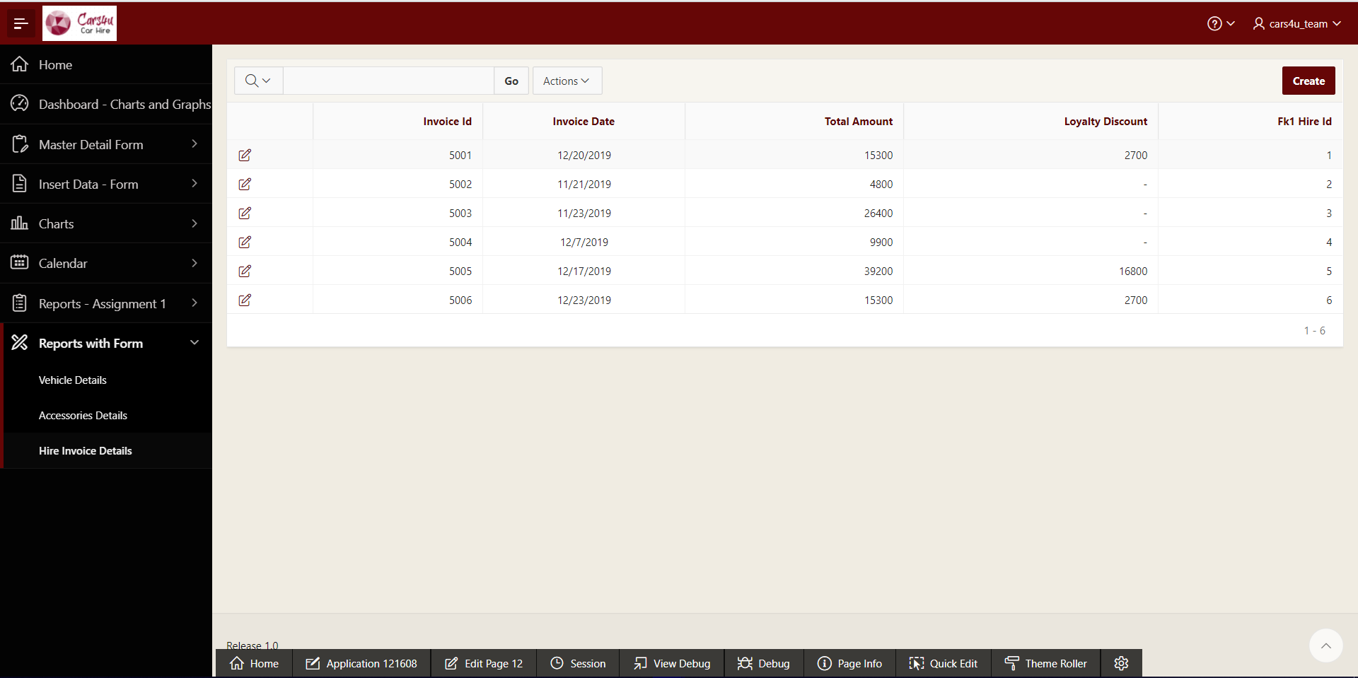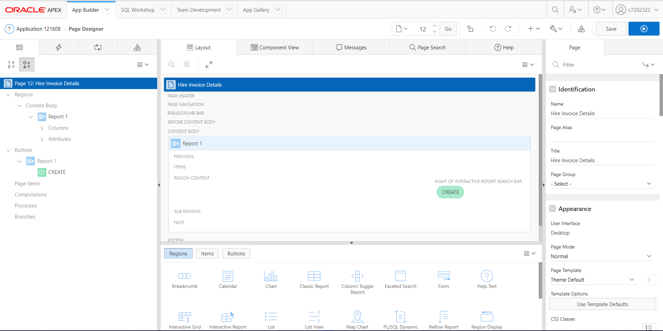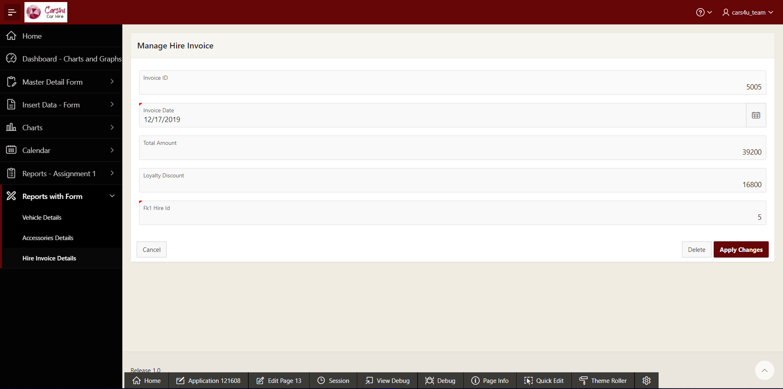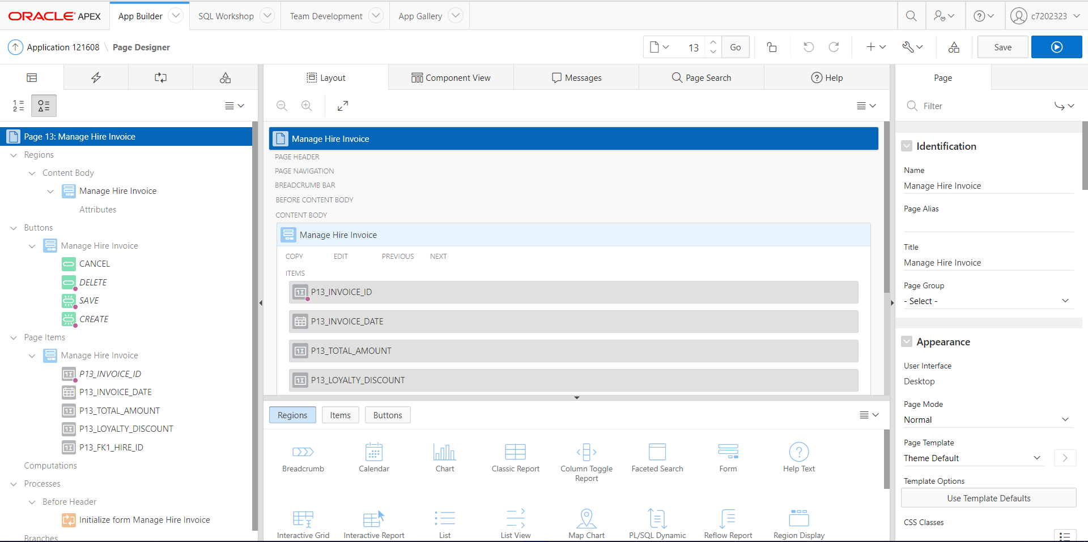

### Multiple User Access

Finally, the application allows multiple user access which facilitates administration facility, application operator and application reader. Each user type can only view application’s features which has been allowed to access, for that particular user type.

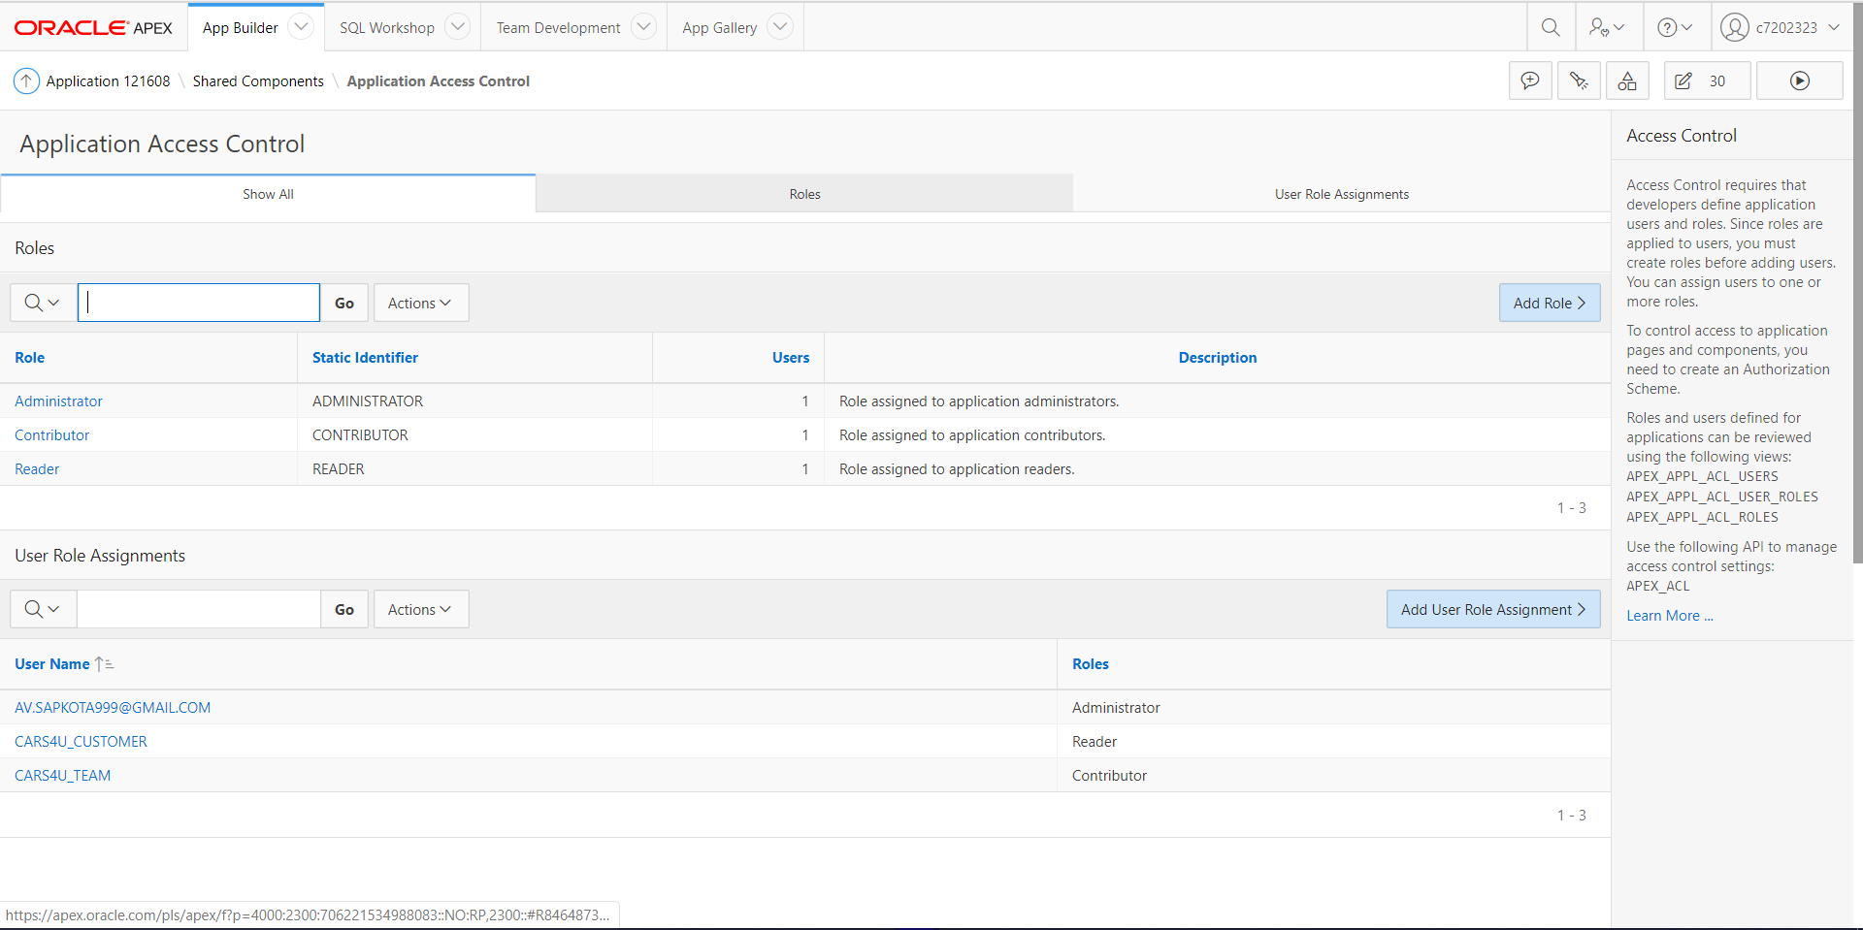

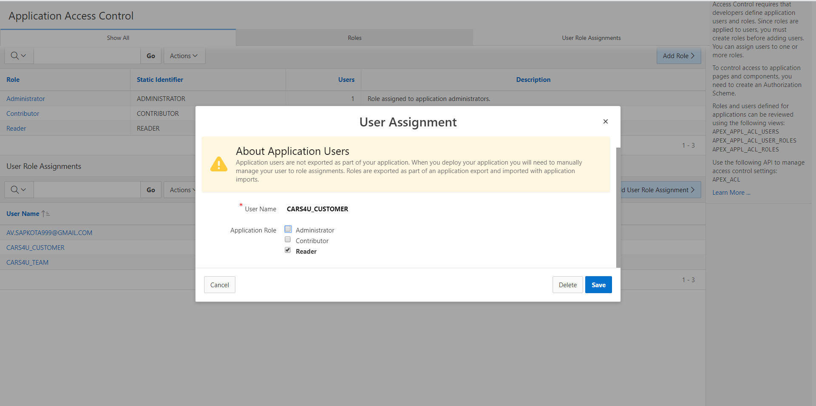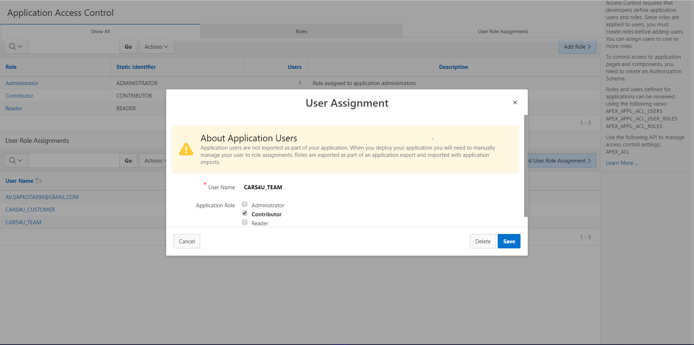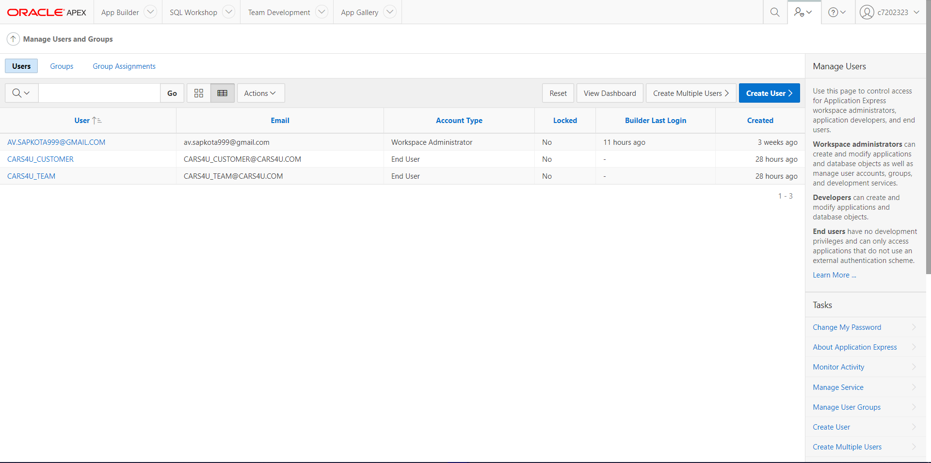

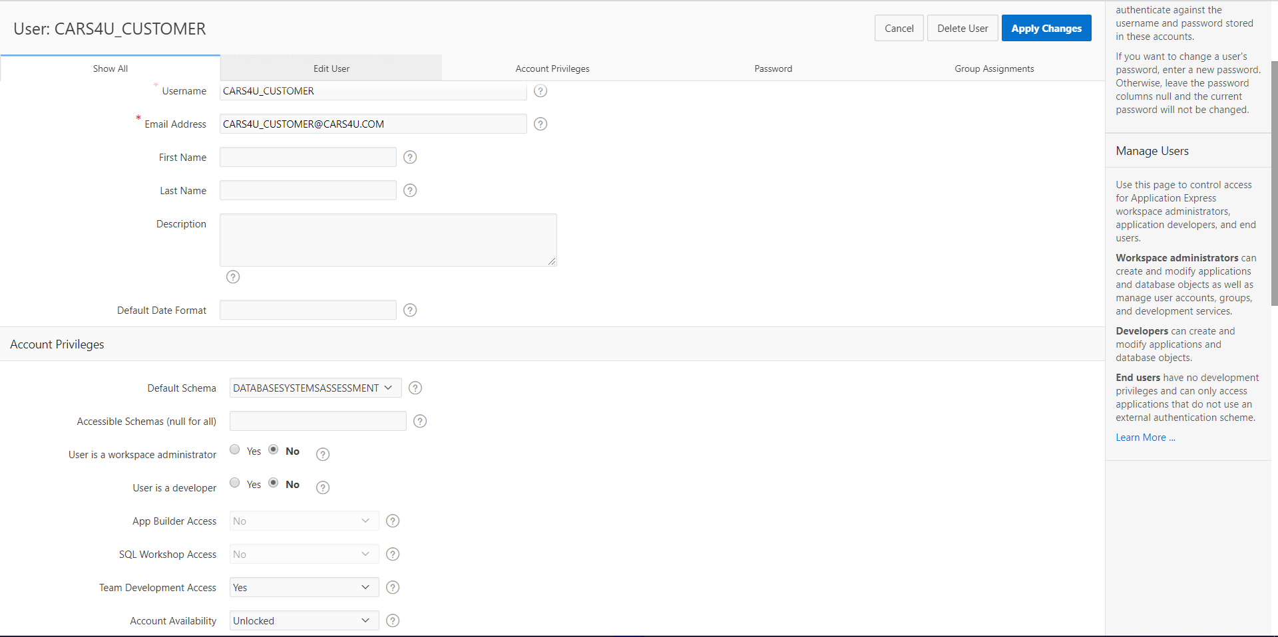

### Application Administrator

Application’s administrator can access all the features of the application.

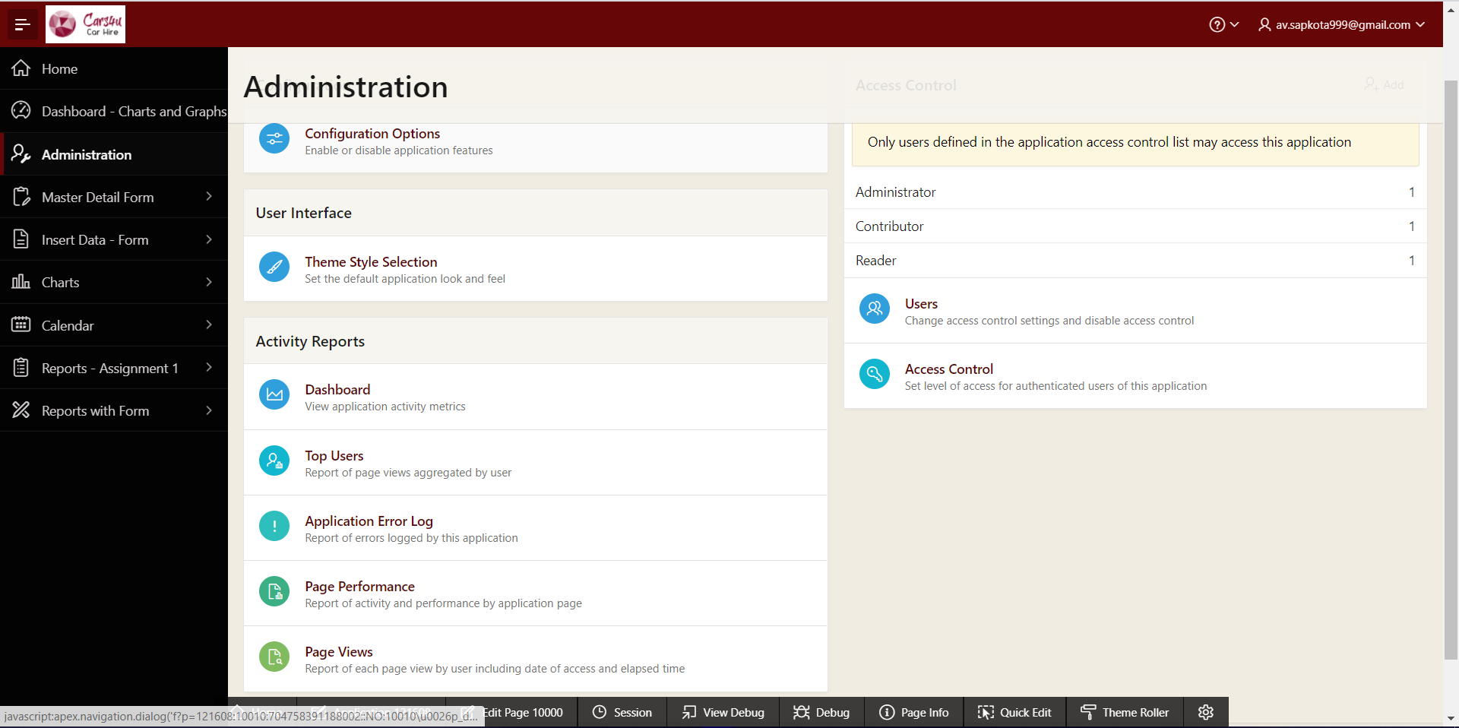

### Application’s Reader – CARS4U Customer

Application’s reader can access home page, dashboard, charts, calendar and report from the application. However, they cannot access master detail forms, insertion forms and reports with forms as user are not meant to make changes into the system according to the CARS4U point of view (assumed).

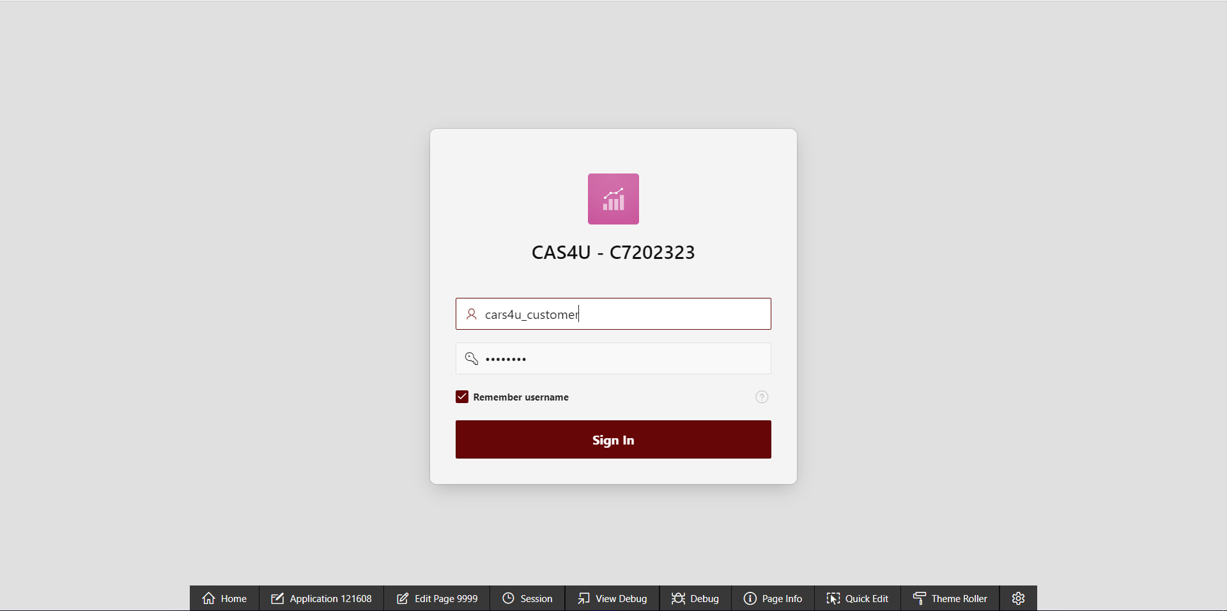

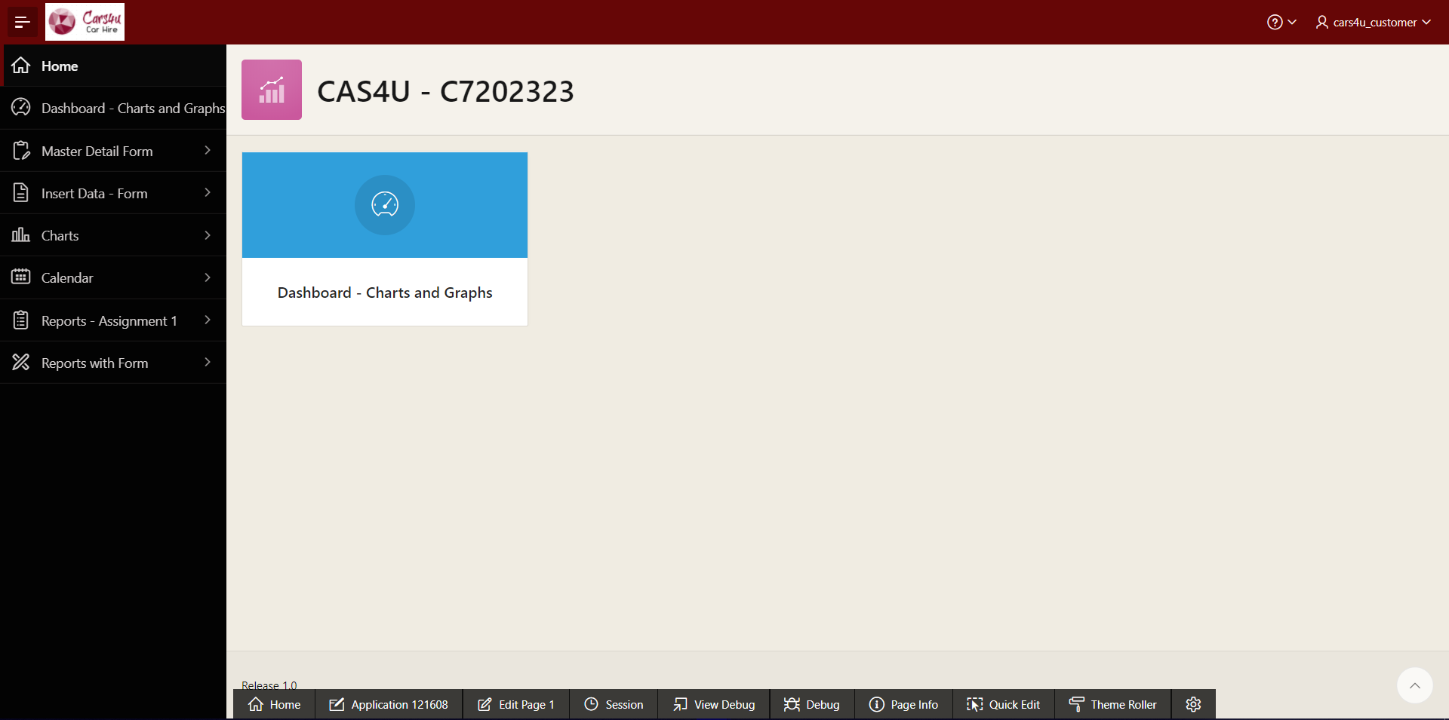

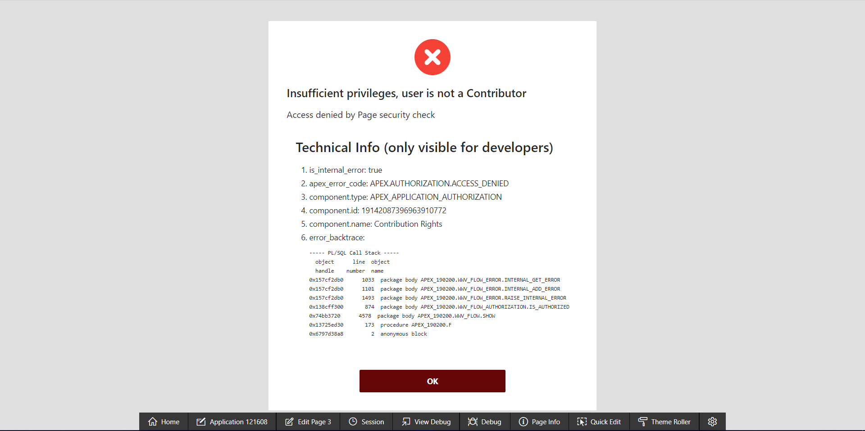

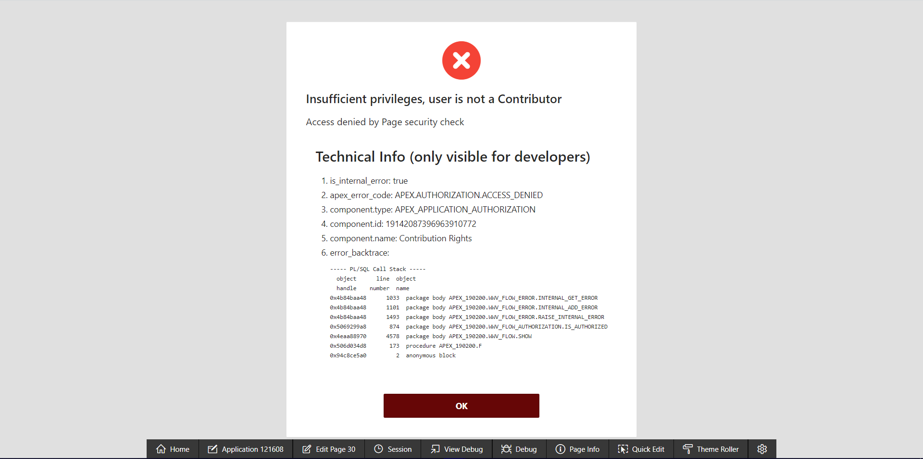

### Application’s Contributor – CARS4U Team

Application’s contributor can access home page, dashboard, master-detail forms, insertion forms, charts, calendar, reports and reports with form from the application. As CARS4U team is the one who is going to use this application and update tables and records accordingly (assumed). However, they do not have access to the backend of the application (only administrator can use those functionalities).

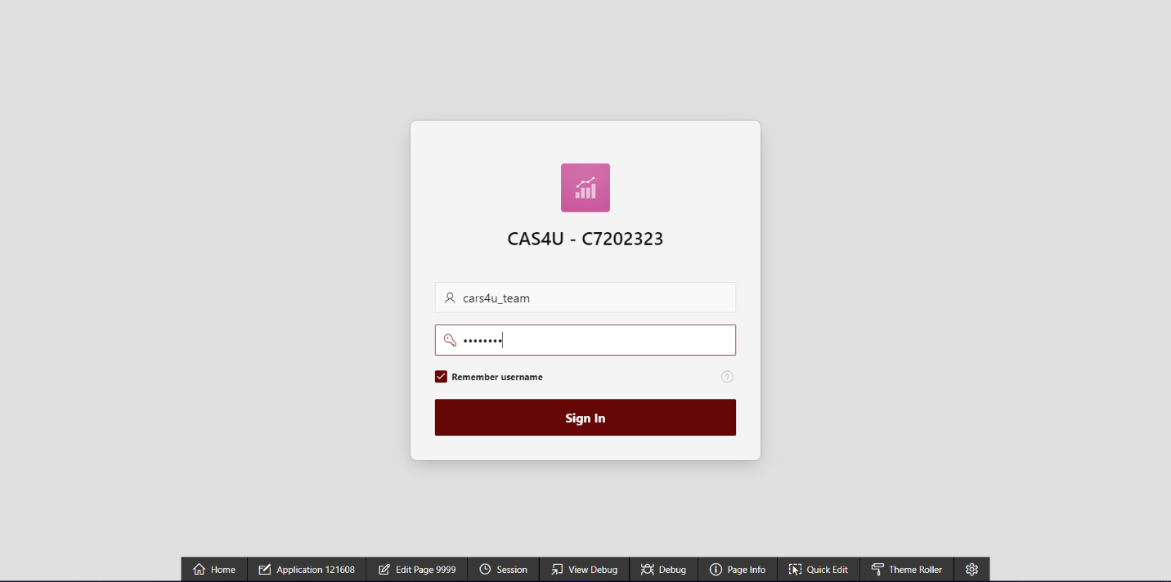

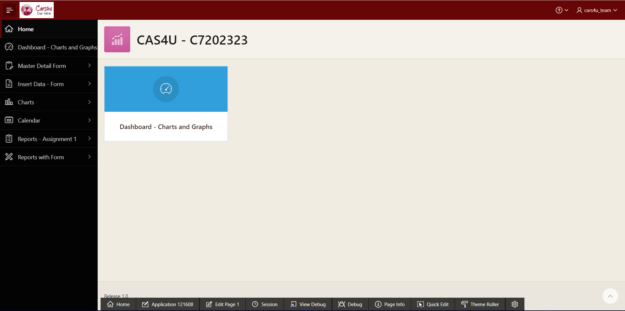

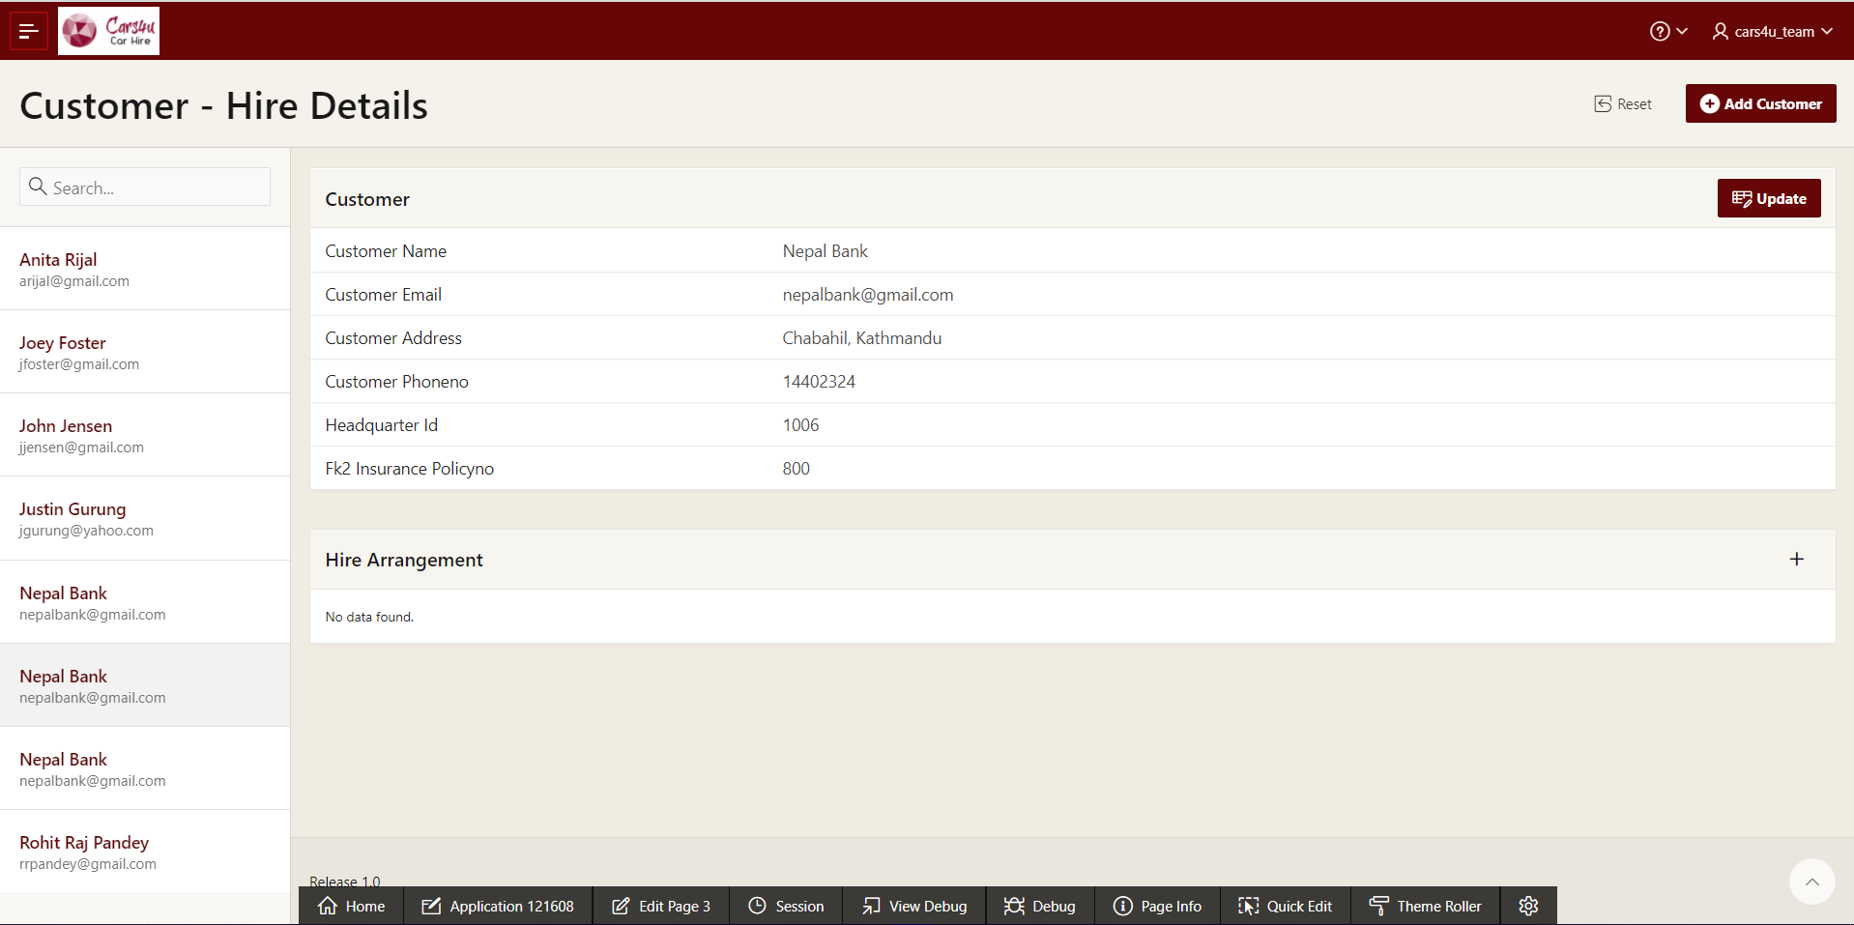

# Bibliography

* SQL Statements. (2019). docs.oracle.com [online] Available at: <https://www.docs.oracle.com/cd/E11882_01/timesten.112/e21642/state.htm> [Accessed 12,13,14 Jan. 2020].
* Oracle Learning Library (2009). apexapps.oracle.com [online] Available at: <https://apexapps.oracle.com/pls/apex/f?p=44785:2:0:FORCE_QUERY::2,RIR,CIR:P2_GROUP_ID,P2_PRODUCT_ID:1000%2C2039> [Accessed 12,13,14 Jan. 2020].
* Oracle Database Server Messages. docs.oracle.com [online] Available at: <http://docs.oracle.com/cd/B10500_01/server.920/a96525/rdbms_pa.htm> [Accessed 13,14 Jan. 2020].
* Pl/SQL challenge website. Plsqlchallenge.oracle.com [online] Available at: <https://plsqlchallenge.oracle.com/pls/apex/f?p=10000:8>:::::: [Accessed 12 Jan. 2020].

# Appendix

* DDL and DML codes have been attached into the script folder.
* SQL for reports and PL/SQL triggers has also been attached into the script folder.
* Screenshots have been attached with the assignment inside a screenshots folder.